# International Institute of Professional Studies

**Devi Ahilya Vishwa Vidhyalaya**

**Indore, M.P.**



## Project Report

**On**

**Student Support System**

### This Project is submitted for VI-semester

for degree of

#### M.Tech(IT)-2015

Guided By : Submitted By :

Mr. Shaligram Prajapat *Vaibhav Sabharwal(IT-2K-12-36)*

*Varun Wadhwani(IT-2K-12-38)*

**BONAFIDE CERTIFICATE**

This is to certify that the project report entitled “Student Support System” submitted to Devi Ahilya University in partial fulfilment of the requirement for the award of the degree of BACHELOR OF COMPUTER APPLICATION (M.Tech ), is carried out by Mr. Vaibhav Sabharwal (IT-2K12-36) and Mr. Varun Wadhwani (IT-2K12-38) under my guidance.

The matter embodied in this project is genuine work done by the student and has not been submitted whether to this University or to any other UNIVERSITY / Institute for the fulfilment of the requirements of any course of study.

Internal Examiner : External Examiner :

## RECOMMENDATION

The Project work entitled “**Student Support system”** submitted by Vaibhav Sabharwal and Varun Wadhwani is satisfactory account of the bona fide work under my supervision and is recommended towards the end of their III year of M.Tech 2015.

**Guided By :**

**Mr. Shaligram Prajapat**

## ACKNOWLEDGEMENT

“ We have taken efforts in this project.” However it would not have been possible without the kind support and help of numerous individuals and our respective educational institution (International Institute of Professional Studies,DAVV).

We would like to extend our sincere thanks to all of them.

We’re highly indebted to Mr Shaligram Prajapat,IIPS for his guidance and constant supervision as well as for providing his valuable suggestions thus helping in making our project much better following the valid improvisations.

We would like to express our gratitude towards our parents and members of the Development Centre (IIPS,DAVV) for their kind cooperation and encouragement which helped us in the completion of this project.

**ABSTRACT**

The purpose of this project is to design and develop a Student Support System primarily concerned with the reprisal or the solution of the problems or the grievances being faced by the students in numerous domains using the concepts of database design and following the steps of IT project management. The focus thus is IIPS, DAVV’s needs for student support or student grievance redressal system.A short discussion accompanies each requirement, to add the background and framework necessary to explain the functionality. It also describes non-functional requirements and other factors necessary to provide a complete and comprehensive description of the requirements for the software.

**TABLE OF CONTENTS**

**1. INTRODUCTION 10**

* 1. The Client Organization 10
  2. Problem definition 10
  3. Aim 11
  4. Objectives 11
  5. Project Goals 12
  6. Benefits 12
  7. Methodology 13

**2. CURRENT SYSTEM AND PROPOSED SYSTEM 15**

* 1. Current system 16
  2. Limitations of Current System 17
  3. Proposed system 17
  4. Objectives of Proposed System 18

**3. FEASIBILITY STUDY 19**

* 1. Feasibility Analysis 19
  2. Economic Feasibility 20
  3. Technical Feasibility 21
  4. Behavioural Feasibility 24

**4. ANALYSIS 26**

*Analysis of renowned colleges 26-73*

4.1 Questionnaire 74

4.2 Statistical Analysis 74

4.3 Overall Statistical analysis 75 4.4 Interview 75

**5. PROJECT PLANNING 80**

* 1. Project Scope 80
  2. Document Plan 80
  3. Team Structure 81
  4. Project Deliverables 82
  5. Gantt Chart 83

**6. DESIGN 72**

6.1 Logical Design 77

61.1 Entity Definition 78

6.1.2 Attribute Definition 79

6.1.3 Relationship 80

6.1.4 E-R Diagram 82

6.1.5 Data Flow Diagram 84-92

6.1.6 Activity Diagram 93-97

6.1.7 Sequence Diagram 98-101

6.1.8 Use case Diagram 102-104

6.2 User Case design 105 **Interfaces**  106-115

**7. IMPLEMENTATION**

**8. CODE SNIPPET 116-143**

**9. TESTING 144**

9.1 Black box testing 145

9.2 White box testing 145

9.3 Unit testing 146

9.4 Integration testing 147

9.5 System testing 148

**10. FUTURE PROSPECTIVE 147**

**12. BIBLIOGRAPHY 148**

**13. REFERENCES 149**

INTRODUCTION

* 1. **The Client Organisation**

The International Institute of Professional Studies is acting as a client organisation here, which is a renowned institute being a reputed department of DAVV, Indore which has various departments involved in the functioning of the institution including Administrative Cell, Placement Cell, Career Development Cell & student information of various courses being managed through management systems involved.

* 1. **Problem Definition**

The following points describe the problem domain at the institution:-

* + Non availability of a proper Student Grievance Redressal Cell
  + Non availability of proper Health Facilities inside the Institution premises
  + Lack of proper steps to curb severe issues like Ragging
  + Lack of sound or proper counselling facilities
  + Lack of a women Cell in the institute system
  + Non integration of fellowship & scholarship facilities with administrative Cell
  1. **Aim**

To design and develop a Student Support System primarily concerned with the reprisal or the solution of the problems or the grievances being faced by the students in numerous domains using the concepts of database design and following the steps of IT project management.

**1.4 Objective**

* + - The objective of the development are as follows :-
* Development of a system for the Grievance redressal in an institution as The redressal mechanism would act as a platform where a student can not only lodge complaints against any irregularities in the admission process, withhold or refusal to return any document or certificates, but can also lodge complaints of harassment and victimization including sexual harassment.
* Any institute having its own Grievance Redressal system is an informal manner i.e. through direct supervision of the Principal. But in a formal sense along with the provision of Online Feedback suggestion Form and Online Grievance Cell.
* To ensure a democratic environment in the campus, to acquaint all the faculty, Student about their rights and duties, to solve the various personal and educational related grievances of the teacher Student to make the institution student friendly, and to ensure the qualitative as well as quantitative development of the institution through the grievance and redressal cell.

**1.5Project Goals**

* To build a prototype of Student Affairs System for the solution of Student Grievances.
* To provide an electronic version for the Grievance Management.
* System would have a user friendly graphical interface.
* Diversification of the problem being faced by the victim and provide an apt support regarding the same through an appropriate counsellor.

**1.6 Benefits**

* **Easy Access to the counsellor**

The counsellor for the solution of the victim’s problem can be easily accessible with the help of the automated system as compared to the manual one.

* **No Dependency on a single person for the solution of the problem**

The victim wouldn’t have to rely on a single person for the redressal to their issue as the automated system may contain many sub bodies for the solution or even transferring the problem from one level to another in a prompt manner.

* **Saves time and effort**

The victim wouldn’t have to wait as the online system would be quite prompt as compared to the manual forwarding system of the complaints, thus the victim would be able lodge complaints at a single click without much efforts.

**1.7 Methodology**

The project plan is to carry the design and implementation of the project in a completely step-by-step manner. The entire project is divided in the following phases:-

**Phase 1 – Study and Analysis Phase**

* Questionnaire done to know the facilities and problem encountered by the student in different institutions .(included in Investigation report)
* Some drawbacks were encountered from this section. (included in Investigation report)
* Development of a check –Cross matrix based upon the initial analysis done on 15 different colleges/universities/UTD’s of Madhya Pradesh (India) fixing up some salient features which are considered mandatory to be included in the Support system of an educational institution. (included in Investigation report)

**Phase 2 - Design Phase**

In this phase the database design of the system has been realised through following steps:-

* Identification of the entities and their relationships from the scenario.
* Designing numerous UML diagrams for the proposed system.
* The logical model of the system has been designed, normalizing the relations.
* Data flow diagram of the whole system has been constructed.
* Flow chart of each process of DFD is constructed for better flow of data and its verification. (included in project report)
* Proposed the physical design of the system.

* Defining hardware and software requirements.

**Phase 3 - Coding Phase**

* The design of the system is implemented through actual code.
* Proper validation of data is used.
* Proper validation on important fields provided.
* User does not need to have the knowledge of the code, output is defined user friendly.

**Phase 4 – Testing and Implementation**

Testing is done on various test cases and data set. Testing is applied on:-

* Testing on each form by taking different user cases.
* Updation of record when a student enters details.
* Updation when complaint is registered.
* Records are managed when student checks the complaint status.

Testing is done by:-

Black box testing, White box testing and unit testing.

The above plan follows the Software Development Life Cycle (SDLC) model for the development of the proposed system. There are several ways for developing software. They consist of the following steps:

**Preliminary Investigation** - When a request to receive assistance from an information system is made, the first system activity, the preliminary investigation begins. It has three parts-

* **Request clarification** - All the request of the student support system are met by clarifying each one with the admin.
* **Feasibility analysis** - An important outcome, The system is technically feasible, institution’s budget is kept in mind, so economically supportive, and implementation is not so difficult, so operationally feasible.
* **Request Approval** - Not all requests are desirable or feasible. So the admin and authority decides which one are important and then we schedule them accordingly.

**Determination of system requirements** – We studied the institution’s process to answer the following questions:

* 1. What is being done for grievance redressal and how is it being done?
  2. How frequently a student register complain ?
  3. How great is the volume of complaints or decisions (from complaint authority)?
  4. How well is the issue/return utility task being performed?
  5. Does a problem occur in updation?

For this questionnaire and survey are done. Statistical results are also drawn from questionnaire; these all documents are attached in the project report.

**Design of a system** - It produces the details that state how the system will meet the requirements specified during systems analysis.

Design of report and output 🡪 Design of input data and form, and data to be stored 🡪 Calculation performed🡪 validation and verification code done🡪 testing.

**2.Current and Proposed system**

***2.1 Current System***

The current system of the student Support system or the Grievances Redressal management being used in the IIPS,Davv is completely manual in nature which works on the basis of lodging complaints in written, providing suggestions through drop box method and presence of an Anti Ragging council which works manually as well with the respective intervention of various faculties involved into the same.

***2.2 limitations of the current system***

*The prevalent system of the Grievance management in IIPS,Davv has a large number of shortcomings or drawbacks which thus makes the victim not too easy to come out with their respective issues. The drawbacks are as under:*

* Though, the prevailing website of IIPS,Davv consists of an option stating ‘Grievances & support’. The option has not been of any use as the students could not get desired results or the solutions to their complaints being lodged by them.
* The available option directs us to a form which has proven to be a vague approach as it lacks the proper maintenance of the records (complaints being lodged) through a DBMS.
* Lack of proper awareness amongst the students about the drop box thing available in order to lend ears to the issues being faced in different domains.
* Hesitation among the victims in writing up complaints and approaching the concerned authorities which comes out to be as a possibility in most of the cases.
* Lack of awareness amongst the students as to whom to reach at the time of reporting of the issues.
* The current system thus has proved to be sort of vague and unreliable for the victims facing issues in the Institution.
* Drop box method leads to various nuisances as there’s no way to authenticate the victim and track him down.

**2.3 Proposed system**

The following points covers the salient features of the proposed system:

* The proposed system is a completely automated system, which manages the entire operability of the Student Support System.
* The proposed system helps the user to retrieve the information as quickly as possible.
* The system provides backup plans to avoid data loss that is of high priority.
* The system is reliable enough to perform in adverse conditions.
* It is Scalable so that in near future the system can be expanded and customized to the firm’s needs.
* The system provides a user-friendly interface with a realistic view
* The system provides an error free environment.
* The system provides search facilities to find a specific entry from the database.
* The system consists of an Auditor as a supreme body for the overlooking of the entire system’s performance.
* The system consists an administrator & a collector within whom the tasks can even be passed at the time of encountering someone not proficient to handle to given task, thus the system works smoothly without further delays.
* Victim’s authentication is done beforehand in order to avoid the nuisances which used to happen in the manual system.

***2.4 Objectives of the Proposed System***

*The aim of the proposed system is to address the limitations of the current system. Following are the objectives of the proposed system:*

* Implement validation techniques and checks that will help reduce the margin of error in operations.
* Provides adequate data backup facilities in order to ensure system restart even after a calamity
* The system ensures consistency
* The system is a fool proof system that simulates and replaces the present manual system.
* The system aims at providing appropriate redressals to the grievances being lodged by referring the same to a counsellor who could handle it well as compared to a manual system.
* The problem is often diversified into domains & allotting the right person with the relating issue helps in providing an adequate and effective solution.

**3.Feasibility Study**

**3.1 Feasibility Analysis**

Feasibility study examines how beneficial is the project economically, technically and non- technically. The Student Support System is a truly feasible project and satisfies all the three conditions described below.

**3.2 Economic Feasibility**

The economic analysis of the project counts for the cost effectiveness of the project.

The economic feasibility of Student Support System is measured under the following heads:

* The project fits in the proposed budget.
* The project satisfies the economic constraints.
* The existing hardware meets the budget proposed.

This project can be regarded as economically feasible because the IIPS,Davv possesses the computer systems with them, so there is no need of bearing any cost on the resources needed for the development of the system. The only cost involved in the project is the installation cost. The only resource required for proper and successful installation is a computer system meeting software and hardware requirements of the system. These costs are quite minimal and easily available with the organization. In addition, there are no start-up costs for communications equipment installations, recruitment of new personnel, cost of disruption to the rest of the system.

**3.3 Technical Feasibility :**

The criteria for technical feasibility of Student Support System are:

* **Easy to use :** The users were assumed to be normal ordinary people having knowledge of simple computer operation for the user and a basic knowledge of database operations for the administrator, so ease of use is a very essential factor if we want to get the job actually done quickly.
* **Security:** As login authentications are used at login time so security is maintained. Some functions are to be kept under control of some specific authority so password protected entry is used.
* **Reliability:** As tables are used for storing the data, so reliability is maintained as exact data is retrieved. Data is regained from each table by using a unique key so the accurate record is accessed.
* **Maintainability :**Maintenance usually comprises of 2 key factors:-
  + **Updation :-**

As the project is built with keeping in mind all the necessary functions so no essential updation is required.

* + Terminals must be updated with antivirus so the proper functioning of operating system can be maintained.
* **Portability:**  The project can easily run on any compatible browser on any computer machine.
* **Extensibility:** The project is easily extensible as PHP support further editing, such as adding new functions, new forms or editing old forms.
* **Reusability:** The extensibility and portability of this project would make it reusable software.
* **Serviceability:** This project will try to provide maximum possible service to the user.

In our project the technical feasibility is considered up to a great extent. The software is build using **Html,Css,Java Script (BootStrap)**, which is freely available. Thus the problem of non- availability of software does not appear. The backend of the system is PHP(MySQL), which is freeware database application. Proposed system can be expanded in future if required. Proposed system has the capacity to hold the data of the firm.

It also provides the data security by password protecting.

**Technology**

**What is HTML? [1]**

HTML is a markup language for describing web documents (web pages).

* HTML stands for Hyper Text Markup Language
* A markup language is a set of markup tags
* HTML documents are described by HTML tags
* Each HTML tag describes different document content

**What is SQL? [2]**

* SQL stands for Structured Query Language
* SQL lets you access and manipulate databases
* SQL is an ANSI (American National Standards Institute) standard

**What Can SQL do? [3]**

* SQL can execute queries against a database
* SQL can retrieve data from a database
* SQL can insert records in a database
* SQL can update records in a database
* SQL can delete records from a database
* SQL can create new databases
* SQL can create new tables in a database
* SQL can create stored procedures in a database
* SQL can create views in a database
* SQL can set permissions on tables, procedures, and views

Although SQL is an ANSI (American National Standards Institute) standard, there are different versions of the SQL language.

|  |  |
| --- | --- |
|  |  |

However, to be compliant with the ANSI standard, they all support at least the major commands (such as SELECT, UPDATE, DELETE, INSERT, WHERE) in a similar manner.

Using SQL in Your Web Site

To build a web site that shows data from a database, you will need:

* An RDBMS database program (i.e. MS Access, SQL Server, MySQL)
* To use a server-side scripting language, like PHP or ASP
* To use SQL to get the data you want
* To use HTML / CSS

**RDBMS [4]**

RDBMS stands for Relational Database Management System.

RDBMS is the basis for SQL, and for all modern database systems such as MS SQL Server, IBM DB2, Oracle, MySQL, and Microsoft Access.

The data in RDBMS is stored in database objects called tables.

A table is a collection of related data entries and it consists of columns and rows.

**JavaScript** is the most popular programming language in the world.

This page contains some examples of what JavaScript can do.

## **JavaScript Can Change HTML Content [5]**

One of many HTML methods is **getElementById().**

This example uses the method to "find" an HTML element (with id="demo"**)**, and changes the element content (**innerHTML**) to "Hello JavaScript":

**What is CSS? [6]**

* CSS stands for **C**ascading **S**tyle **S**heets
* CSS defines how HTML elements are to be displayed
* Styles were added to HTML 4.0 to solve a problem
* CSS saves a lot of work
* External Style Sheets are stored in CSS files

CSS Solved a Big Problem

HTML was NEVER intended to contain tags for formatting a document.

HTML was intended to define the content of a document, like:

<h1>This is a heading</h1>

<p>This is a paragraph.</p>

When tags like <font>, and color attributes were added to the HTML 3.2 specification, it started a nightmare for web developers. Development of large web sites, where fonts and color information were added to every single page, became a long and expensive process.

To solve this problem, the World Wide Web Consortium (W3C) created CSS.

In HTML 4.0, all formatting could (and should!) be removed from the HTML document, and stored in a separate CSS file.

CSS Saves a Lot of Work!

The style definitions are normally saved in external .css files.

With an external style sheet file, you can change the look of an entire Web site by changing just one file!

**What is jQuery? [7]**

jQuery is a lightweight, "write less, do more", JavaScript library.

The purpose of jQuery is to make it much easier to use JavaScript on your website.

jQuery takes a lot of common tasks that require many lines of JavaScript code to accomplish, and wraps them into methods that you can call with a single line of code.

jQuery also simplifies a lot of the complicated things from JavaScript, like AJAX calls and DOM manipulation.

The jQuery library contains the following features:

* HTML/DOM manipulation
* CSS manipulation
* HTML event methods
* Effects and animations
* AJAX

Why jQuery?

There are lots of other JavaScript frameworks out there, but jQuery seems to be the most popular, and also the most extendable.

Many of the biggest companies on the Web use jQuery, such as:

* Google
* Microsoft
* IBM
* Netflix

**3.4 Behavioural Feasibility :**

Behavioural feasibility of Student Support System is the measure that how effective the client uses the system. It is one of the major factors of feasibility analysis. The new and the proposed system of Student Support System for IIPS,Davv includes:-

* + Easy to operate,
  + Convenient in maintenance and
  + Effective in its work.

Thus behavioural feasibility is very important factor to be considered for effective working of system. The systems analyst must still consider the behavioural feasibility of the requested Student support system. It is dependent on the human resources available for the student Support system (Administrator, Committee member etc.) and involves projecting the system operates and be used when installed. The system is behaviourally feasible if it fulfils the following points:

* The student Support system is easy to operate.
* In all the areas of application the expanded results are better than the earlier.
* Individual performance is not expected to deteriorate after implementation.
* Retrieval of information is easy, accurate and fast.

**4.Analysis**

**Student Affairs/Support System at various Renowned Institutes**

**(Madhya Pradesh,India)**

**Chapter 1**

**Grievance & Redressal Mechanism**

**Grievance/Complaint’** - A “Grievance/Complaint” is defined as any communication that expresses dissatisfaction about an action or lack of action, about the standard of service/deficiency of service of an institute and the complainant asks for remedial action. **[8]**

**Grievance Redressal**- Grievance Redressal Mechanism is part and parcel of the machinery of any administration. No administration can claim to be accountable, responsive and user-friendly unless it has established an efficient and effective grievance redress mechanism. In fact, the grievance redress mechanism of an organization is the gauge to measure its efficiency and effectiveness as it provides important feedback on the working of the administration.**[9]**

* The redressal mechanism would act as a platform where a student can not only lodge complaints against any irregularities in the admission process, withhold or refusal to return any document or certificates, but can also lodge complaints of harassment and victimization including sexual harassment.
* Any institute having its own Grievance Redressal system is an informal manner i.e. through direct supervision of the Principal. But in a formal sense along with the provision of Online Feedback suggestion Form and Online Grievance Cell.
* The Grievance Redressal cell of the institute functions with the following purposes; to ensure a democratic environment in the campus, to acquaint all the faculty, Student about their rights and duties, to solve the various personal and educational related grievances of the teacher Student to make the institution student friendly, and to ensure the qualitative as well as quantitative development of the institution through the grievance and redressal cell.
* Moreover, considering the nature and depth of the grievances due inquiry is made by the members of the cell, and through personal discussion the matter is solved. If anybody is found to be guilty of any kind of nuisance he or she is given punishment with due consideration with the principal.
* The nature of punishment includes verbal as well as written warning, information to the parents, financial punishment, information to the police (if the situation arises for so) and expelling from the institute as per the rule.

***Generalised Model of Grievance Redressal System***

**Fig(0.1)**



**Analysis Of various Renowned Institutes**

**Madhya Pradesh ,India**

|  |  |  |  |  |
| --- | --- | --- | --- | --- |
| **S.No.** | **Name of the University/College/**  **Department** | **Year of Establishment** | **Features of Student Support System in the underlying mentioned Institutes**  **(features marked red either don’t exist or not available at institute’s website)** | **URL of the referred**  **webpages**  **Of the respective Institutes** |
| 1. | **Jiwaji University**  *(Renowned University of Madhya Pradesh at Gwalior)* | 1964 | * ***Anti Ragging committee/Helpline(24*7)*** * ***Placement Cell*** * ***Infrastructure*** * ***Health*** * ***Scholarship & Fellowship*** * ***Internship*** * ***Sexual harassment Helpline*** * ***Women Cell*** * ***Skill Development / personality development Cell***   ***Administration***   * **Admissions** * **Safety & security** * **Maintenance of student Records** | <http://www.jiwaji.edu/> |
| 2. | **Rani Durgavati Vishwavidyalaya**  *(Renowned University of Madhya Pradesh at Jabalpur)* | 1956 | * ***Anti Ragging committee/Helpline(24*7)*** * ***Placement Cell*** * ***Infrastructure*** * ***Health*** * ***Scholarship & Fellowship*** * ***Internship*** * ***Sexual harassment Helpline*** * ***Women Cell*** * ***Skill Development / personality development Cell*** * ***Administration*** * **Admissions** * **Safety & security** * **Maintenance of student Records** | <http://www.rdunijbpin.org/>  ***(as on feb,20’15 at 23:00) hr*** |
| 3. | **ITM University**  *(Renowned University of Madhya Pradesh at Gwalior)* | 1997 | * ***Anti Ragging committee/Helpline(24*7)*** * ***Placement Cell*** * ***Infrastructure*** * ***Health*** * ***Scholarship & Fellowship*** * ***Internship*** * ***Sexual harassment Helpline*** * ***Women Cell*** * ***Skill Development / personality development Cell*** * ***Administration*** * **Admissions** * **Safety & security** * **Maintenance of student Records** | <http://www.itmuniversity.ac.in>  ***(as on feb’20,15 at 23:00***  ***Hrs)*** |
| 4. | **Indira Gandhi Engineering College**  *(Renowned Engineering college of Madhya Pradesh at Sagar)* | 1993 | * ***Anti Ragging committee/Helpline(24*7)*** * ***Placement Cell*** * ***Infrastructure*** * ***Health*** * ***Scholarship & Fellowship*** * ***Internship*** * ***Sexual harassment Helpline*** * ***Women Cell*** * ***Skill Development / personality development Cell*** * ***Administration*** * **Admissions** * **Safety & security** * **Maintenance of student Records** | <http://www.igecsagar.ac.in/hospital.php>  <http://www.igecsagar.ac.in/hospital.php>  ***(as on feb,20’25 at 23:00 hrs)*** |
| 5. | **Jaypee Institute of Engineering & Technology**  *(Renowned Engineering College of Madhya Pradesh at Guna)*  <http://www.jiet.ac.in/> | 1947 | * ***Anti Ragging committee/Helpline(24*7)*** * ***Placement Cell*** * ***Infrastructure*** * ***Health*** * ***Scholarship & Fellowship*** * ***Internship*** * ***Sexual harassment Helpline*** * ***Women Cell*** * ***Skill Development / personality development Cell*** * ***Administration*** * **Admissions** * **Safety & security** * **Maintenance of student Records** | <http://www.juet.ac.in/>  <http://www.juet.ac.in/Facilities/HCC.php>  <http://www.juet.ac.in/Download/JUET-%20Anti-Ragging%20Bodies%202014-15.pdf> |
| 6. | **IPS Academy**  *(Renowned College Of Madhya Pradesh at Indore)*  <http://www.ipsacademy.org/> | 1999 | * ***Anti Ragging committee/Helpline(24*7)*** * ***Placement Cell*** * ***Infrastructure*** * ***Health*** * ***Scholarship & Fellowship*** * ***Internship*** * ***Sexual harassment Helpline*** * ***Women Cell*** * ***Skill Development / personality development Cell*** * ***Administration*** * **Admissions** * **Safety & security** * **Maintenance of student Records** | <http://www.ipsacademy.org/>  ***(as on feb,20’15 at 23:00 hrs)*** |
| 7. | **Acropolis College of Engineering**  *(Renowned Engineering College of Madhya Pradesh at  Indore)* | 2005 | * ***Anti Ragging committee/Helpline(24*7)*** * ***Placement Cell*** * ***Infrastructure*** * ***Health*** * ***Scholarship & Fellowship*** * ***Internship*** * ***Sexual harassment Helpline*** * ***Women Cell*** * ***Skill Development / personality development Cell*** * ***Administration*** * **Admissions** * **Safety & security** * **Maintenance of student Records** | <http://www.acropolis.in/page/anti-ragging>  <http://www.acropolis.in/page/women-cell> |
| **8.** | **Barkatullah University,Bhopal** *(Renowned University of Madhya Pradesh at Bhopal)* | 1988 | * ***Anti Ragging committee/Helpline(24*7)*** * ***Placement Cell*** * ***Infrastructure*** * ***Health*** * ***Scholarship & Fellowship*** * ***Internship*** * ***Sexual harassment Helpline*** * ***Women Cell*** * ***Skill Development / personality development Cell*** * ***Administration*** * **Admissions** * **Safety & security** * **Maintenance of student Records** | <http://www.bubhopal.nic.in/>  <http://www.bubhopal.nic.in/students.htm>  ***(as on feb,20’15 at 23:00 hrs)*** |
| **9.** | **Shri Gobindram Seksaria Institute of Technology and Science (SGSITS),Indore** *(Renowned Engineering College of Madhya Pradesh at  Indore)* | 1952 | * ***Anti Ragging committee/Helpline(24*7)*** * ***Placement Cell*** * ***Infrastructure*** * ***Scholarship & Fellowship*** * ***Internship*** * ***Health(available but link directs us to the home page)*** * ***Sexual harassment Helpline*** * ***Women Cell*** * ***Skill Development / personality development Cell*** * ***Administration*** * **Admissions** * **Safety & security** * **Maintenance of student Records** | <http://www.sgsitsindore.in/Academics/Central_Library.aspx>  <http://www.sgsitsindore.in/Placement/PlacementCell.aspx>  ***(as on feb,20’15 at 23:00 hrs)*** |
| **10.** | **Rajiv Gandhi Proudyogiki Vishwavidyalaya (RGPV),Bhopal** *(Renowned Engineering University of Madhya Pradesh at Bhopal)* | 1998 | * ***Anti Ragging committee/Helpline(24*7)*** * ***Placement Cell*** * ***Infrastructure*** * ***Scholarship & Fellowship*** * ***Internship*** * ***Health(directs us to a pdf with some vague content which is also shown in its corresponding image)*** * ***Sexual harassment Helpline*** * ***Women Cell*** * ***Skill Development / personality development cell*** * ***Administration*** * **Admissions** * **Safety & security** * **Maintenance of student Records** | <https://www.rgpv.ac.in/AboutRGTU/FinishSchoolActivities.aspx>  <https://www.rgpv.ac.in/AboutRGTU/CentersandFacility.aspx>  ***(as on feb,20’15 at 23:00*** |

|  |  |  |  |  |
| --- | --- | --- | --- | --- |
| **11.** | **Lakshmi Narain College of Technology (LNCT), Bhopal** *(Renowned Engineering College of Madhya Pradesh at  Bhopal)* | 1993 | * ***Anti Ragging committee/Helpline(24*7)*** * ***Placement Cell*** * ***Infrastructure*** * ***Scholarship & Fellowship (no information is available at their website)*** * ***Internship*** * ***Health (no information is available at their website)*** * ***Sexual harassment Helpline*** * ***Women Cell*** * ***Skill Development / personality development cell*** * ***Administration*** * **Admissions** * **Safety & security** * **Maintenance of student Records** | <http://www.lnctgroup.in/LNCT/Health-Care>  <http://www.lnctgroup.in/LNCT/Career-Development-Cell>  <http://www.lnctgroup.in/LNCT/Activities>  ***(as on feb,20’15 at 23:00*** |
| **12.** | **Medi-caps group of Institutions,Indore** *(Renowned College of Madhya Pradesh at  Indore)* | 2000 | * ***Anti Ragging committee/Helpline(24*7)*** * ***Placement Cell*** * ***Infrastructure*** * ***Scholarship & Fellowship*** * ***Internship*** * ***Health*** * ***Sexual harassment Helpline*** * ***Women Cell*** * ***Skill Development / personality development Cell*** * ***Administration*** * **Admissions** * **Safety & security** * **Maintenance of student Records** | [http://medicaps-institute.ac.in/#](http://medicaps-institute.ac.in/)  ***(as on feb,20’15 at 23:00*** |
| **13.** | **Devi Ahilya Vishwavidyalaya, Indore** *(Renowned University of Madhya Pradesh at  Indore)* | 1964 | * ***Anti Ragging committee/Helpline(24*7)*** * ***Placement Cell (present at its various departments but no separate link/information at its own website )*** * ***Infrastructure*** * ***Scholarship & Fellowship*** * ***Internship*** * ***Health*** * ***Sexual harassment Helpline*** * ***Women Cell*** * ***Skill Development / personality development Cell*** * ***Administration*** * **Admissions** * **Safety & security** * **Maintenance of student Records** | <http://www.dauniv.ac.in/>  <http://www.dauniv.ac.in/Ragging.php>  ***(as on feb,20’15 at 23:00*** |
| **14.** | **Institute of Engineering and Technology(IET),Indore** *(Renowned Engineering College of Madhya Pradesh at  Indore)* | 1996 | * ***Anti Ragging committee/Helpline(24*7)*** * ***Placement Cell*** * ***Infrastructure*** * ***Scholarship & Fellowship (no information is available at their website)*** * ***Internship*** * ***Health*** * ***Sexual harassment Helpline*** * ***Women Cell*** * ***Skill Development / personality development cell*** * ***Administration*** * **Admissions** * **Safety & security** * **Maintenance of student Records** | <http://www.iet.dauniv.ac.in/antiragging>  <http://www.iet.dauniv.ac.in/training-a-placement>  ***(as on feb,20’15 at 23:00*** |
| **15.** | **International Institute of Professional Studies (IIPS),Indore** *(Renowned College of Madhya Pradesh at  Indore)* | 1992 | * ***Anti Ragging committee/Helpline(24*7)*** * ***Placement Cell*** * ***Infrastructure*** * ***Scholarship & Fellowship*** * ***Internship*** * ***Health*** * ***Sexual harassment Helpline*** * ***Women Cell*** * ***Skill Development / personality development Cell*** * ***Administration* (no link/information is available)** * **Admissions** * **Safety & security** * **Maintenance of student Records** | <http://www.iips.edu.in/greviances>  <http://www.iips.edu.in/placements>  <http://www.iips.edu.in/infrastructure>  ***as on feb,20’15 at 23:00*** |

***Survey at a Glance***

|  |  |  |  |  |  |  |  |  |  |  |  |  |  |  |  |
| --- | --- | --- | --- | --- | --- | --- | --- | --- | --- | --- | --- | --- | --- | --- | --- |
| Institution      Features | 1 | 2 | 3 | 4 | 5 | 6 | 7 | 8 | 9 | 10 | 11 | 12 | 13 | 14 | 15 |
|  |  |  |  |  |  |  |  |  |  |  |  |  |  |  |  |
| ***Anti Ragging committee*** | ✓ | ✓ | ✓ | ✓ | ✓ | ✓ | ✓ | ✓ | ✓ | ✓ | ✓ | ✓ | ✓ | ✓ | ✓ |
| ***Placement Cell*** | ✓ | ✓ | ✓ | ✓ | ✓ | ✓ | ✓ | ✓ | ✓ | ✓ | ✓ | ✓ | ✓ | ✓ | ✓ |
| ***Infrastructure*** | ✓ | ✓ | ✓ | ✓ | ✓ | ✓ | ✓ | ✓ | ✓ | ✓ | ✓ | ✓ | ✓ | ✓ | ✓ |
| ***Health*** | 🗶 | ✓ | 🗶 | ✓ | ✓ | 🗶 | 🗶 | 🗶 | ✓ | 🗶 | 🗶 | 🗶 | 🗶 | 🗶 | 🗶 |
| ***Scholarship & Fellowship*** | ✓ | ✓ | ✓ | ✓ | ✓ | ✓ | ✓ | ✓ | ✓ | 🗶 | 🗶 | 🗶 | 🗶 | 🗶 | 🗶 |
| ***Internship*** | ✓ | ✓ | ✓ | ✓ | ✓ | ✓ | ✓ | ✓ | ✓ | ✓ | ✓ | ✓ | 🗶 | ✓ | ✓ |
| ***Sexual harassment Helpline*** | 🗶 | 🗶 | 🗶 | 🗶 | 🗶 | 🗶 | 🗶 | 🗶 | 🗶 | 🗶 | 🗶 | 🗶 | 🗶 | 🗶 | 🗶 |
| ***Women Cell*** | 🗶 | 🗶 | 🗶 | 🗶 | 🗶 | ✓ | ✓ | 🗶 | 🗶 | 🗶 | 🗶 | 🗶 | 🗶 | 🗶 | 🗶 |
| ***Skill / personality development Cell*** | 🗶 | 🗶 | 🗶 | ✓ | ✓ | ✓ | ✓ | 🗶 | 🗶 | 🗶 | 🗶 | ✓ | 🗶 | 🗶 | 🗶 |
| ***Administration*** | 🗶 | ✓ | ✓ | ✓ | ✓ | ✓ | ✓ | ✓ | ✓ | ✓ | ✓ | ✓ | ✓ | ✓ | 🗶 |

**Graphical representation of the Survey**

**Fig(0.2)**

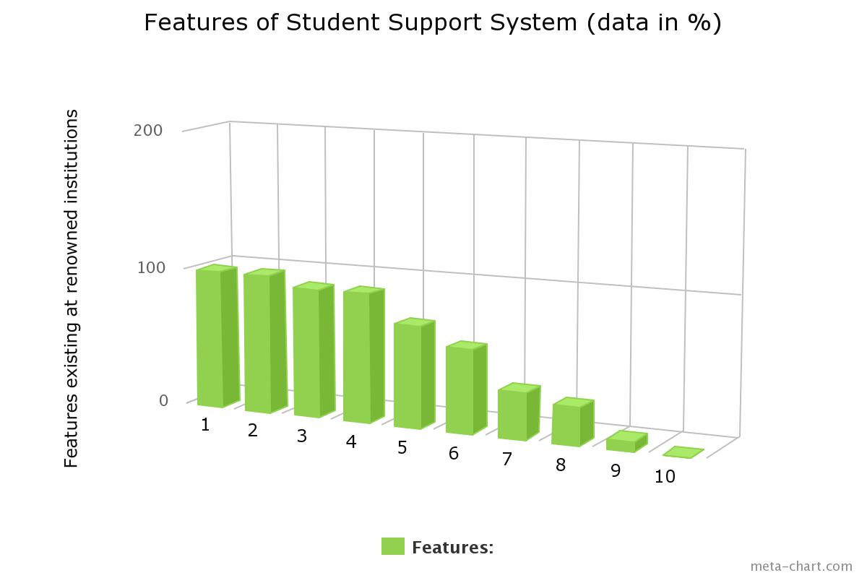

**With respect to above graph:**

1. Anti ragging committee
2. Infrastructure
3. Placement cell
4. Internship
5. Administration
6. Scholarship and fellowship
7. Skill/personality development cell
8. Health
9. Women cell
10. Sexual harassment cell [10]

*fig(1) website of Jiwaji University as on Feb’09,2015*

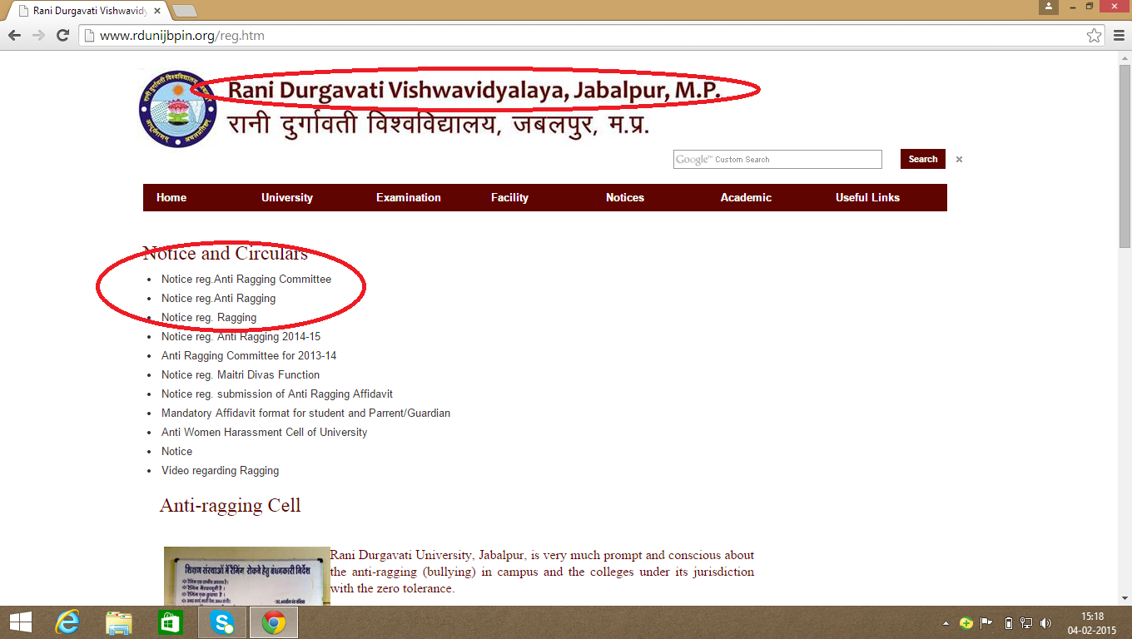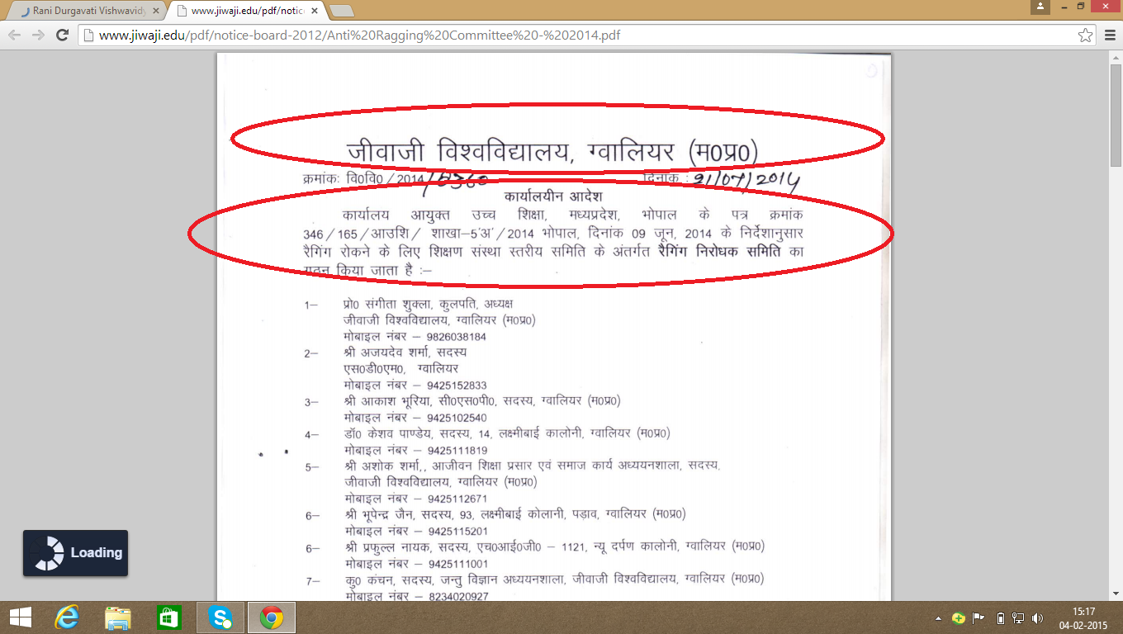

*fig(2)website of Rani Durgavati College as on feb’09,2015*

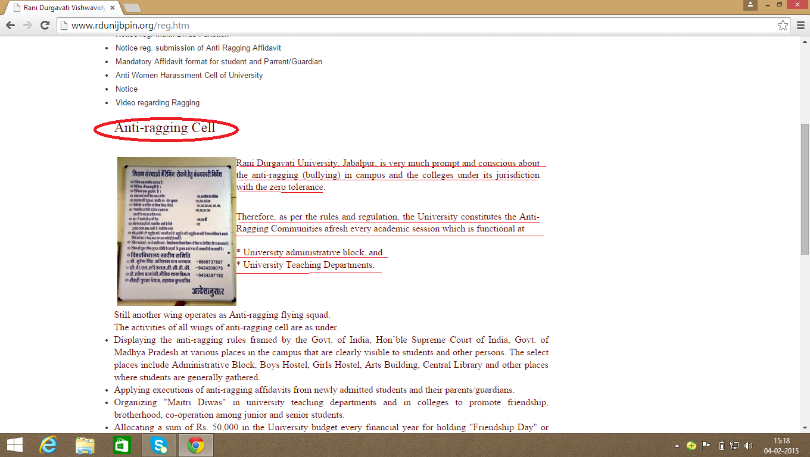

*fig(2.1)website of Rani Durgavati University as on feb ’09,2015*

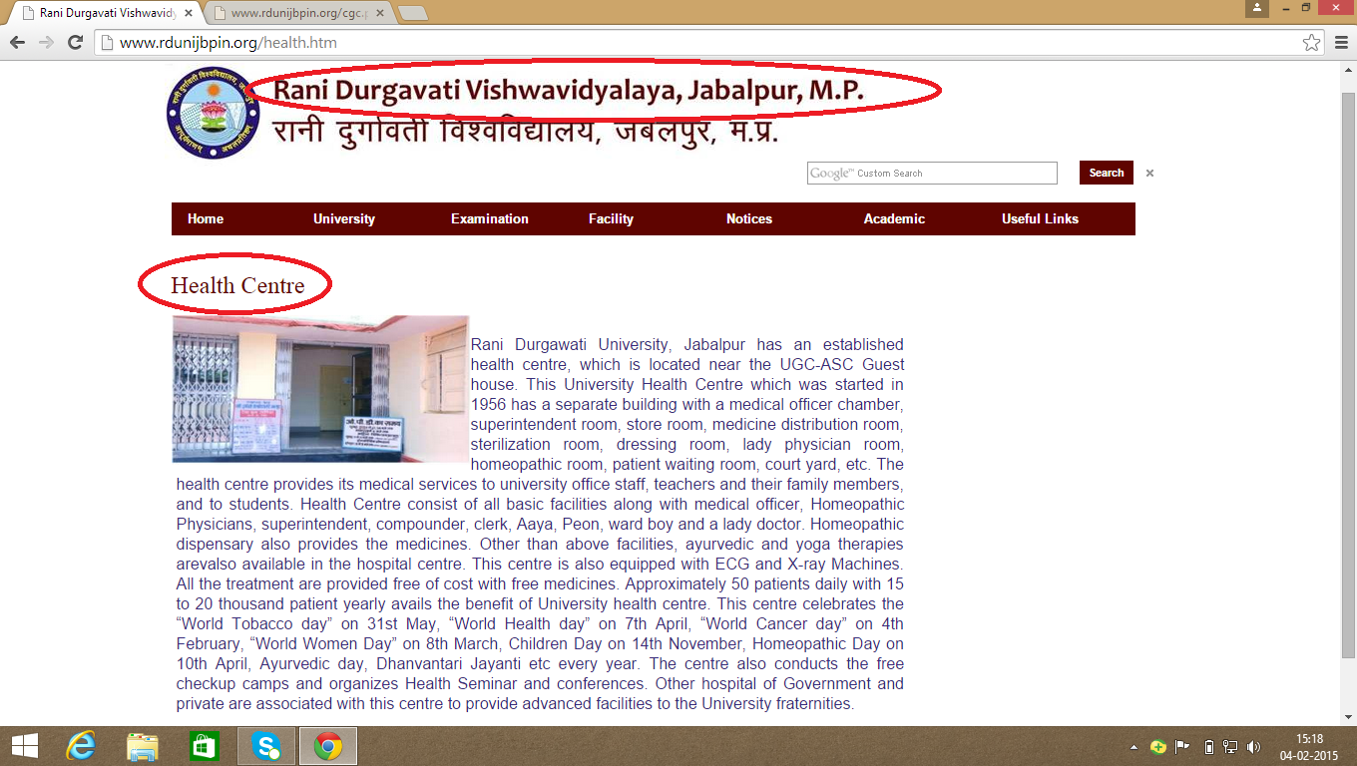

*fig(2.2)website of Rani Durgavati University as on feb’09,2015*

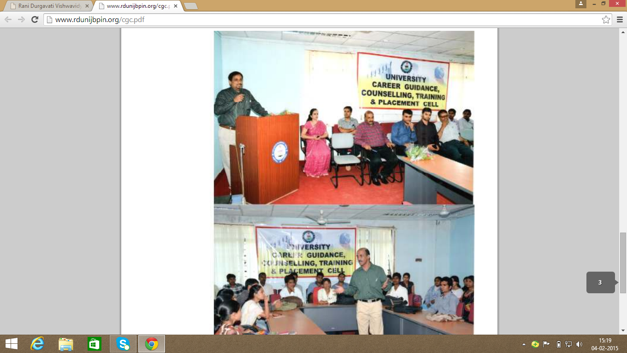

*fig(3.1)website of Jaypee College of engineering as on feb’09,2015*

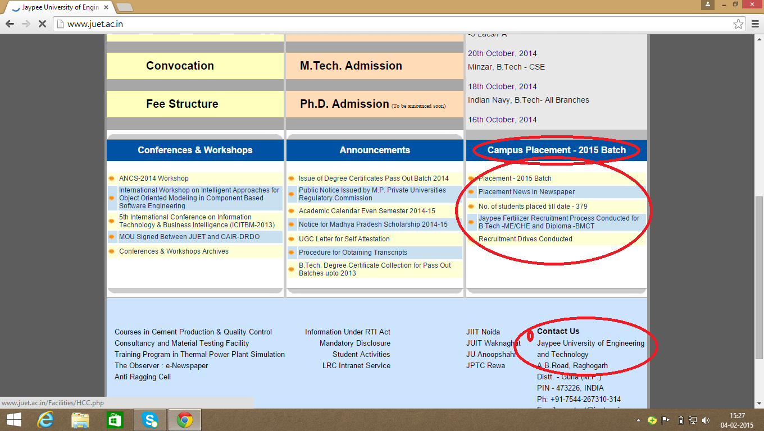

*fig(3.2)website of Jaypee college of engineering as on feb’09,2015*

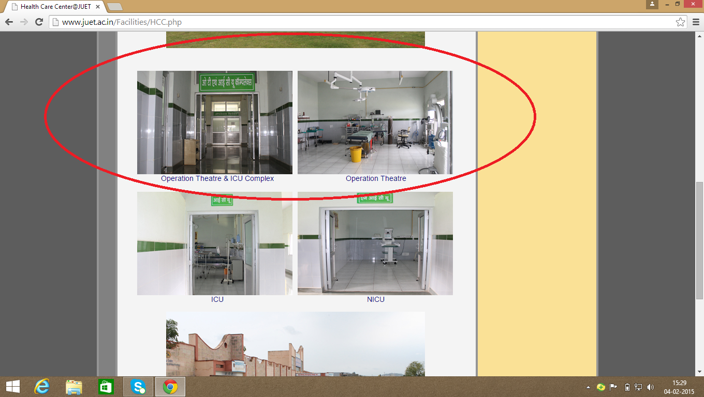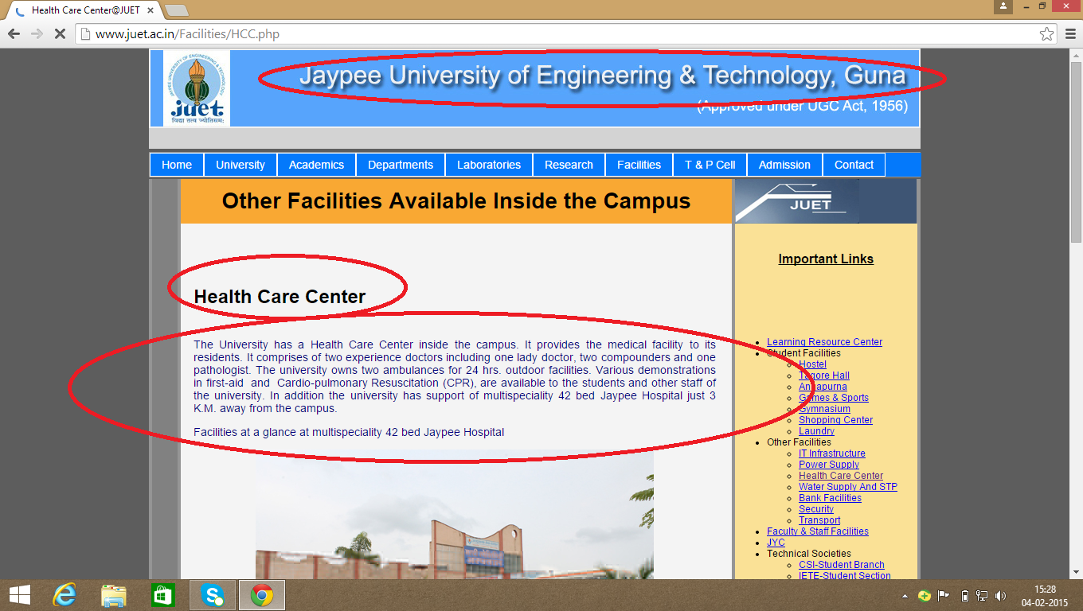

*fig(3.3)website of Jaypee college of engineering as on feb’09,2015*

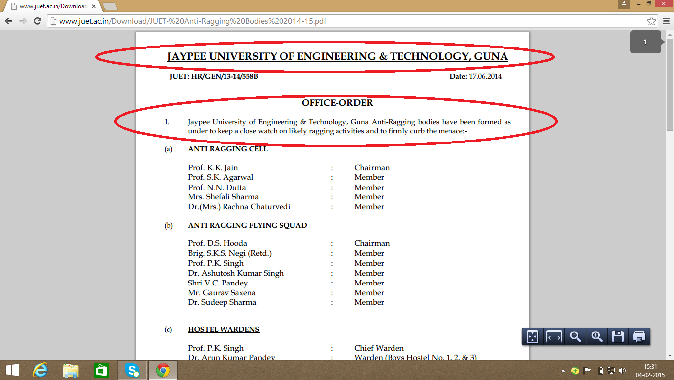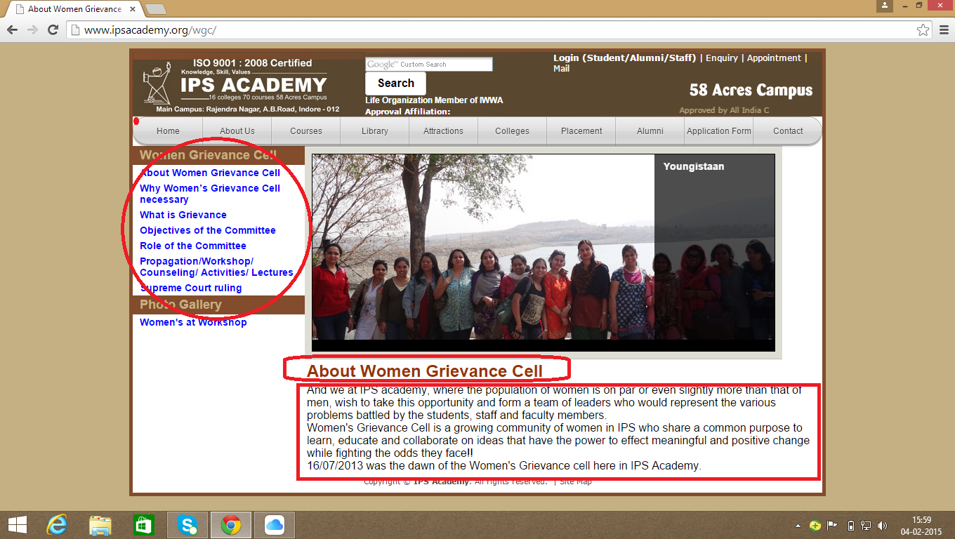

*Fig(4)website of ips academy as on feb’09,2015*

*fig(5)website of Indira Gandhi engineering college as on feb’09,2015*

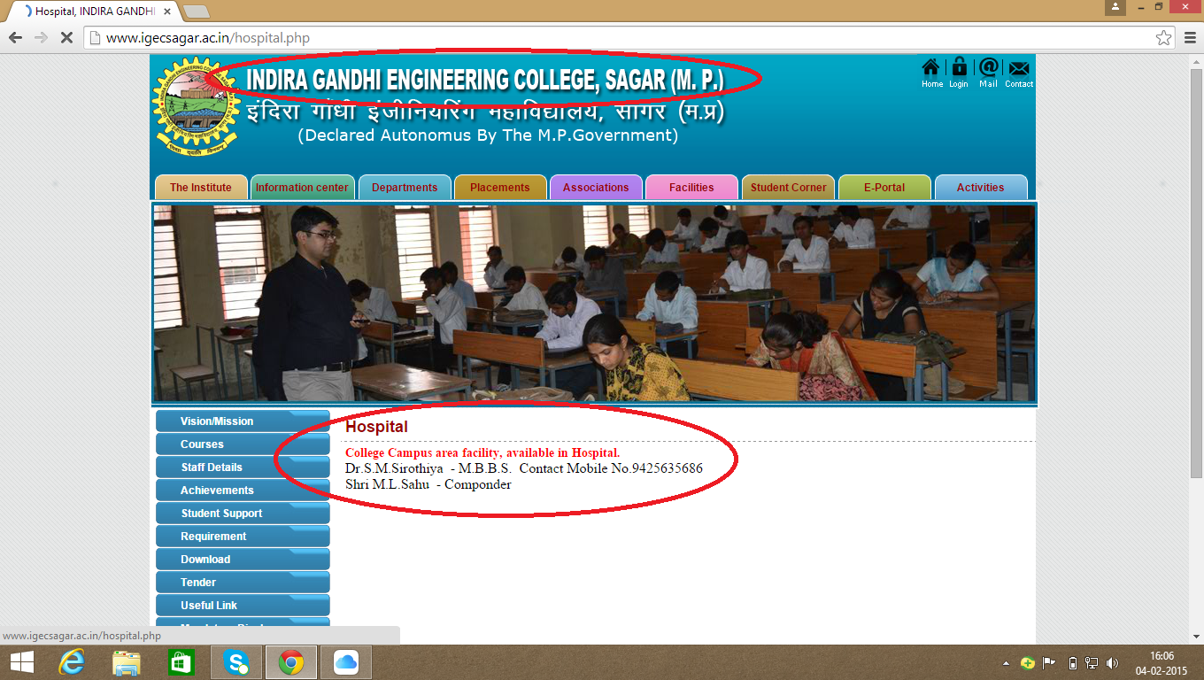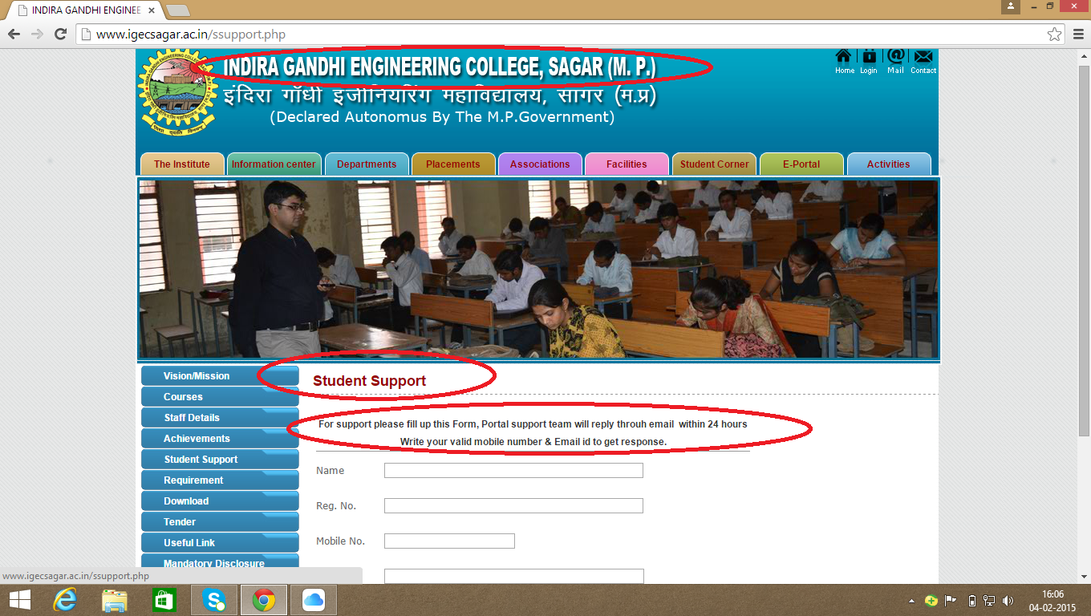

*Student Support System (Indira Gandhi college)*

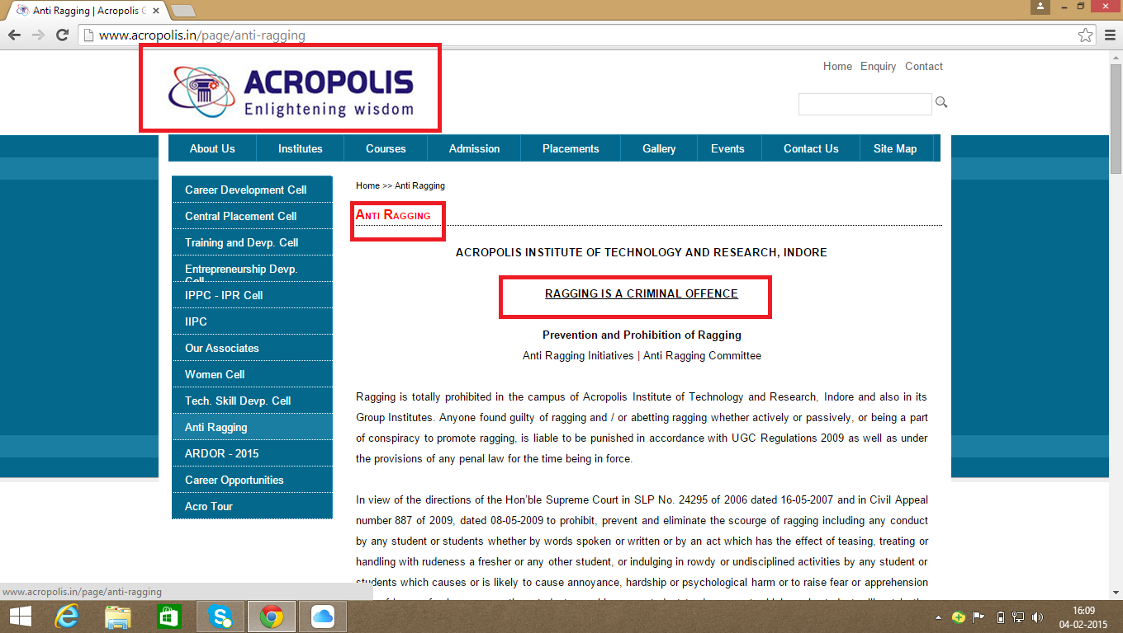

*Fig(5)website of Acropolis college as on feb’09,2015*

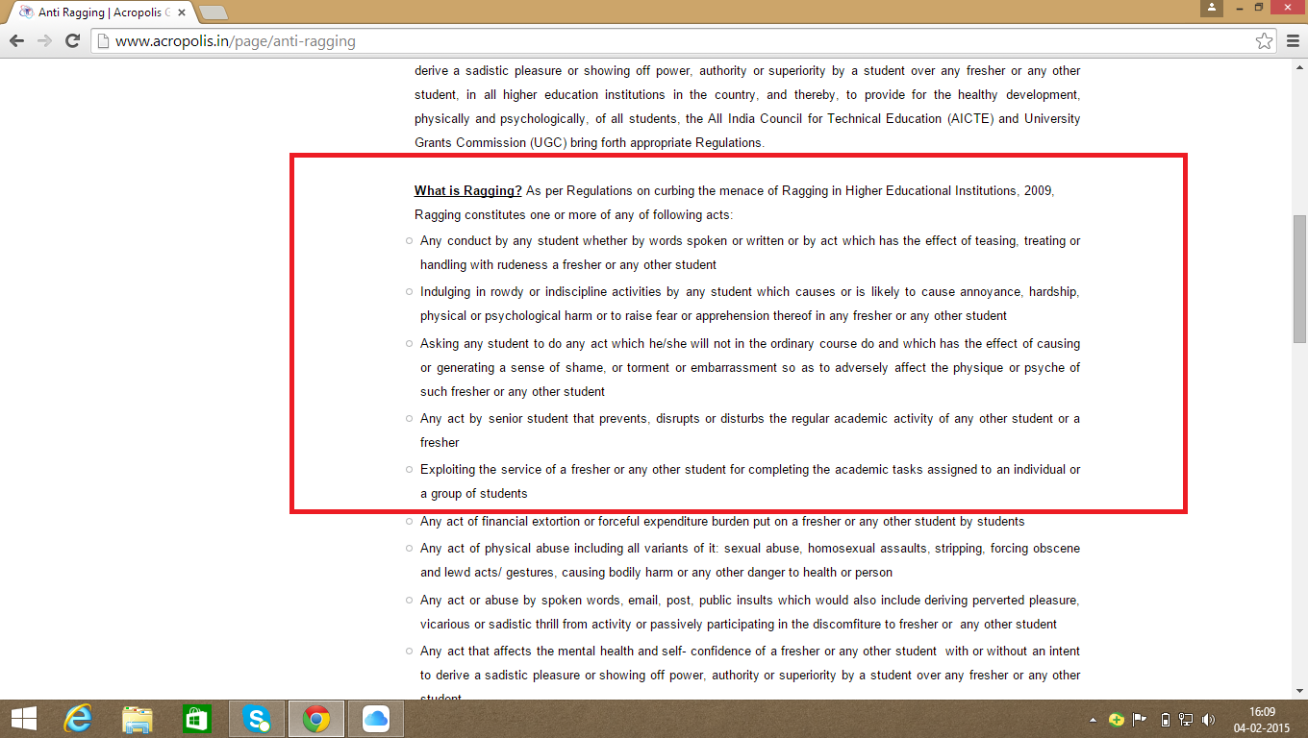

*Fig(5.1)website of acropolis college as on feb’09,2015*

*fig(5.3)website of acropolis college as on feb’09,2015*

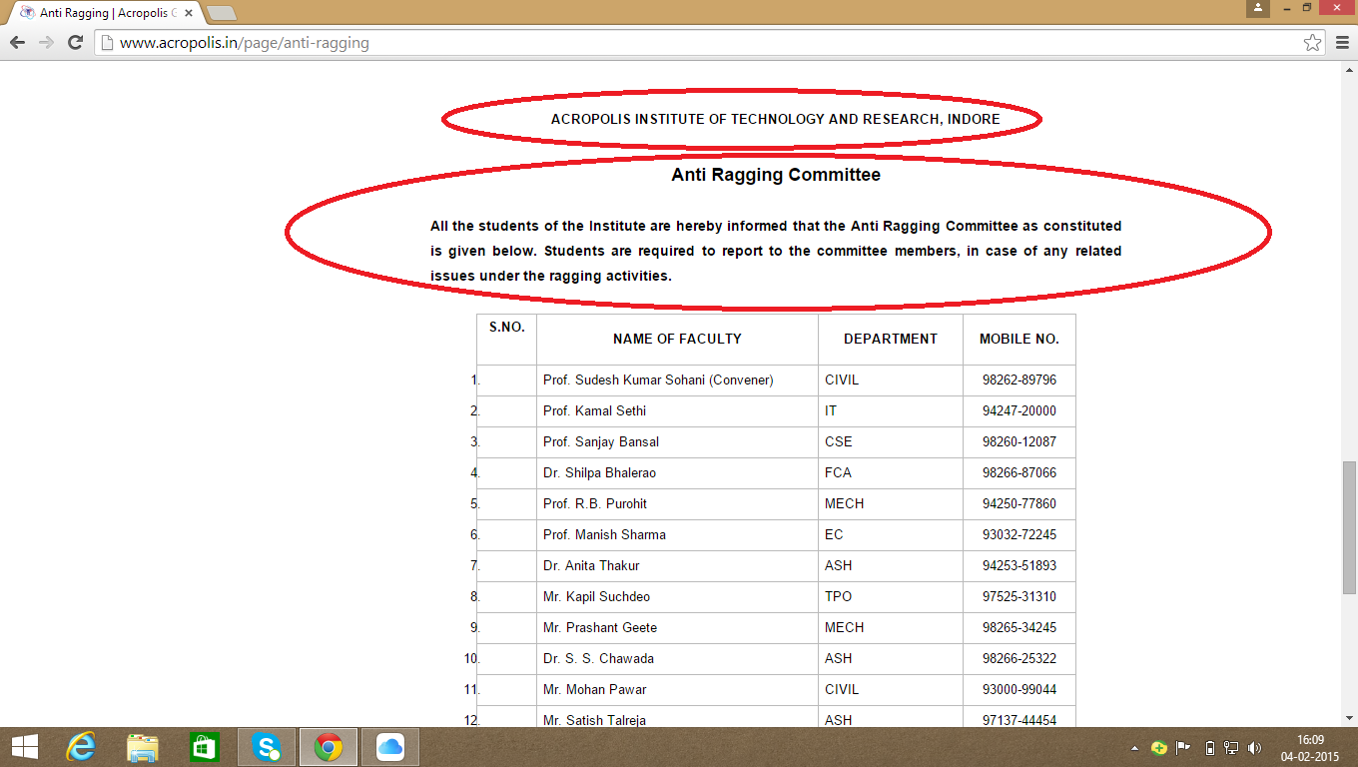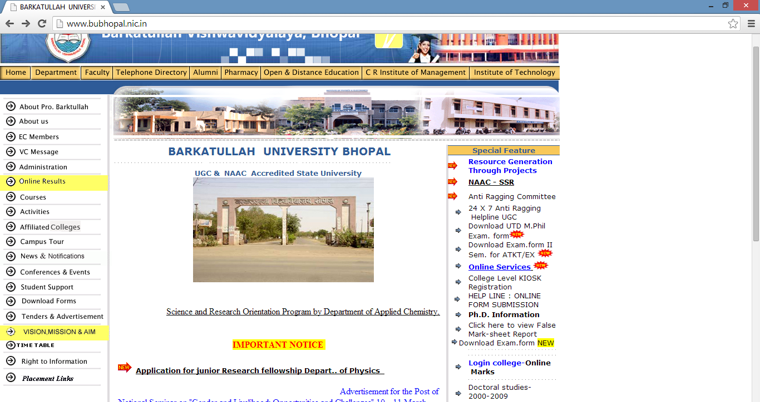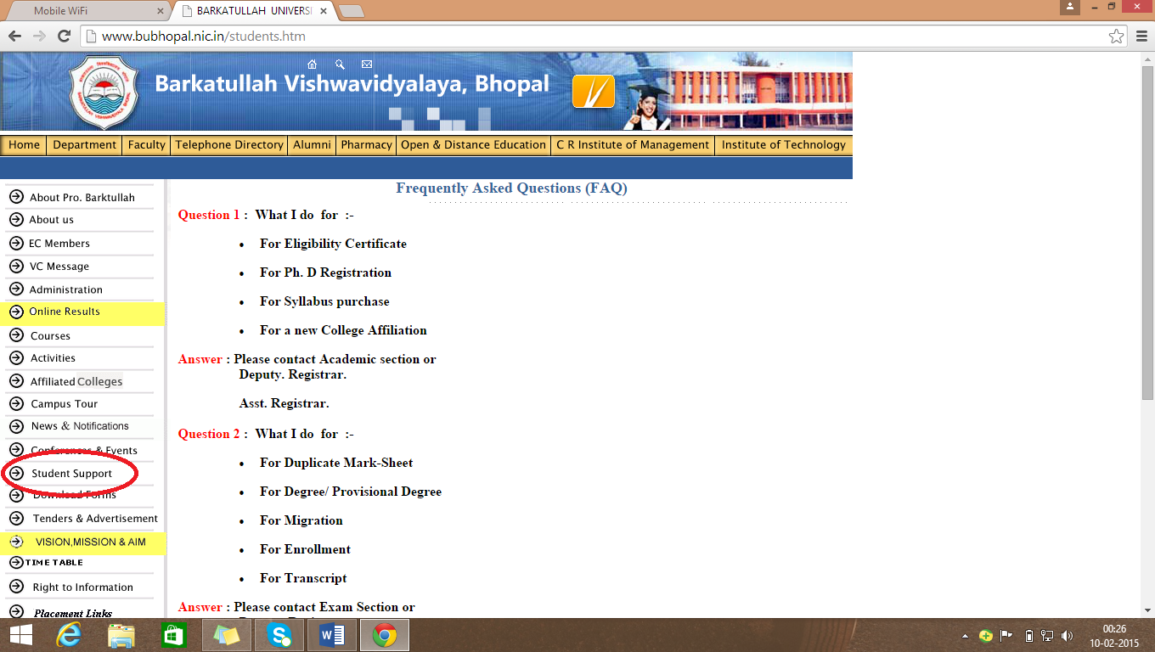

*Fig(6)website of Barkatullah University as on feb’09,2015*

Administration

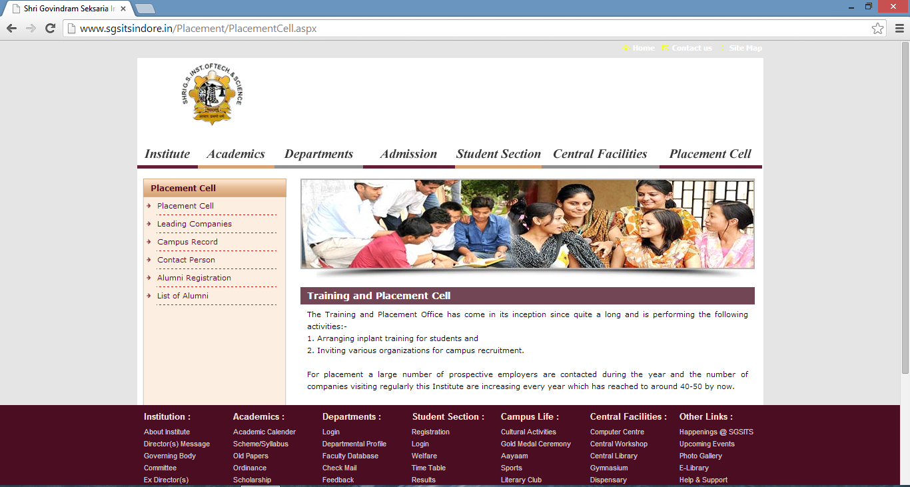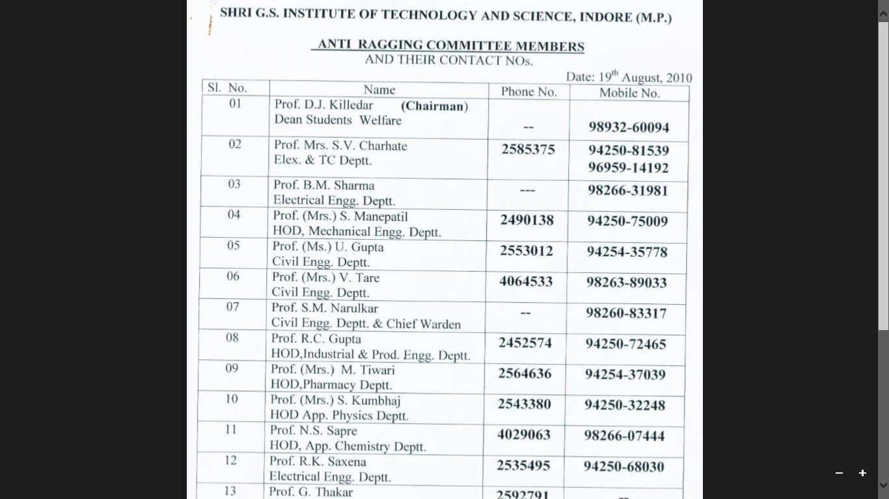

*Fig(7) website of SGSITS,Indore as on feb’09,2015*

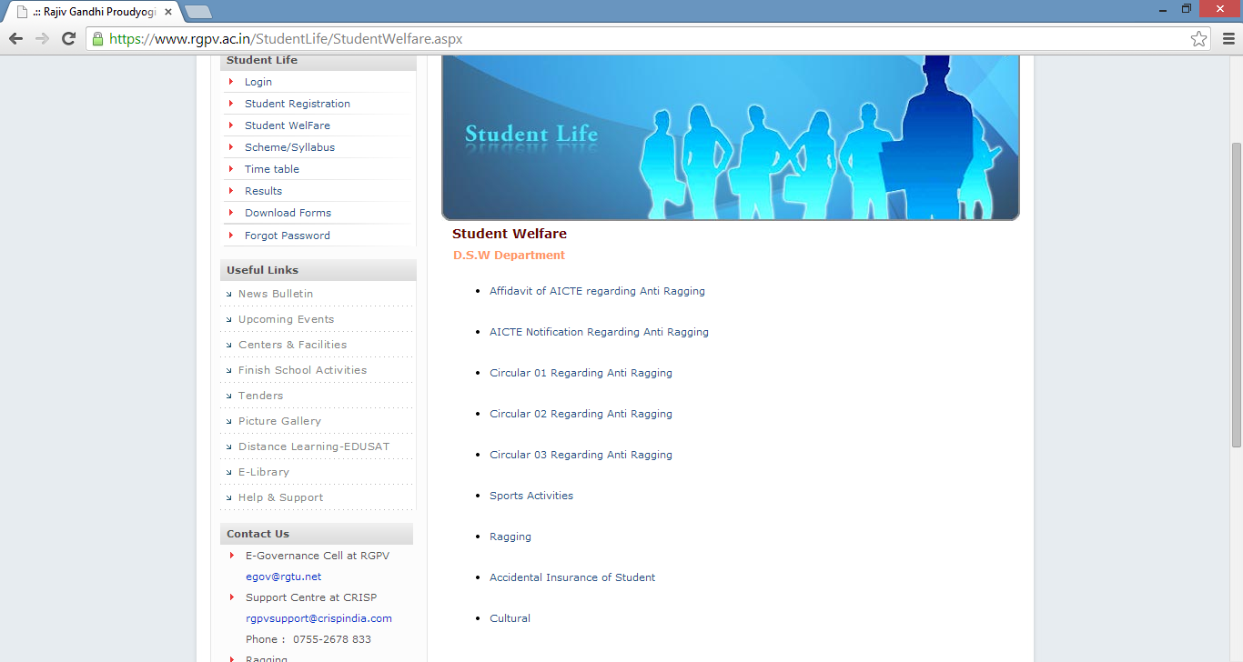

Encrypted version unavailable

((

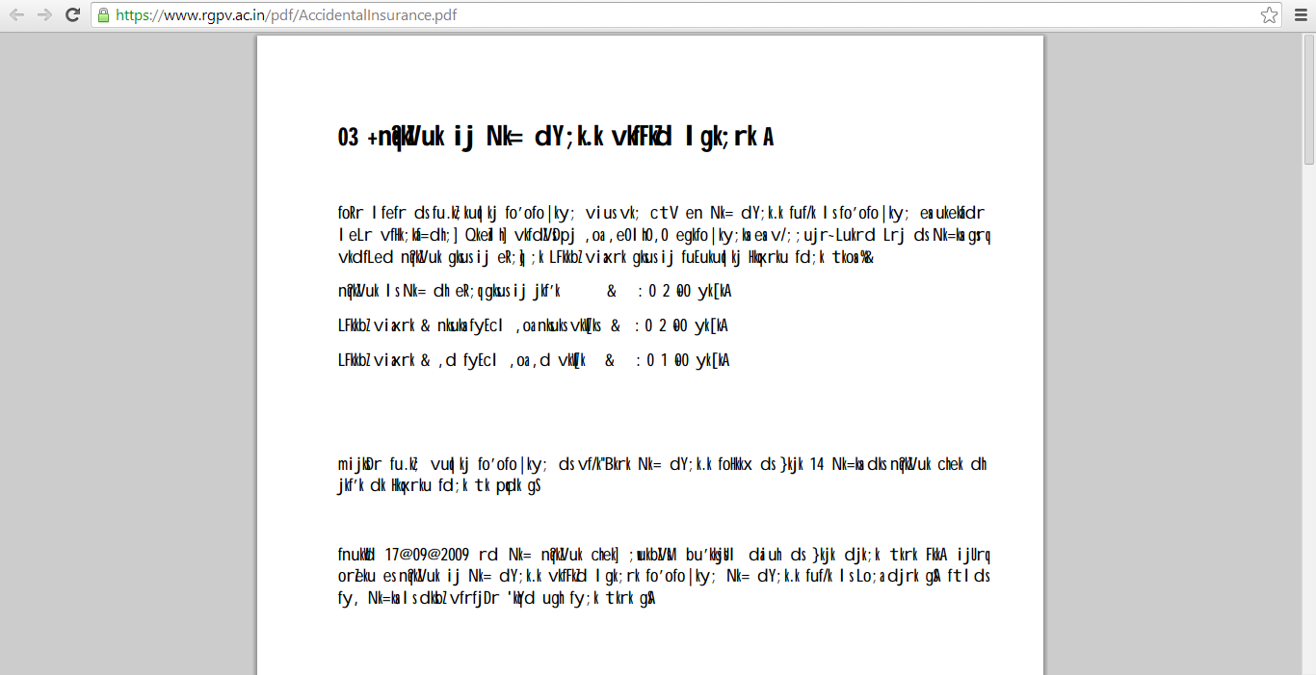

*Fig(8) website of RGPV,Indore as on feb’09,2015*

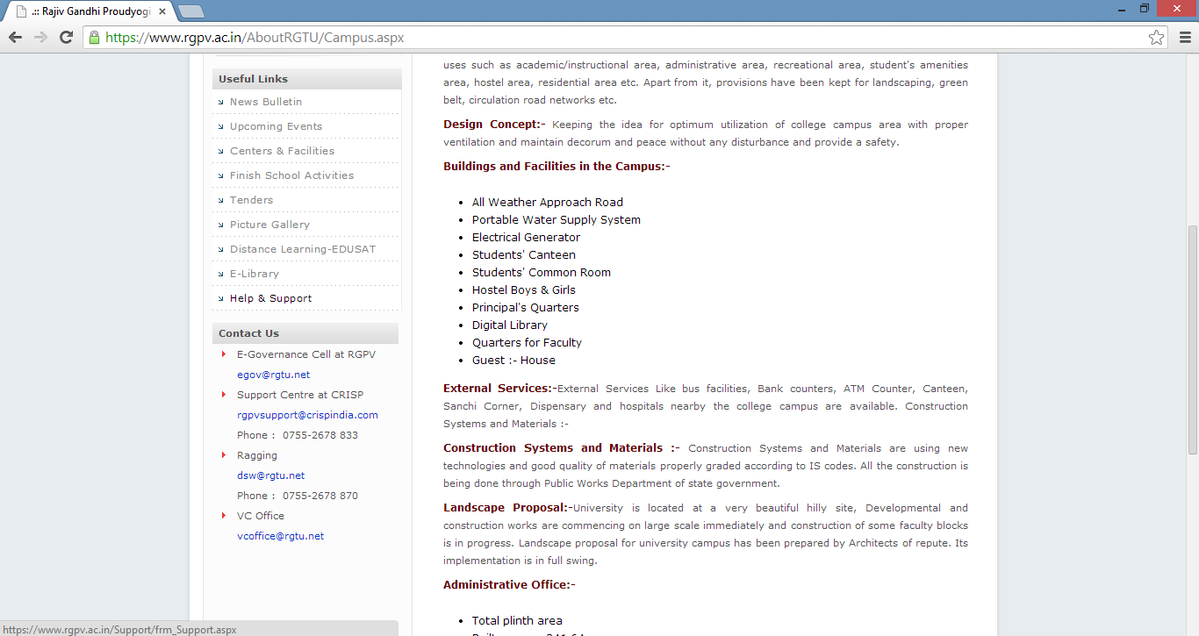

Infrastructure

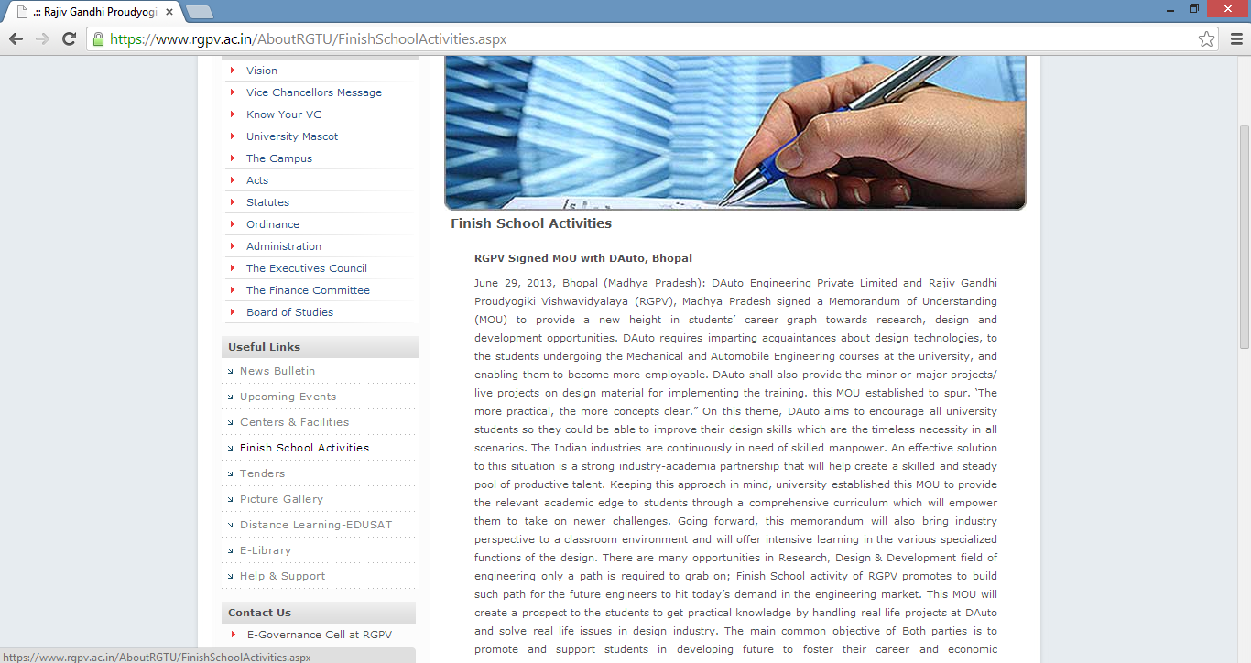

*Fig(9) website of IIPS, as on feb’09,2015*

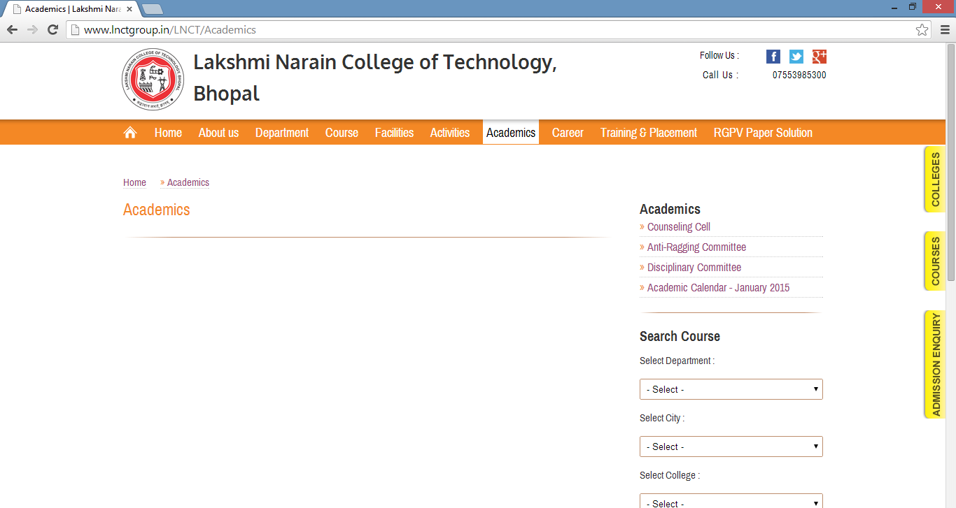

Infrastructure

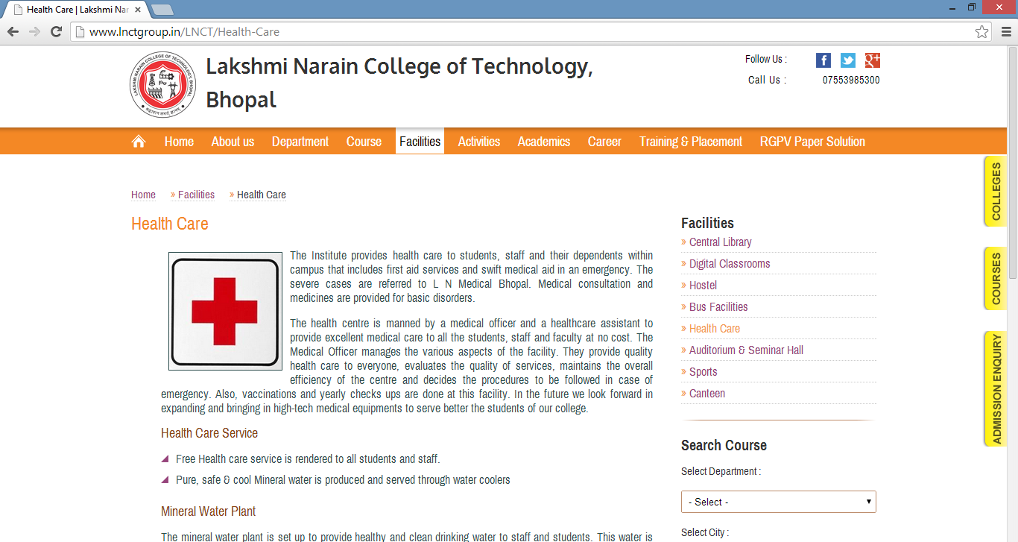

*Fig(10) website of LNCT,bhopal as on feb’09,2015*

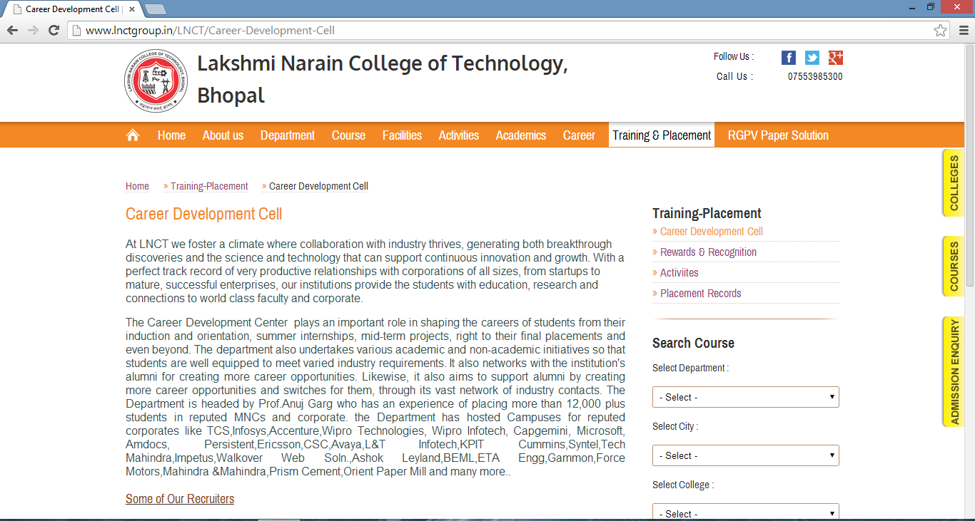

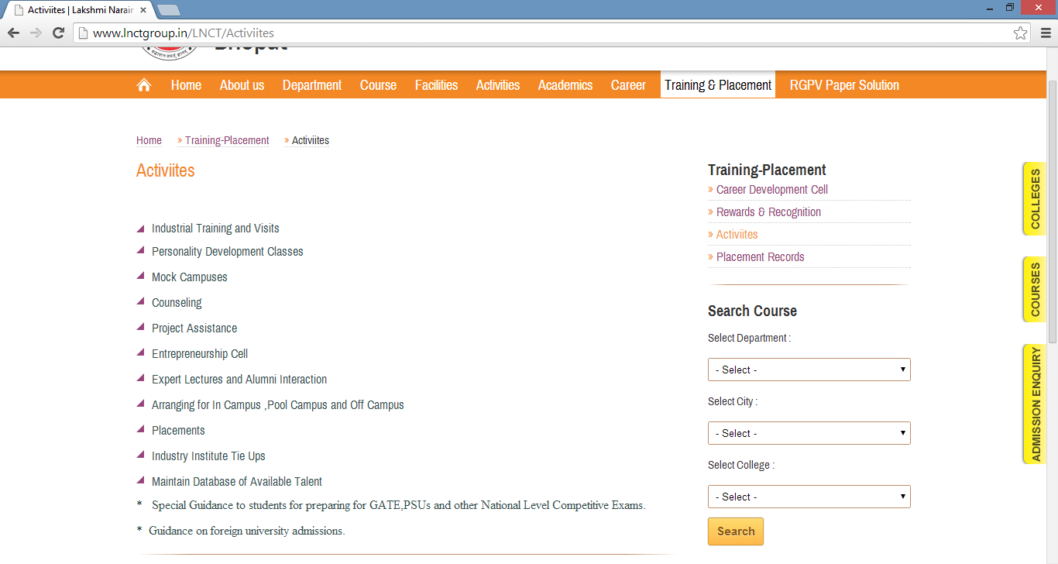

*Fig(11) website of LNCT,Bhopal as on feb’09,2015*

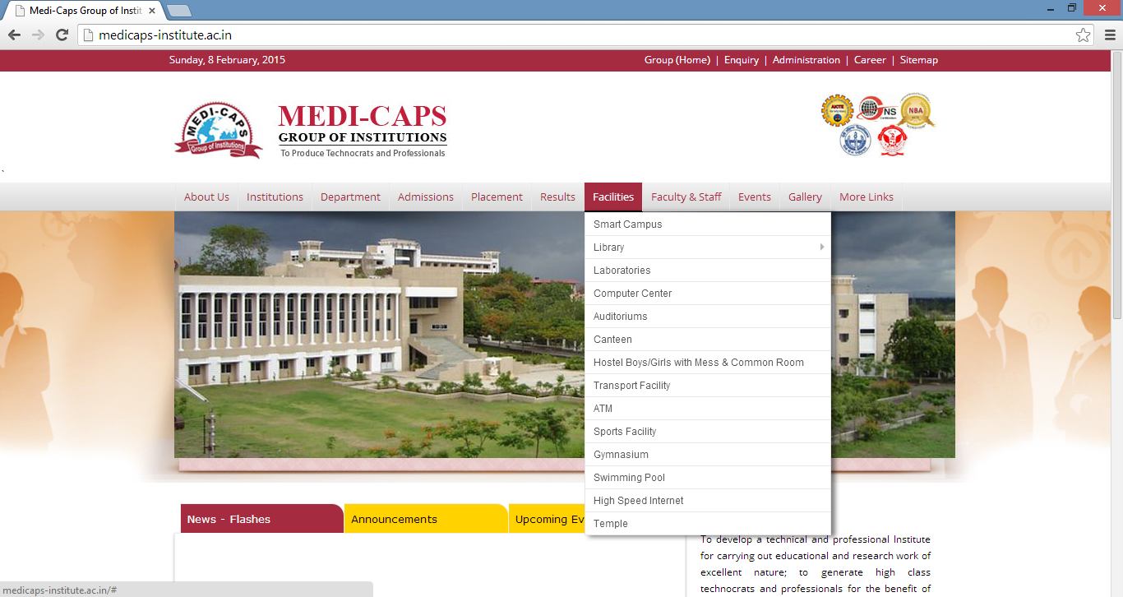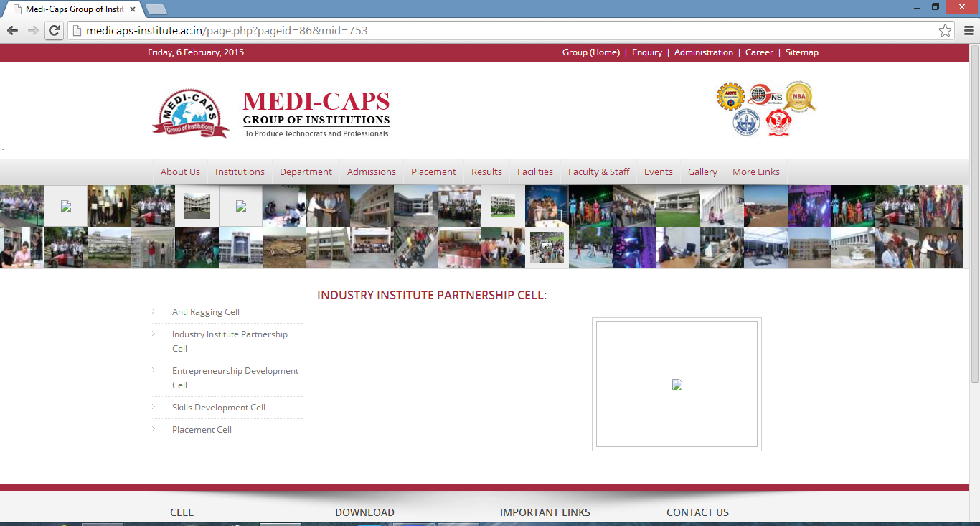

*Fig(12) website of Medicaps,Indore as on feb’09,2015*

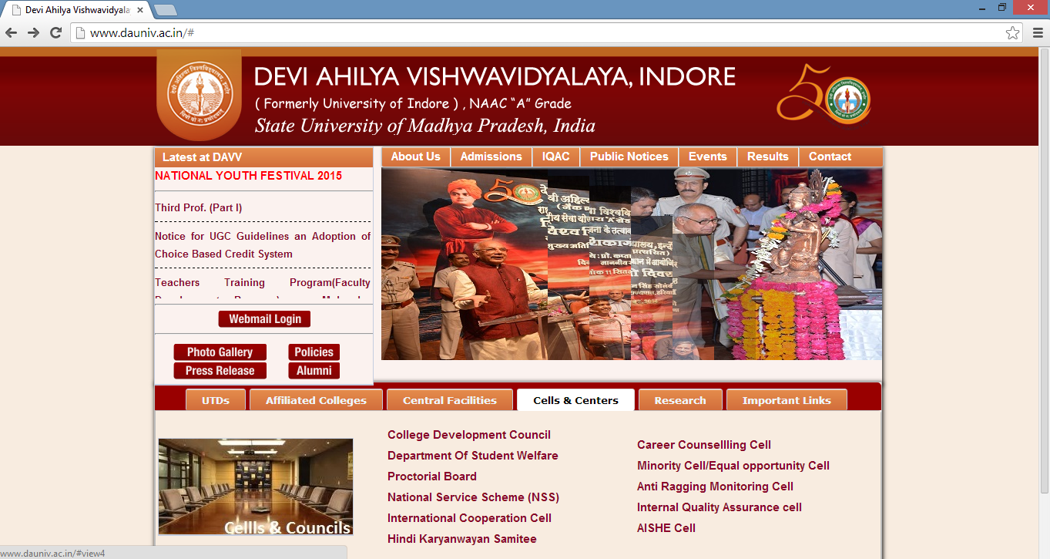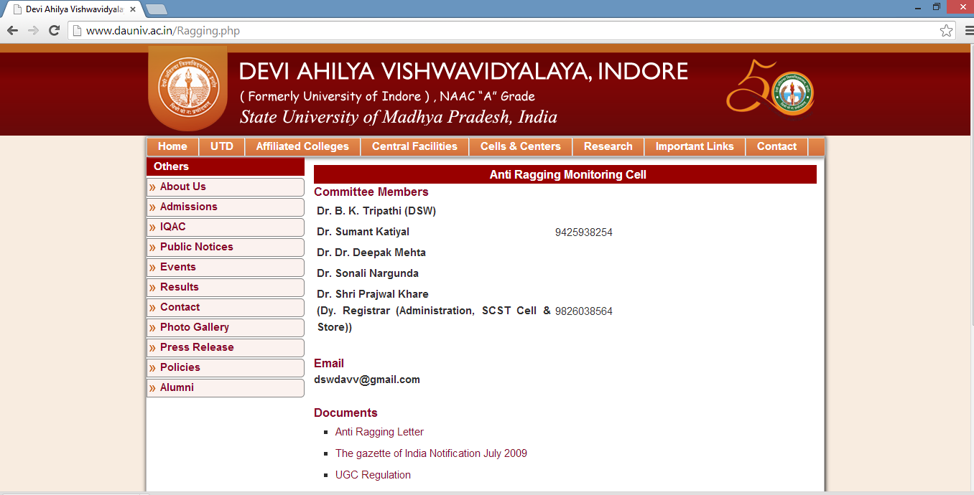

*Fig(13) website of DAVV,Indore as on feb’09,2015*

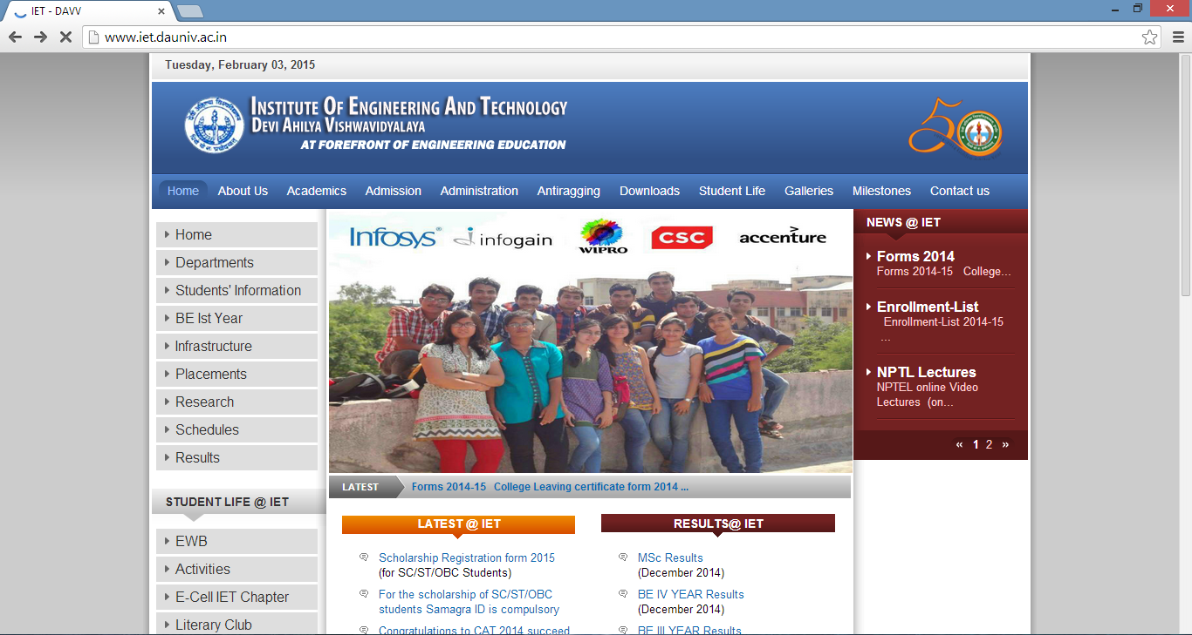

*Fig(14) website of IET,Indore as on feb’09,2015*

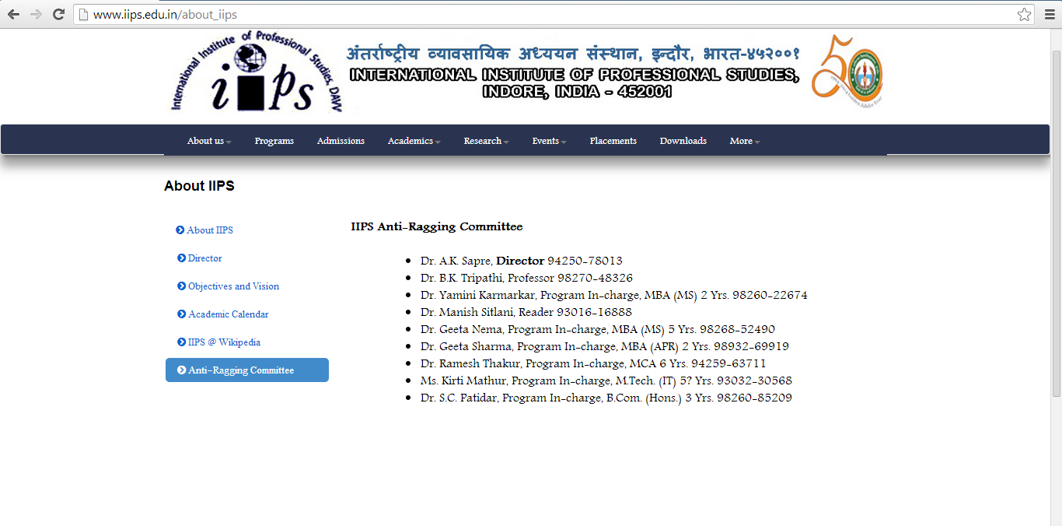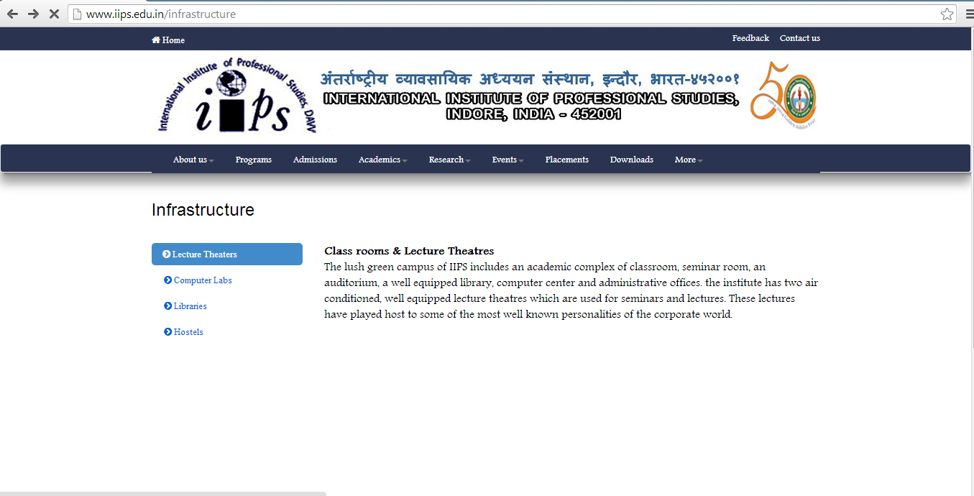

*Fig(15) website of IIPS,Indore as on feb’09,2015*

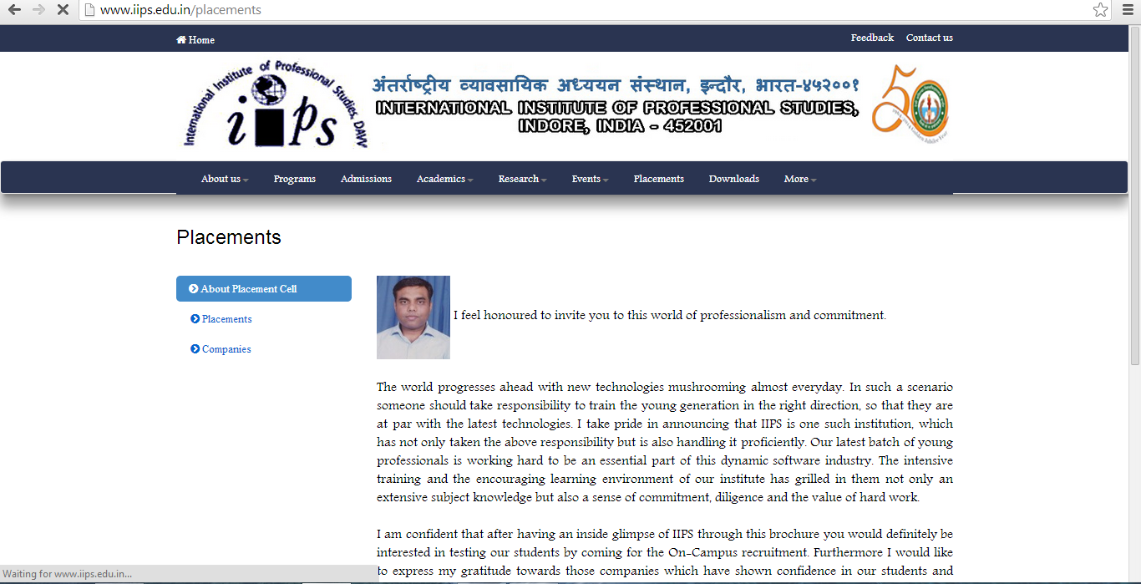

*Fig(16) website of IIPS,Indore as on feb’09,2015*

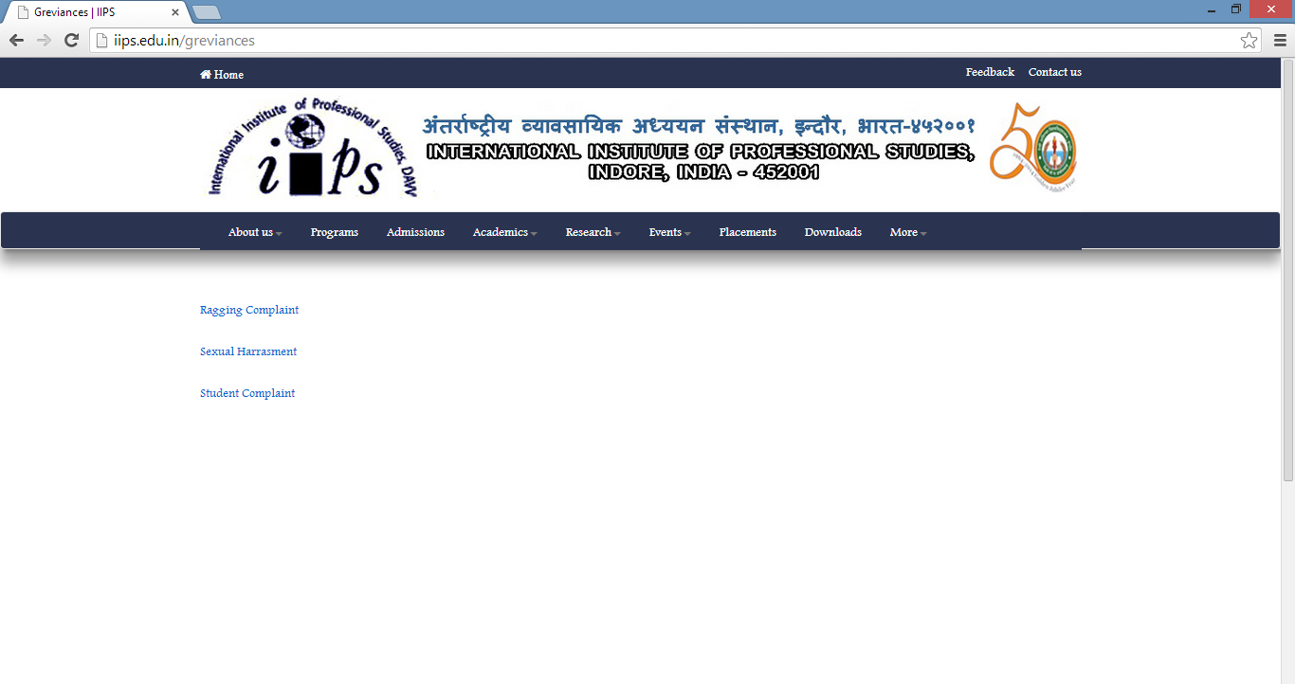

All the three links direct us to this page

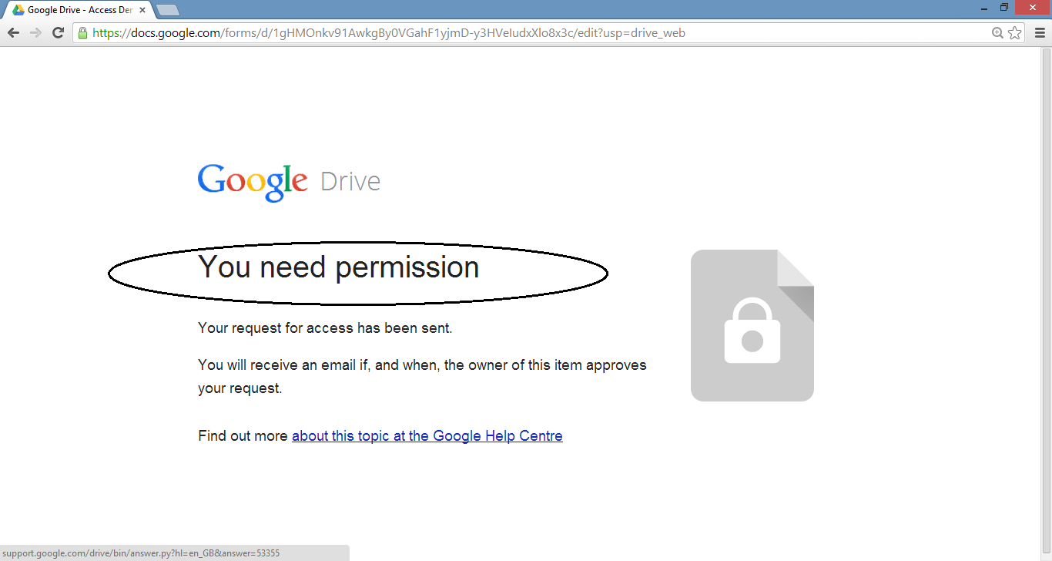

*Fig(17) website of IIPS,Indore as on feb’09,2015*

**Chapter 2**

**Shortcomings/limitations of current IIPS website**

Grievances section includes

* Ragging complaint
* Sexual harassment
* Student complaint

All the three sections directs us to log in through our e-mail id and then our request is sent to the owner .When it is granted ,an approval e-mail is sent to us and then we can lodge our complaint.

**Limitation :**

This process is tedious and time taking and is definitely not fruitful because anyone who is in need will not be able to get help at the very moment.

Rather the suggestions in the next chapter must be implemented to actually solve such grievances. **[11]**

**Suggested sections/features for Student Support System of IIPS website**

[**(http://iips.edu.in/)**](http://iips.edu.in/)

**Must implement features**

1. 24*7 anti ragging helpline
2. Women cell with 24*7 separate helpline (especially for those in hostel)
3. Information about scholarships to keep transparency as well (In this section work of SGSITS,Indore is commendable)
4. Health center/hospital must be in the university(DAVV) campus with ambulance facility and an emergency helpline number on the website
5. Skill development and personality development cell
6. Information about college administration
7. Student profiles/records must be updated as soon as possible (which is under progress)

**[12]**

**Chapter 3**

**MANIT as a model for the prevalent Institutes of Madhya Pradesh**

We chose *Maulana Azad National institute of technology* *,Bhopal* as a model to quote an example from for an ideal institute or to highlight some of the world class features which MANIT possess which could serve as a basis to set a benchmark in the education Field.

Some of the underlying features supported by snapshots of the respective website of MANIT :-

* 24*7 Anti Ragging Helpline
* Wide Range of Security Services inside the Institute Premises
* All the required and necessary Health Facilities including escort service to the respective Hospital
* World Class Infrastructural facilities including Campus wifi and uninterrupted internet connectivity
* Dispensary under the respective recognition of reputed Doctors
* Skill Development & placement Cell

Snapshots of the website of MANIT,Bhopal as on feb’09,2015 are provided underneath

***[13]***

|  |  |  |
| --- | --- | --- |
| **MANIT**  *(National Institute of Technology,Bhopal)*  ***Considered as a Model For the prevalent Institutes of Madhya Pradesh having all the basic amenities an ideal institute should possess*** | 1960 | * ***Anti Ragging Helpline(24*7)*** * *Placement Cell* * *Infrastructure* * ***Health*** * *Scholarship & Fellowship* * *Internship* * ***Sexual harassment Helpline*** * ***Women Cell*** * *Skill Development Cell / personality development* * ***Administration*** * Admissions * Safety &security * Maintenance of student Records |

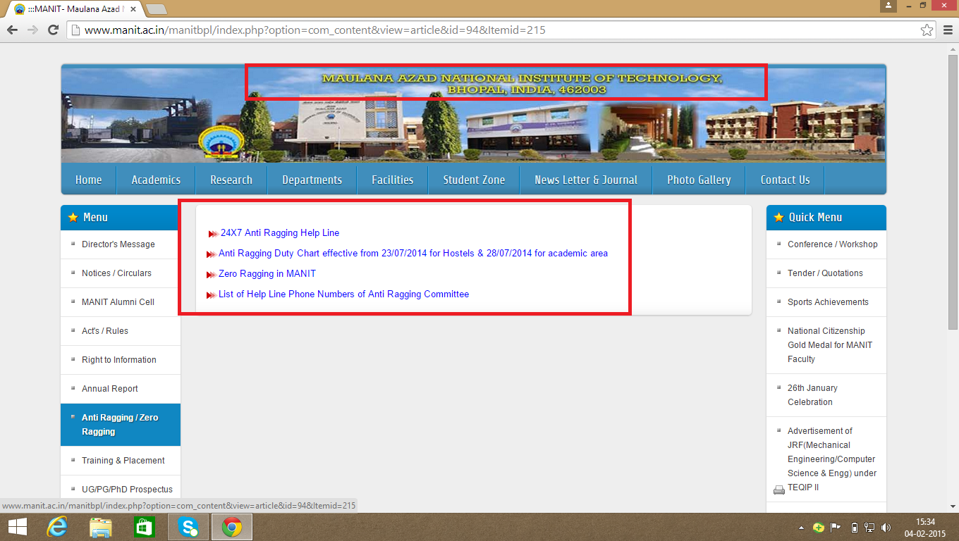

*Fig(18) website of MANIT,bhopal as on feb’09,2015*

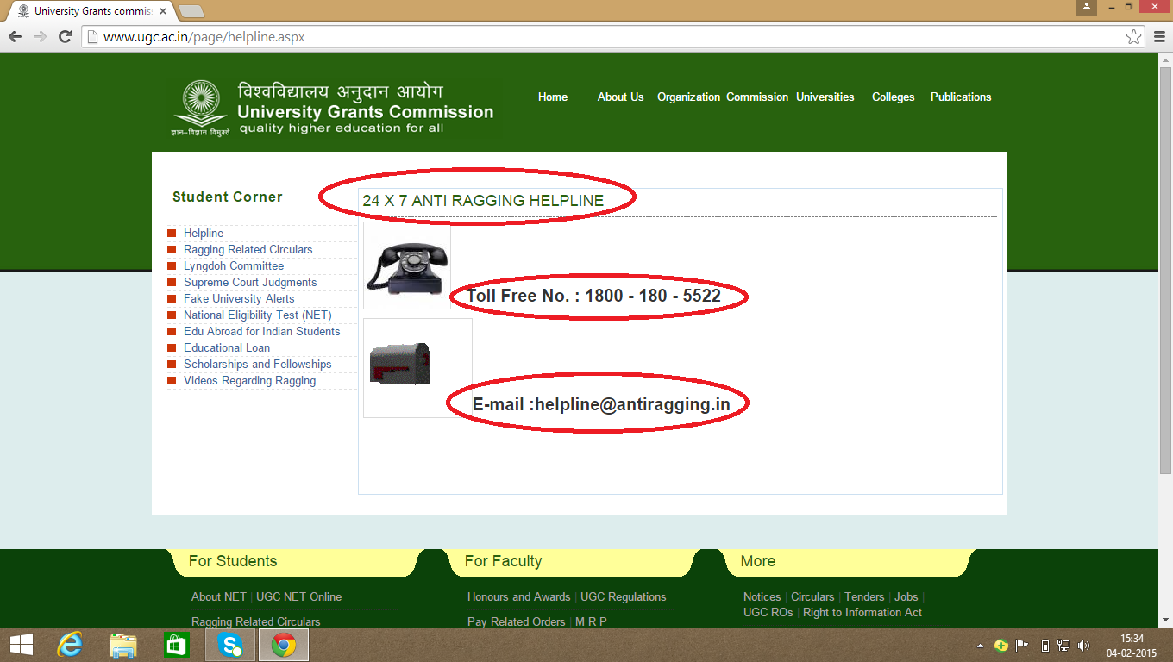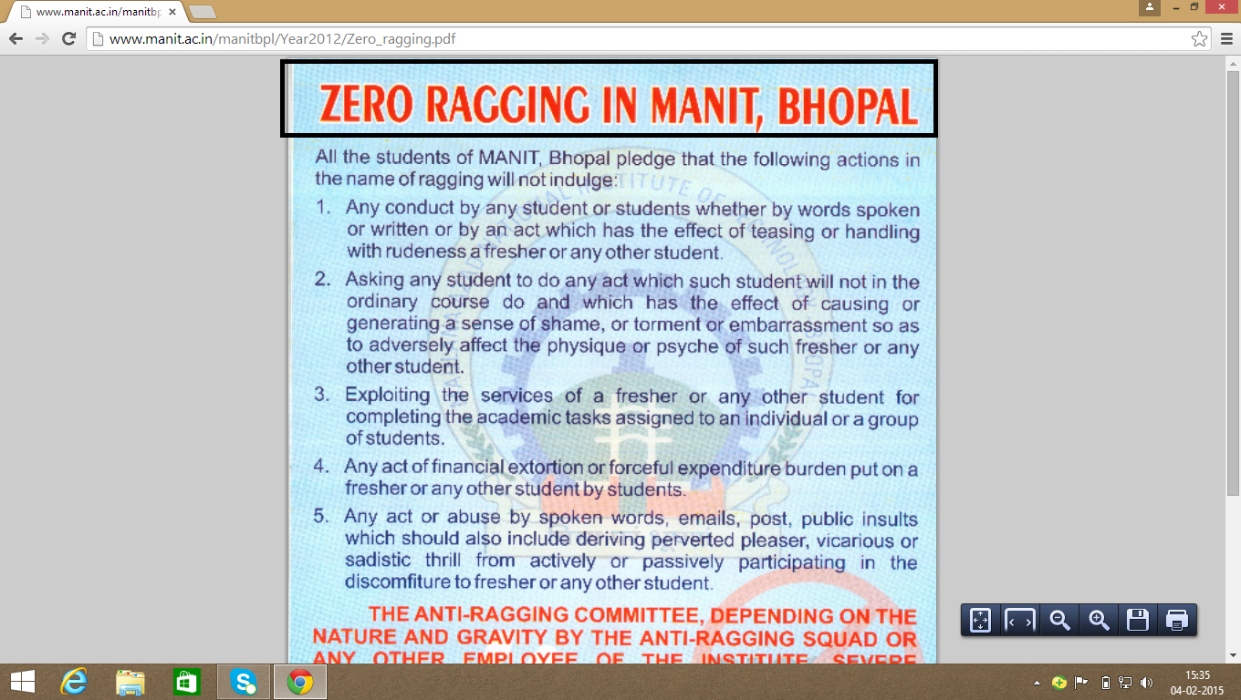

**Chapter 4**

***Reason behind choosing Anti Ragging as a basis for app building activity***

As we could see through the survey conducted by us whose details have been mentioned above in a tabular format ,Anti Ragging has been included by almost each and every educational institution considering ragging to be a too sensitive issue in India which needs to be eradicated at the earliest.

Some of the dreary effects/consequences of ragging and what the term ‘ragging’ signifies has been worked upon below along with a statistical data portraying how ragging affected the youth lately*.*

Through our analysis we could come to a conclusion that though ragging has been mentioned on the respective websites of renowned institutions in the form anti ragging squads and cells mostly covering the following features :-

* Anti ragging squad containing a few faculties as its members
* Listing of severe punishments
* Contact details of the individuals involved in the squad

***What more, thus effective needs to be done***

The efforts of the inclusion of ‘anti ragging’ cells is though appreciable but certainly lack some of the effective measures which could have been incorporated in order to aim zero ragging inside the premises of the respective institution :-

**Suggestions :-**

* Provision of contact details of each and every individual involved in the squad could be tedious as well as uncertain at times thus the need of the hour is the inclusion of anti ragging helpline number which should work as toll free as well as on **24*7** basis since Ragging has been considered as a delicate issue for an individual to cope up with.
* Special counselling concerning motivation on steps dealing with the victims of ragging or providing necessary steps on ‘how to curb raggingon an individual basis’

[14] fig(20)

***Model For the Proposed System***



***Anti Ragging selected amongst features for an ideal institute as a basis for app building***

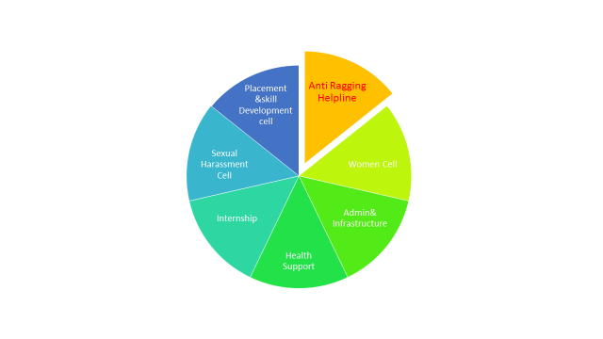

*(fig21)*

|  |
| --- |
| Fig(22)  ***Statistics of Ragging Cases in India including Madhya Pradesh [15]***  Ragging is a damaging form of interaction of the seniors in college or school with the juniors, newcomers or first years. It is similar to but not the same as hazing in the United States, it is not an initiation. It involves insults (simple or suggestive sexual, sarcastic and even physical), running errands for seniors, and many other complex activities. Highly reputed Indian colleges have a wistful history of ragging especially Medical colleges. It has become increasingly unpopular due to several complaints of serious injury to the victims and strict laws regarding ragging. Ragging is now defined as an act that violates or is perceived to violate an individual student's dignity.    Ragging shatters the future of the victim and also the dreams of their parents and the accused cannot pursue the course thereafter. |
| **RAGGING AND ITS EFFECTS**  Ragging is not harmless fun. Students come from different social and cultural backgrounds, and what may be harmless fun for some may turn serious human indignity for some other human being. There are number of cases where some cases the fresher’s and ragging intolerable and it leads to loss of self esteem. Ragging some time causes to loss of innocents lives. Effects of ragging on freshers in different ways.   1. Physical injury through beating, hitting by objects or by forcing to perform dangerous tasks Sexual abuse by forced stripping, masturbation, forced unnatural sex etc. 2. Psychological trauma generated because of intense fear 3. Human Rights abuse 4. Forceful initiation to alcoholism, smoking and drugs 5. Dropping out from college 6. Group Violence 7. Leads to mob mentality and violent mind set 8. Deaths  **[16]**   **RAGGING AND ABUSE OF HUMAN RIGHTS**  Ragging is a traditional and systematical human right abuse in Education and such human right violations in education have not been given proper attention in India, which they otherwise deserve. However, with in United Nation, ragging has been considered as an issue of “Human Rights in education”. Education law in India should take note of practice of ragging in educational system as a major obstacle in realization of the “Right to Education”. Blackstone believed that the principal aim of the society “is to protect individuals **[17]** |

**Study and Analysis**

**4.1 Questionnaire**

Questionnaire done to know:-

* Problems encountered by the students on pretext of ragging
* The facilities provided in the college premises on pretext of health facilities.
* Action taken or handled if the student makes any complaint.
* Availability of the concerned authority to solve the problem.

**4.2 Statistical analysis**

Statistical analysis done on the basis of questionnaire to know the level of requirements in each domain of concern regarding the student facilities prevail ant in the college or some alterations to be made, the recorded results are depicted underneath.

**4.3 Overall strategically planned Analysis**

The analysis was done to cover major Universities\Colleges\UTD’s of Madhya Pradesh to know the prevalent state of student support system and to grab some minute features in order to make the student support system of IIPS, Davv more effective. The features are enclosed in the form of an analysis table underneath in the document.

**4.4 Interview**

Interview of Hostel warden, Mr. Ravindra Yadav, taken to know:-

* Present system functionalities were completely understood.
* Steps of action taken when a student make any complain.
* Action taken by Chancellor against a student, here Warden Register came in to light.
* Premade Proctorial Board for the solution of complaints related to ragging.

Information regarding the project was taken.

**Questionnaire**

**(Related to the Overall Strategically planned Analysis)**

Q.1) Does Student Support system exists at your Institution? Yes No

Q.2) Are you aware of student Rights? Yes No

Q.3 Do you have Anti Ragging as a feature of the student Support system in your institution ? Yes No

Q.4 Have you ever Faced any such issue at your institution ? Yes No

**(Related to the Analysis done in IIPS,Davv)**

Q.5) Does student Support system (i.e Placement Cell,Anti Ragging Cell etc) exists in IIPS?

Yes No

Q.6) If yes, Is the prevalent system easy to comply with ? Yes No

Q.7) Have you ever Faced any such issue at IIPS? Yes No

Q.8) Are you satisfied with the current Placement Scenarios of IIPS? Yes No

Q.9) Are you satisfied with the existing Infrastructural Facilities? Yes No

Yes No

Q.10) *As a* ***Female*** *Student, do you feel safe inside the college premises?*  Yes No

Yes No

Yes No

**Statistical Analysis of the Results obtained above**

**Total forms :- 40**

**(Related to the Overall Strategically planned Analysis)**

Q.1) Does Student Support system exists at your Institution?

YES:- 22 (55%)

NO:- 18 (45% )

Q.2) Are you aware of student Rights?

YES:- 22 (55%)

NO:- 18 (45% )

Q.3) Do you have Anti Ragging as a feature of the student Support system in your institution ?

YES:- 22 (55%)

NO:- 18 (45% )

Q.4 )Have you ever Faced any such issue at your institution ?

YES:- 22 (55%)

NO:- 18 (45% )

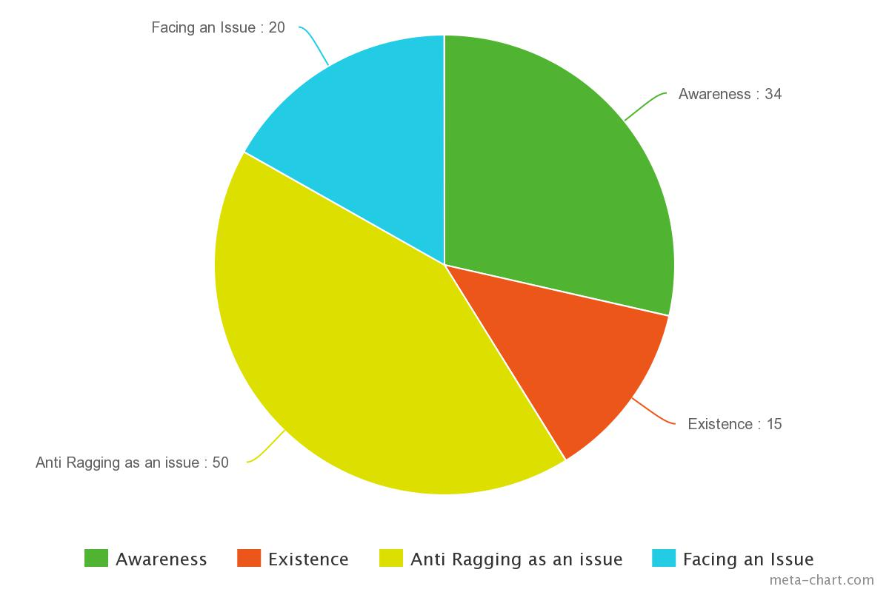

**(Related to the Analysis done in IIPS,Davv) (fig12)**

Q.5) Does student Support system (i.e Placement Cell,Anti Ragging Cell etc) exists in IIPS?

YES:- 22 (55%)

NO:- 18 (45% )

Q.6) If yes, Is the prevalent system easy to comply with ?

YES:- 22 (55%)

NO:- 18 (45% )

Q.7) Have you ever Faced any such issue at IIPS?

YES:- 22 (55%)

NO:- 18 (45% )

Q.8) Are you satisfied with the current Placement Scenarios of IIPS?

YES:- 22 (55%)

NO:- 18 (45% )

Q.9) Are you satisfied with the existing Infrastructural Facilities?

YES:- 22 (55%)

NO:- 18 (45% )

Q.10) *As a* ***Female*** *Student, do you feel safe inside the college premises?*

YES:- 22 (55%) NO:- 18 (45% )

### 5.1 **Project Scope**

The scope of the project can be described in the following manner:

Designing a mechanism which can act as a platform for students to register their problems or grievances.

Designing a user friendly graphical user interface -

for *students* to enter their personal information (name,class,problem/grievance,).

for *administrator* to verify,classify,allocate complaints.

for *committee members* to respond complaints or forward them to any other committee member.

### 5.2 **Development Plan**

The design and implementation of this project has been carried out in a completely step-by-step manner.

* Questionnaire
* Survey
* Design Document
* Software Requirement Specification
* Coding
* Testing
* Project Report

**5.3** **Team Structure**

**Student Support System,IIPS**

**(Project)**

**Internal Guide**

**(Mr. Shaligram Prajapat)**

**Software Developers**

**(Vaibhav Sabharwal)**

**(Varun Wadhwani)**

### 5.4 **Project Deliverables**

**Project Report**

Project report provides an introduction to current system and system to be built. It gives the brief knowledge of current system.

**Project Documentation**

A complete documentation is given in the form of SRS. Software Requirement Specification (SRS) which provides an introduction of the current system and the system to be built. This overview includes the purpose of SRS and a brief knowledge of the current system. The overview also provided an introduction of the proposed system.

**5.5 Gantt chart**

Gantt chart is a time-phased bar chart display that lists tasks or activities along the left side and a corresponding bar for each task. The length of the bar represents the duration of the activity. This scheduling tool used to display the status of a project’s tasks. The Gantt chart shows each task’s duration as a horizontal line. The ends of the lines correspond to the task’s start and end dates.

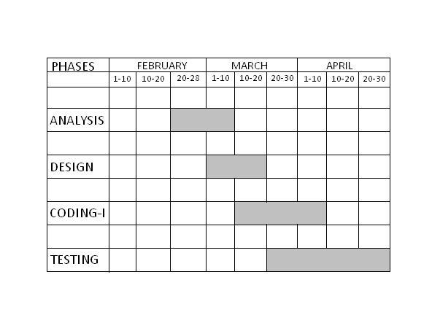

Gantt chart (fig 22)

**6.Design**

**6.1 Logical Design**

Logical design describes the functions required by a system, which are:

* Student registration
* Complaint registration
* Proof uploading
* Reference number generation
* Complain management
* Complaint status retrieval
* Reports generation

The following are the objectives of Logical Design :

* Analyze timely complaint solving, student’s satisfaction(through feedback) and oversee committee members.
* The ER Diagrams constructed by keeping in my general entries related to student ,administrator and committee members and their relation with other entities.
* Transformation of Conceptual Data Model into a Relational Model with data specifications.

**6.1.1 Entities Definitions**

Entities are the principle data object about which information is to be collected. Entities are either concrete or abstract, such as person, places, things, or events, which have relevance to the database.

The following is the **list of entities** that have been identified during analysis:-

* **Name:** Student  
  **Definition:** their can be large number of students

**Identifier:** student_id

* **Name:** Administrator **Definition:** their will be one administrator

**Identifier:** admin_id

* **Name:** Committee Member **Definition:** their will be one committee member for each type of complaint

**Identifier:** member_id

* **Name:** Complaint **Definition:** their will be complaints registered by students

**Identifier:** complaint_id

* **Name:** Account **Definition:** account will be created by students

**Identifier:** account_id

* **Name:** Status  
  **Definition:** status /solution of complaint will be given by committee member

**Identifier:** reference_no

**6.1.2 Attribute Definitions**

The attributes that are identified as part of the entities are listed along with their description.

**1. Name of Entity:** Account

|  |  |  |  |  |
| --- | --- | --- | --- | --- |
| **Attribute** | **Datatype** | **Description** | **Length** | **Allow null** |
| student_id | Id | Id generated by system | 40 | no |
| roll_no | varchar | Student name | 20 | no |
| first_name | varchar | Student’s age | 40 | no |
| last_name | varchar | Student’s gender | 40 | no |
| email | varchar | Student’s email-id | 40 | no |
| password | varchar | Password set by student | 20 | no |

**2. Name of Entity:**Student

|  |  |  |  |  |
| --- | --- | --- | --- | --- |
| **Attribute** | **Datatype** | **Description** | **Length** | **Allow null** |
| student_id | Id | System generated id | 40 | no |
| roll_no | varchar | Type of complaint | 40 | no |
| password | varchar | Password set by Student | 40 | no |

**3. Name of Entity:** Administrator/Committe member

|  |  |  |  |  |
| --- | --- | --- | --- | --- |
| **Attribute** | **Datatype** | **Description** | **Length** | **Allow null** |
| admin_id | Int | System generated id | 11 | no |
| username |  | User’s name | 255 | no |
| password | varchar | Password set by  administrator | 255 | no |
| user_level | varchar | Sets the level of the user | 11 | no |
| type | varchar | Sets the type of the user | 11 | no |

**4. Name of Entity:** Complaint

|  |  |  |  |  |
| --- | --- | --- | --- | --- |
| **Attribute** | **Datatype** | **Description** | **Length** | **Allow null** |
| complaint_id | id | System generated id | 40 | no |
| name | varchar | Name of student | 40 | no |
| roll_no | varchar | Roll number of student | 40 | no |
| phone_no | varchar | Phone number of student | 40 | no |
| email | varchar | Email-id of student | 40 | no |
| complaint | varchar | Type of complaint | 40 | no |
| reference_no | varchar | Reference number  generated by the system | 100000 | no |
| status | varchar | Status updated by admin | 200 | no |

**6.1.3 Relationships**

**Binary relationship**

**One to one:-**

Student < - > Account

**One to many:-**

Student < - >Complaint

Student < - >Proof

Administrator < - > Complaint

Administrator < - > Committee Member

Committee Member < - >Status/solution

**The Entire ER Diagram**

Fig(22)

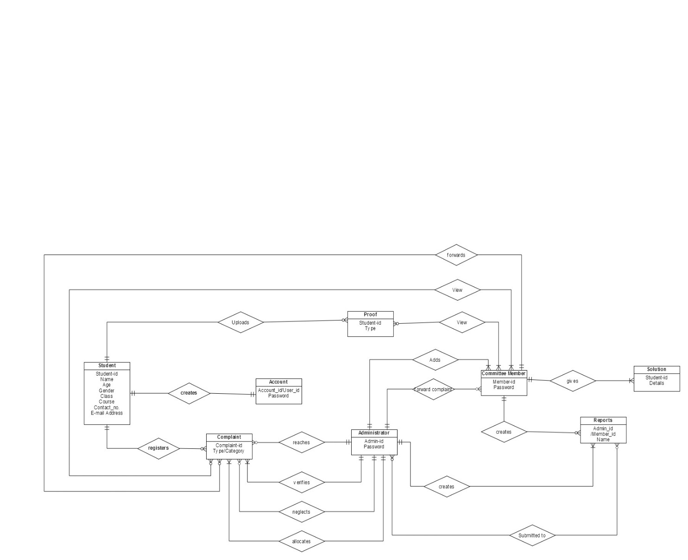**gif**

**Data Flow Diagram(Context Diagram)**

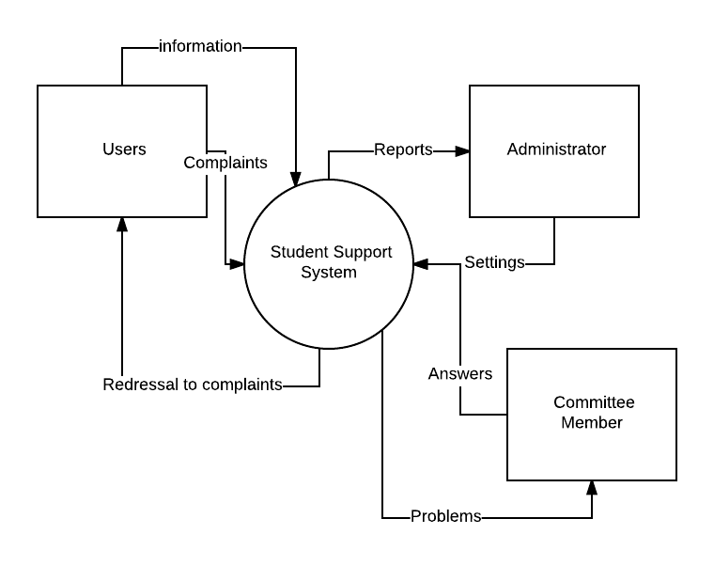

Fig(23)

**Level 1( Data Flow Diagram)** fig(24)

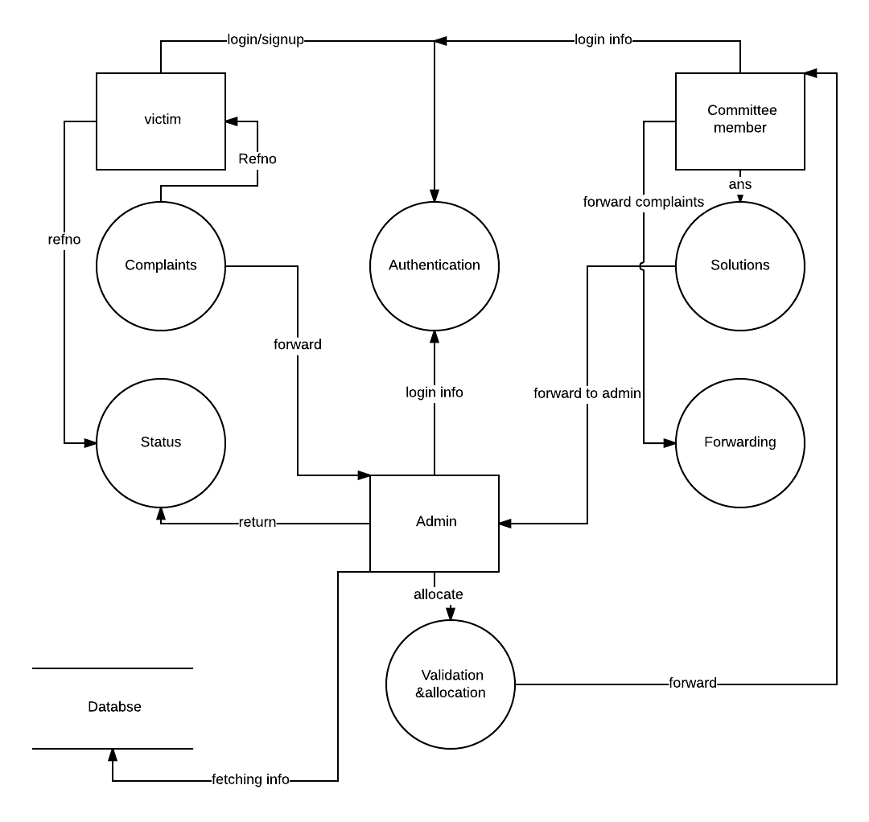

**Level 2(Data Flow Diagram)** *for authentication*

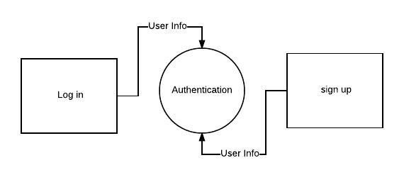

Fig(25)

**Level 2(Data Flow Diagram)***for solutions*

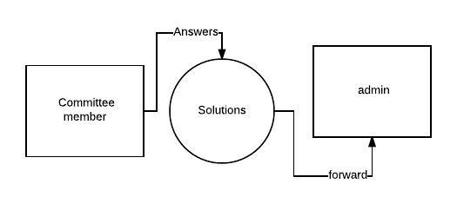

Fig(26)

**Level 2(Data Flow Diagram)** *for Status* Fig(27)

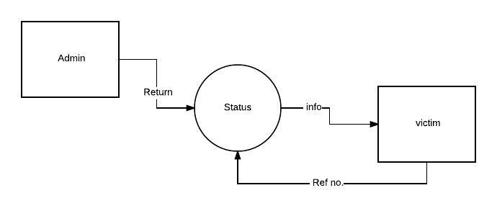

**Data Flow Diagram***for validation and allocation*

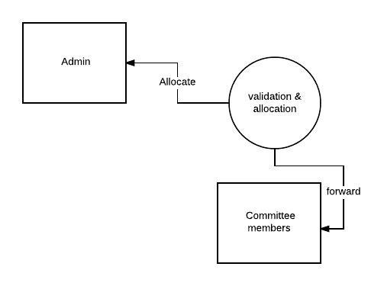

Fig(28)

**Data flow Diagram** *for Complaints*

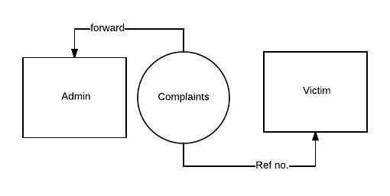

Fig(29)

**Data flow Diagram** *for Forwarding complaints*

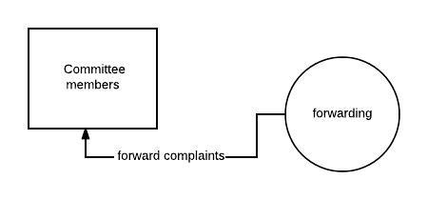

Fig(30)

**Activity diagrams** Fig(31)

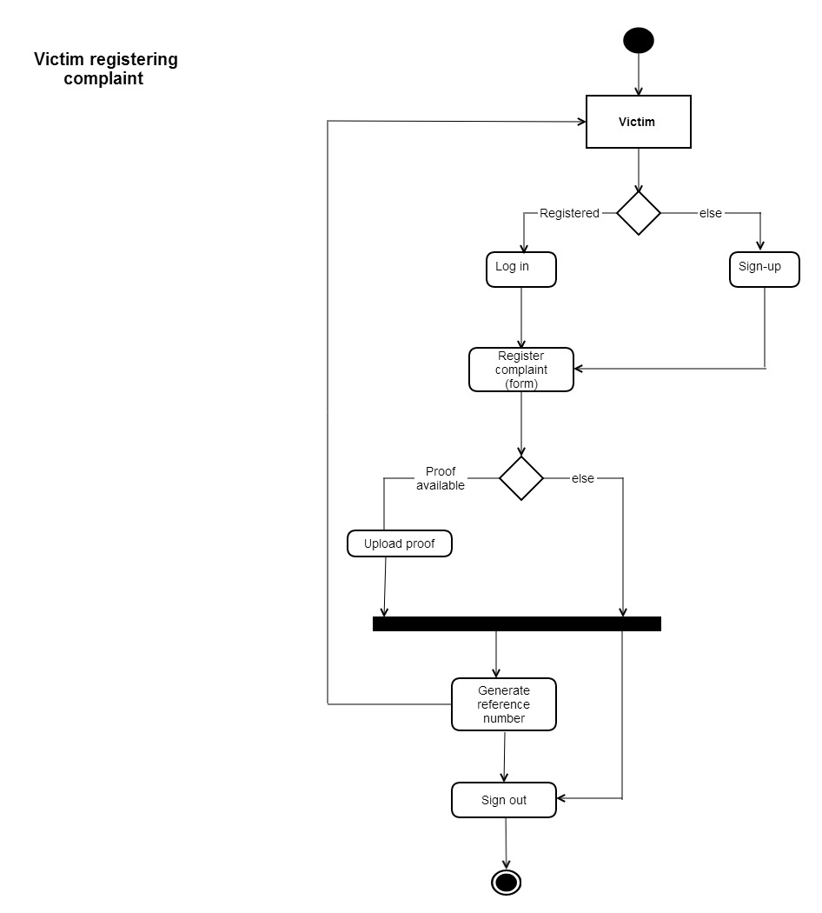

Fig(32)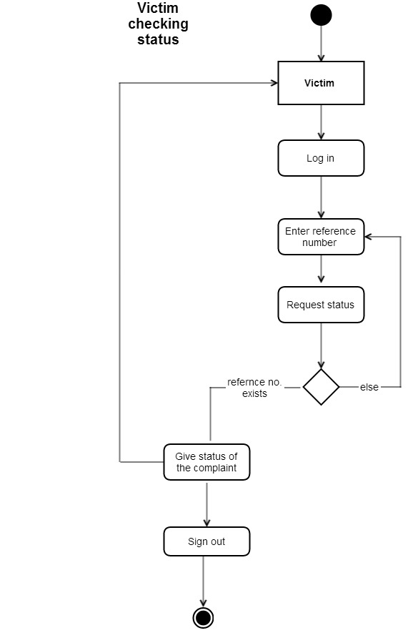

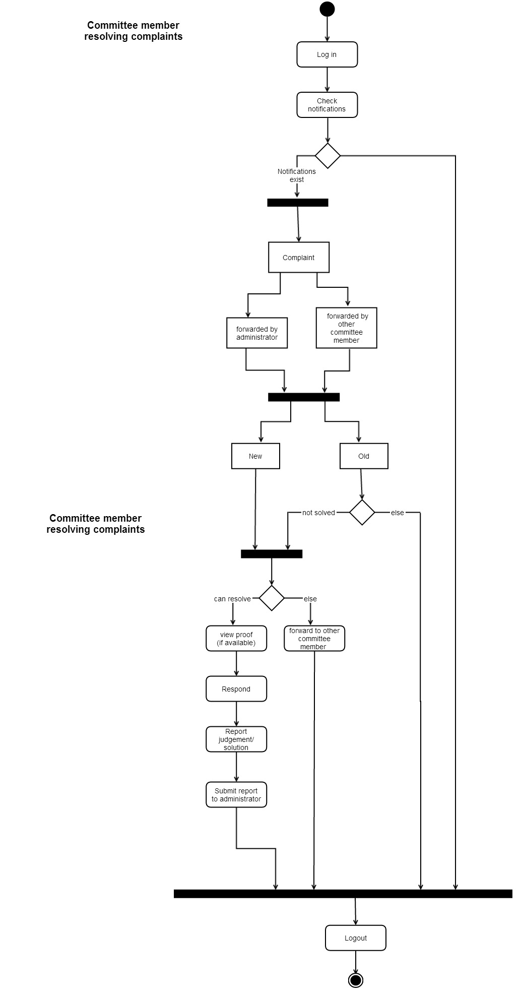fig(33)

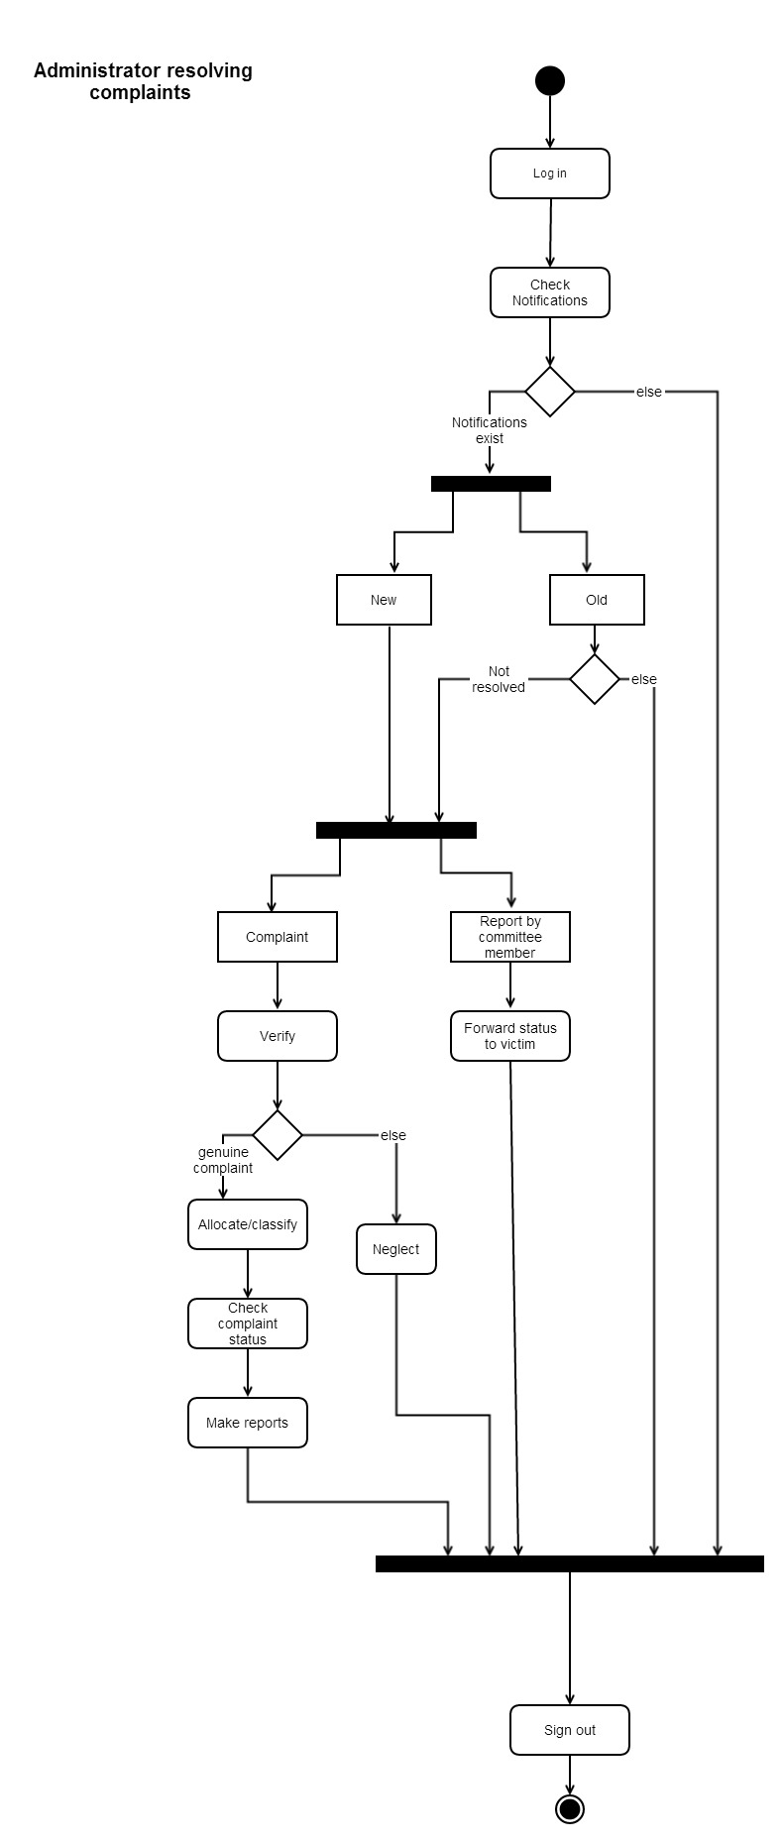fig(34)

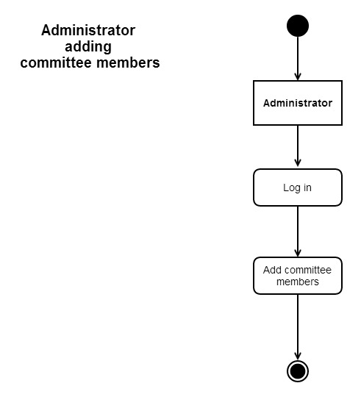

Fig(35)

**Sequence diagrams for Victim, Committee member, Admin**

Fig(36,37,38)

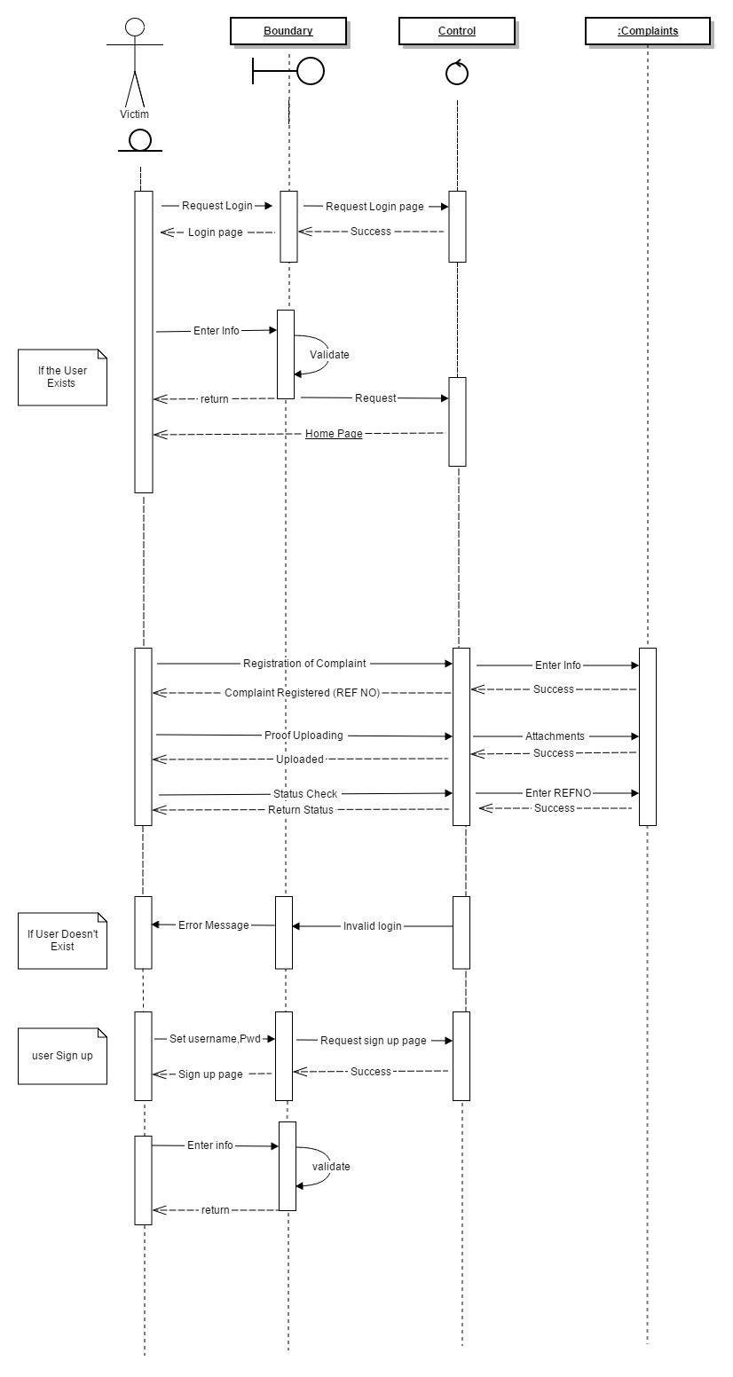figffi

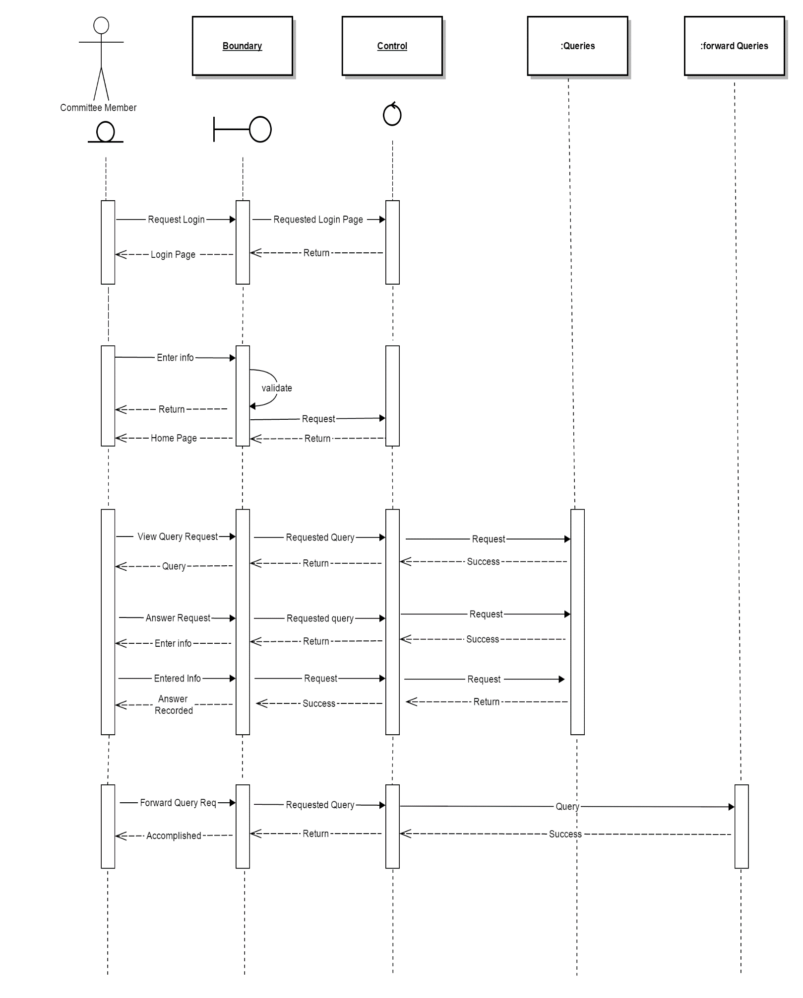

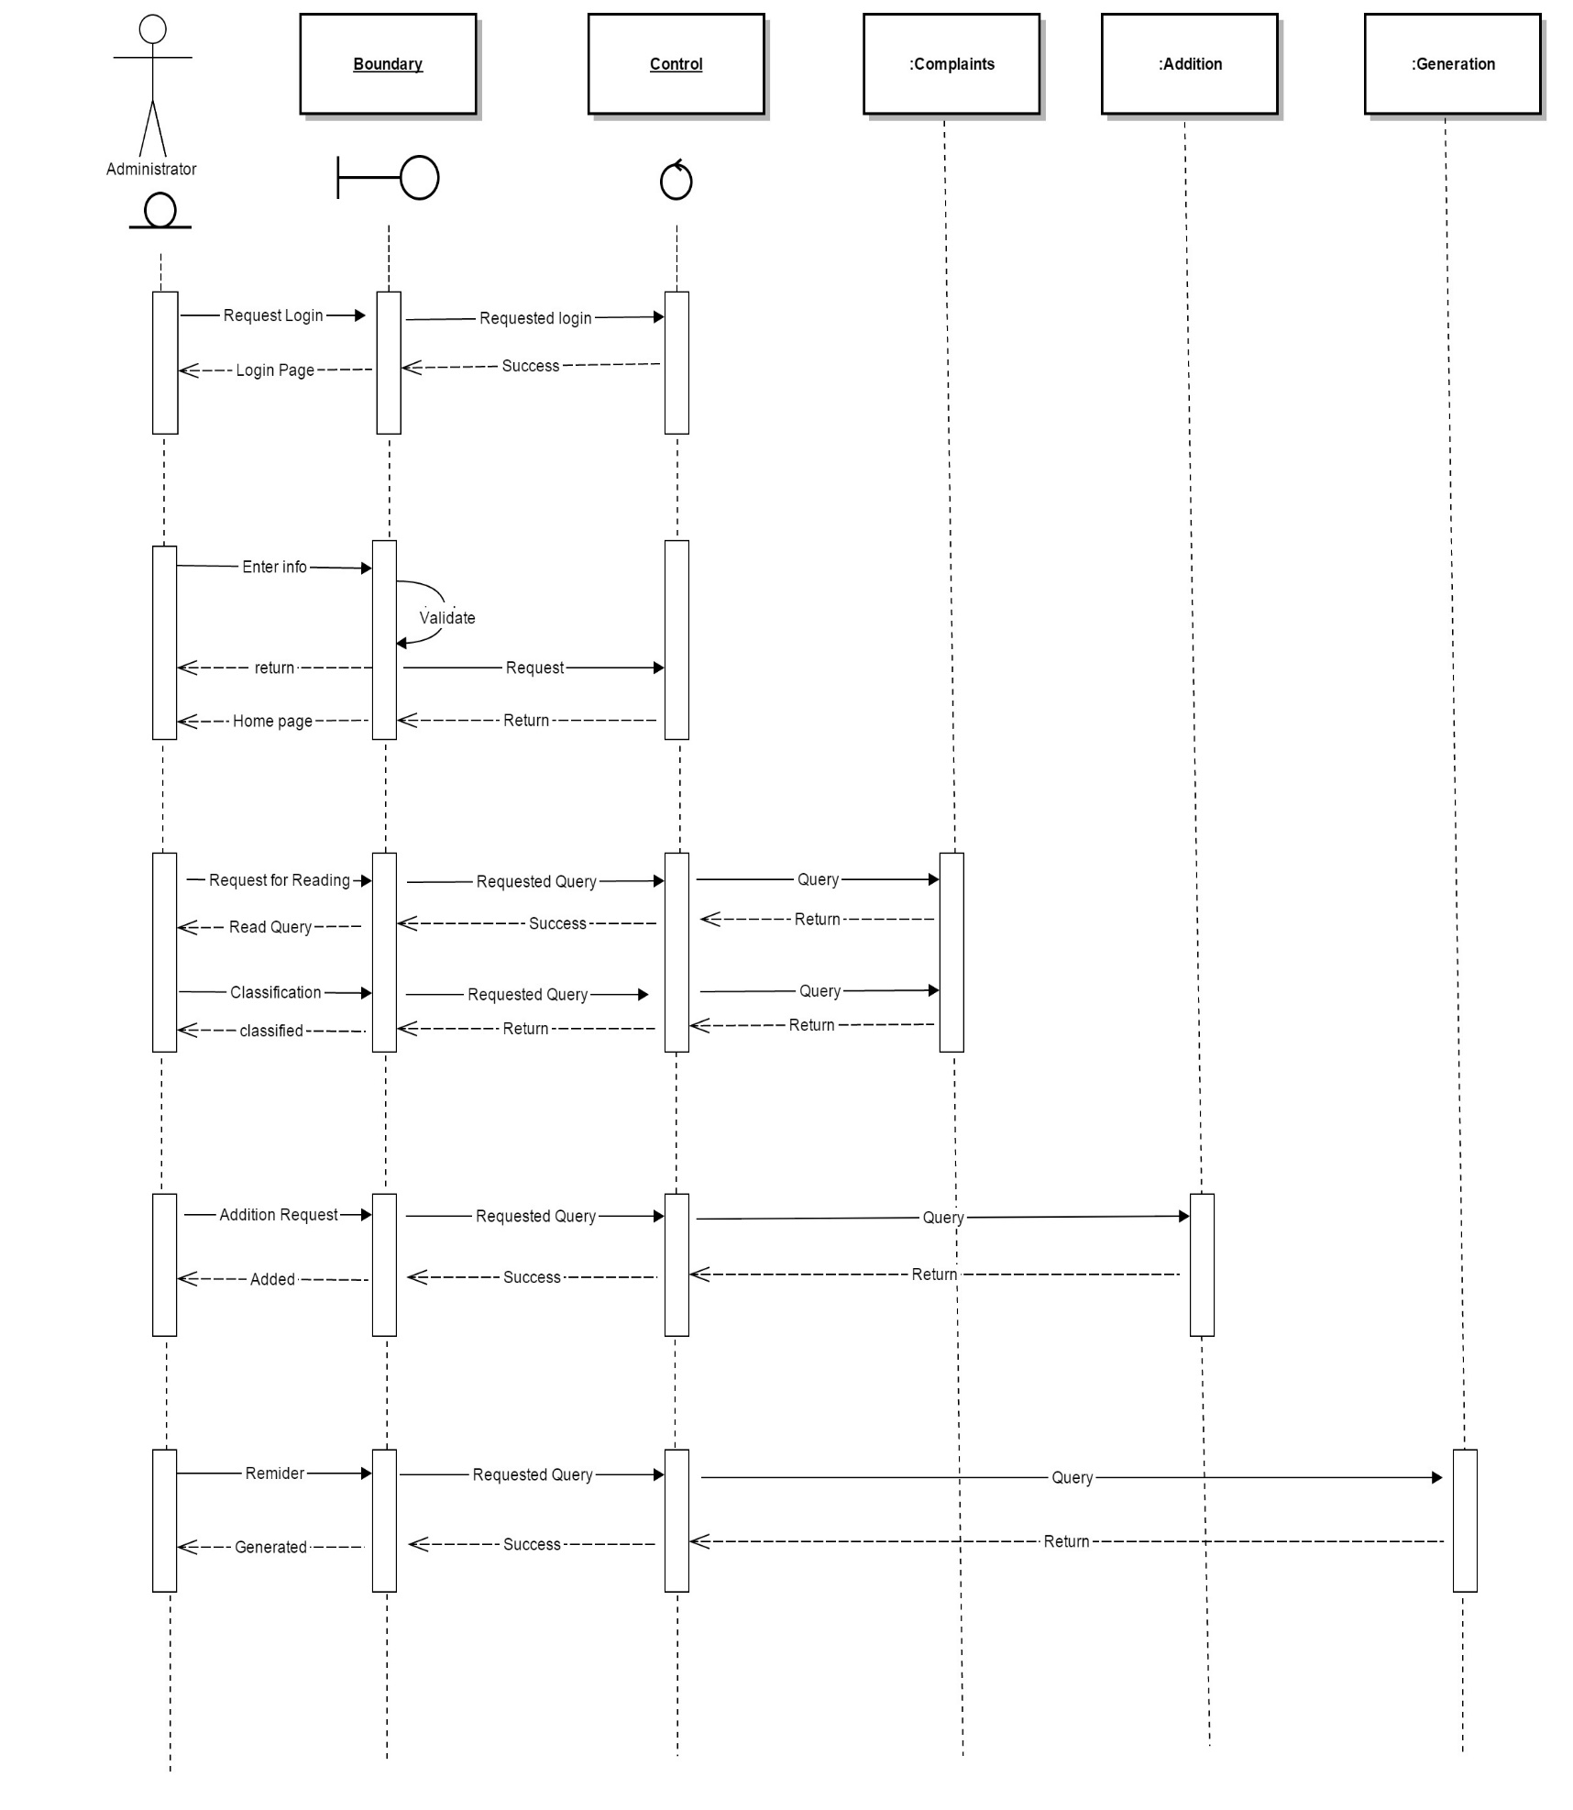

**User Case Diagrams for Victim, committee member, Admin**

Fig(39)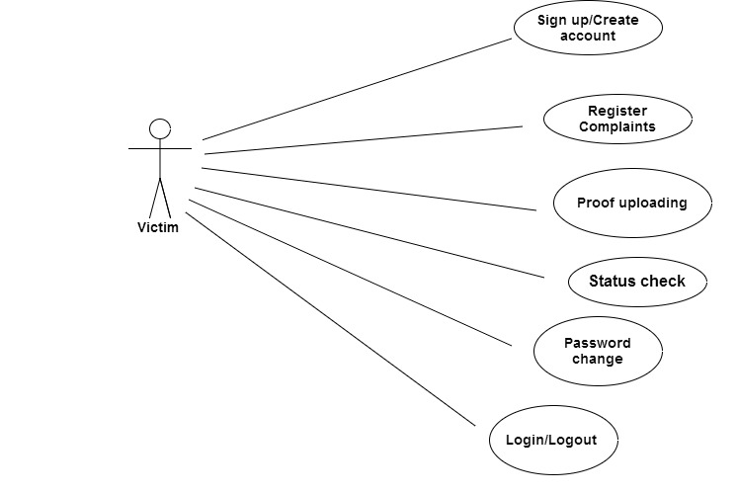

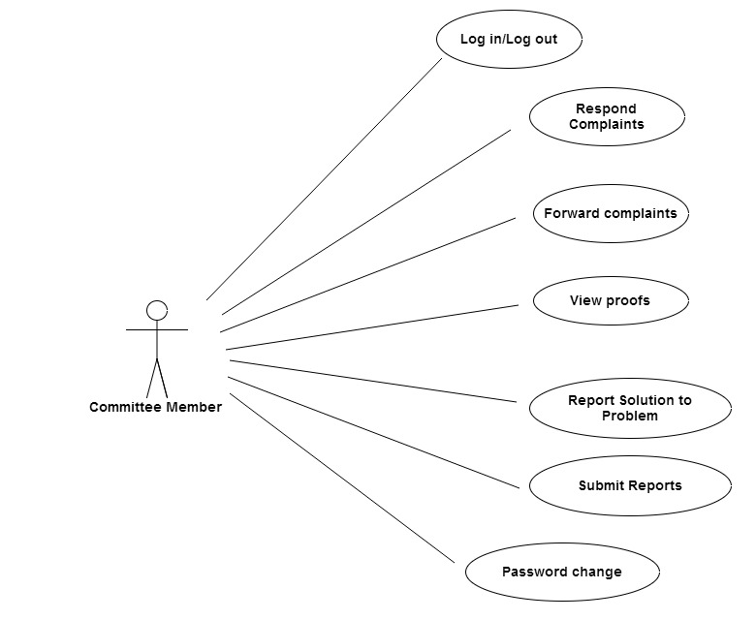fig(40)

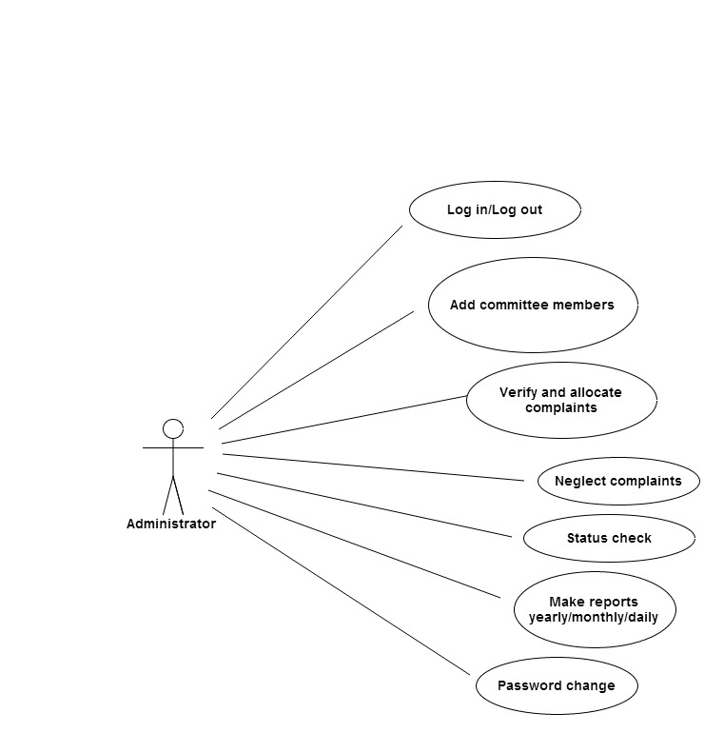fig(41)

**6.2.2 User Interface Design**

HTML, CSS, Jquery, javascript are used as the user interface, covering the points :

* 1. Proper checks generated where field can not be left empty, like name, roll number, e-mail address, phone number, password, complaint type.
  2. ID is generated by system so eliminating confusion, like same name.
  3. Extra protection for field provided, like no name can have special characters, and no number field can have other than numbers.
  4. Student login is password protected.
  5. While registering student enters password twice for the authentication point of view.
  6. Admin login and committee member login is also password protected.
  7. After registering the complaint student gets a system generated reference id which he/she can use to check the status of the complaint.
  8. Form run in a flow of data so not difficult to understand.
  9. All events are click driven so not complex.

Reports made by admin and committee members are generated in printable form .

**Interfaces**

**Student Support System landing page**

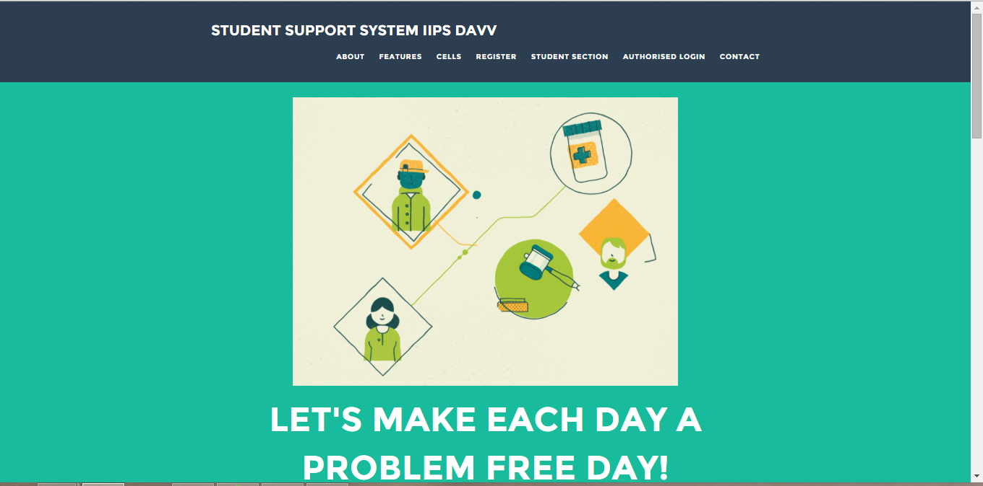

**Student Support System about section**

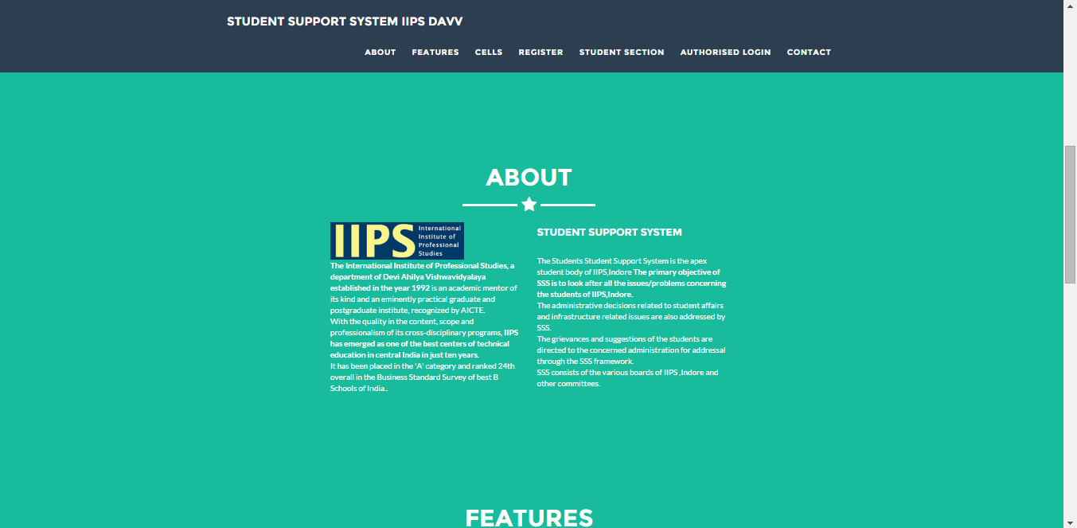

**Student Support System features section**

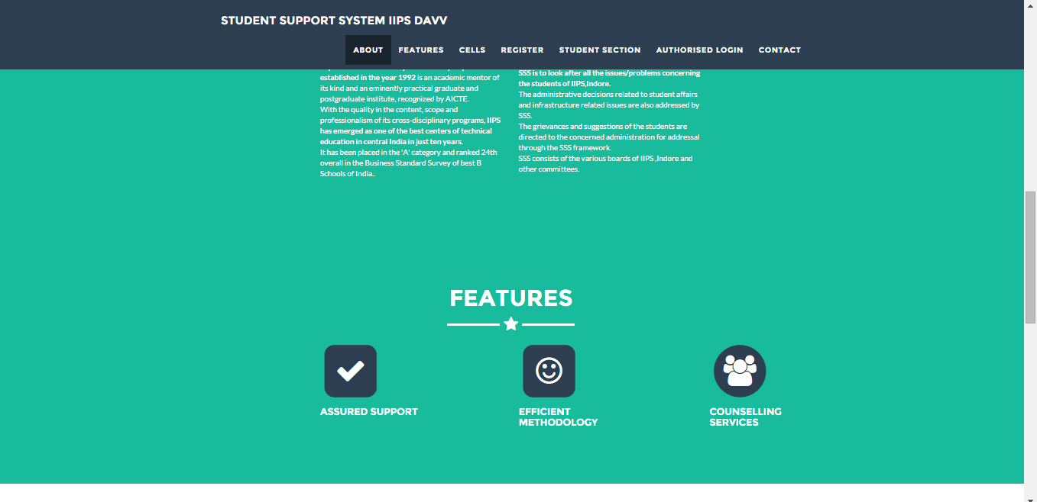

**Cells and Regulations page**

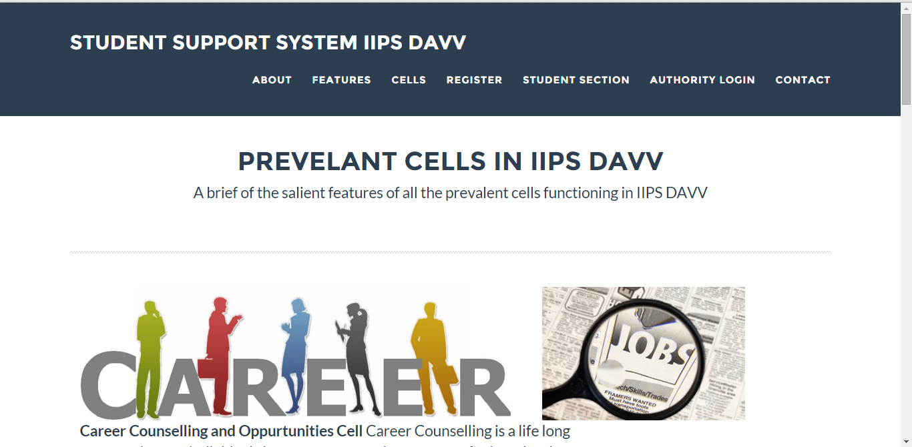

**Student Support System cells section**

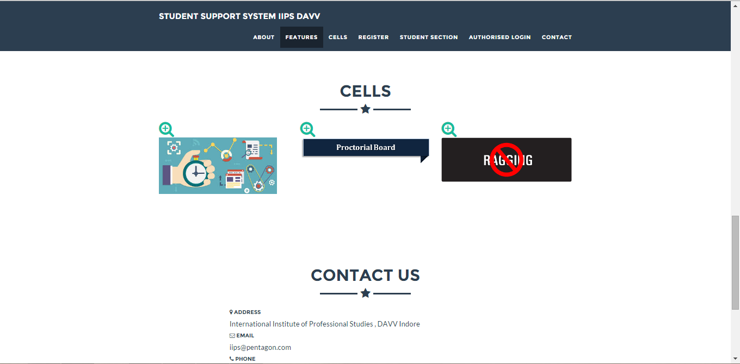

**Student Support System contact section**

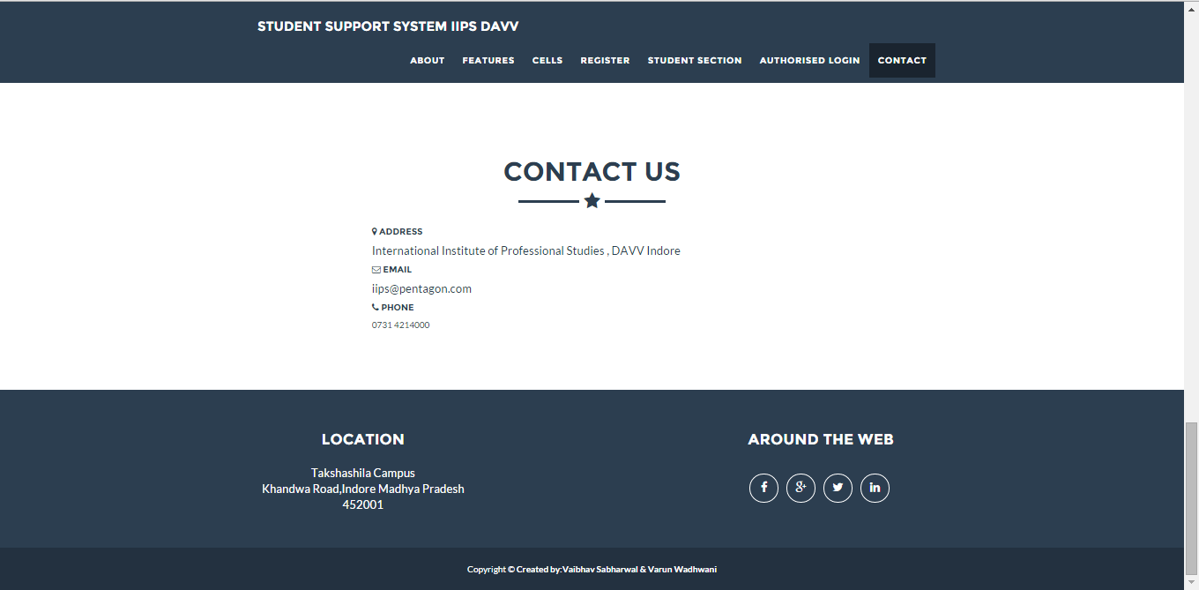

**Student Support System student registration page**

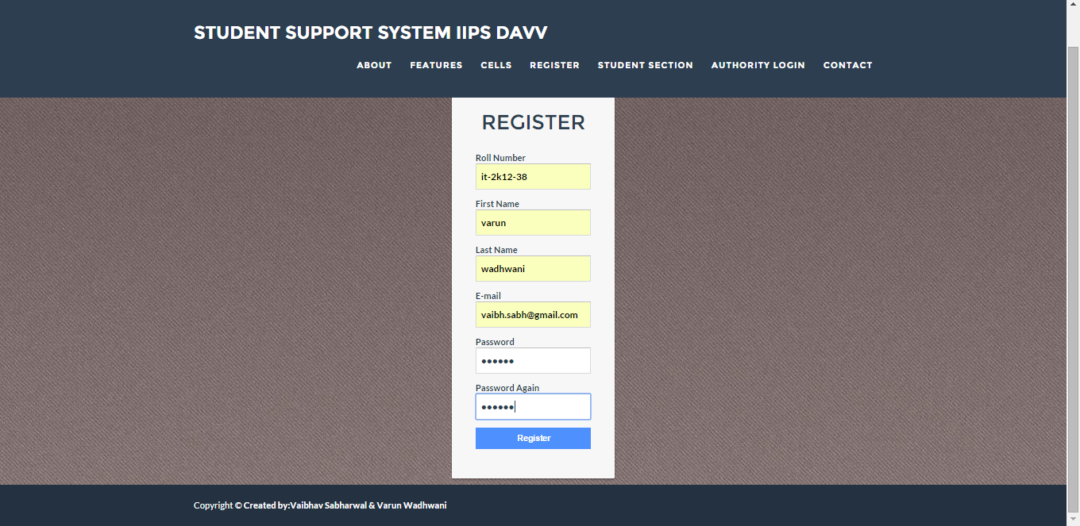

**Student Support System student login page**

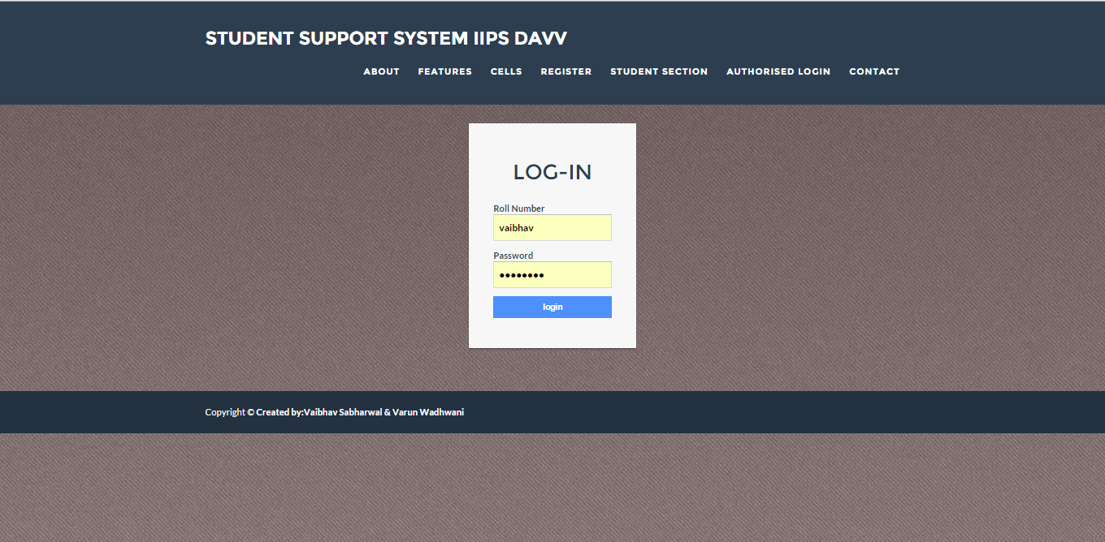

**Student Support System student section page**

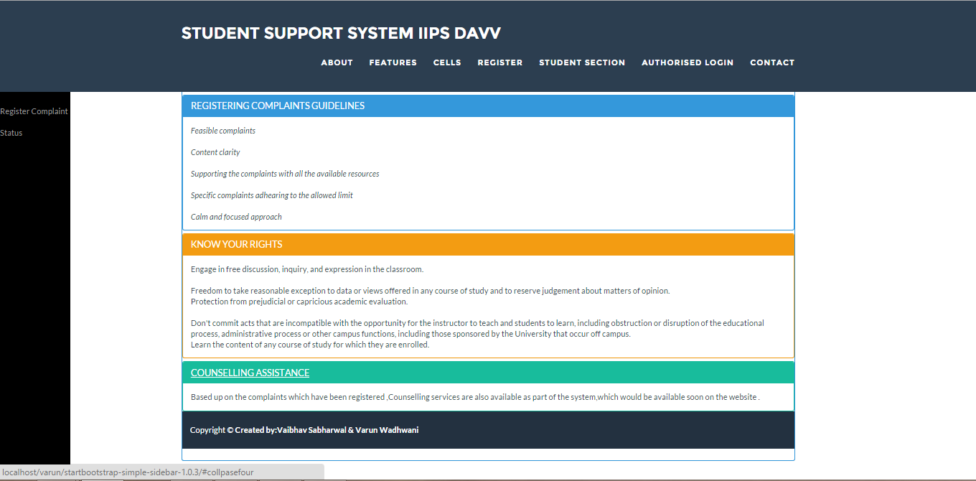

**Student Support System complaint registration page**

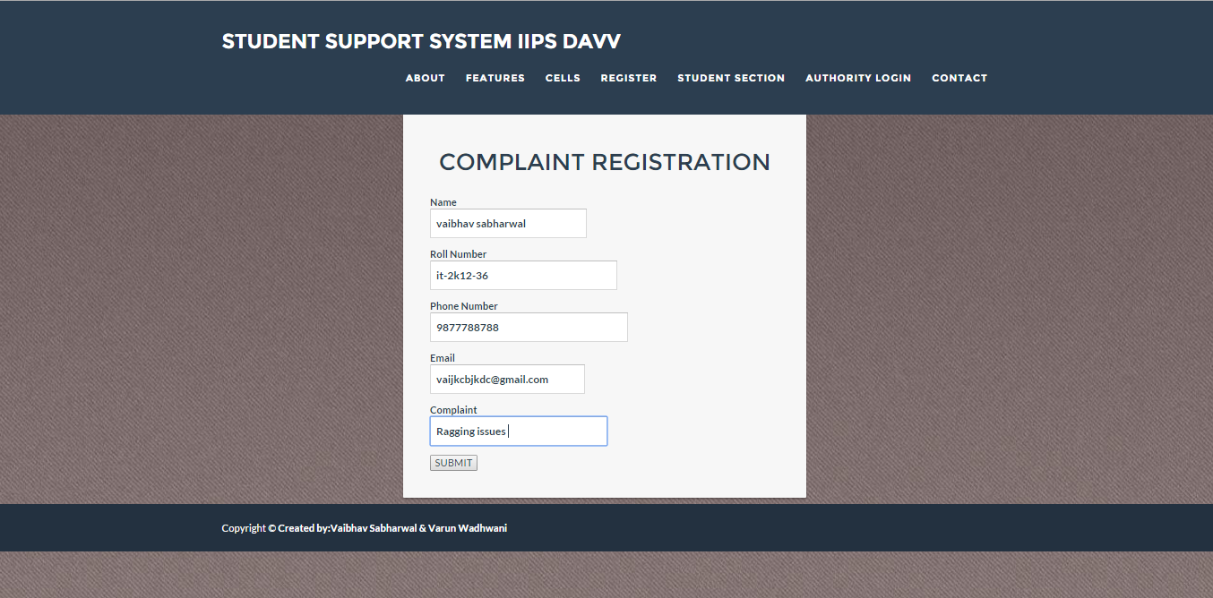

**Student Support System status checking page**

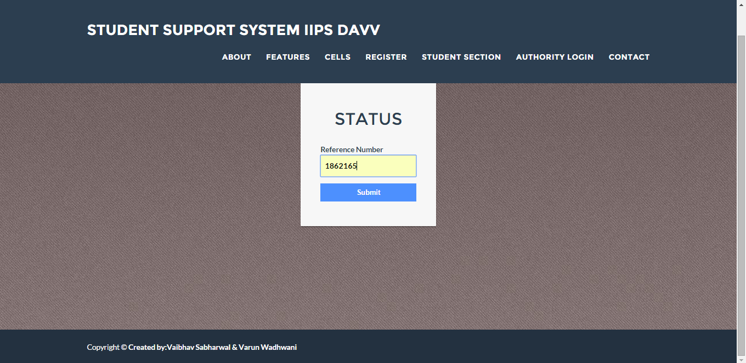

**Admin/committee member profile page**

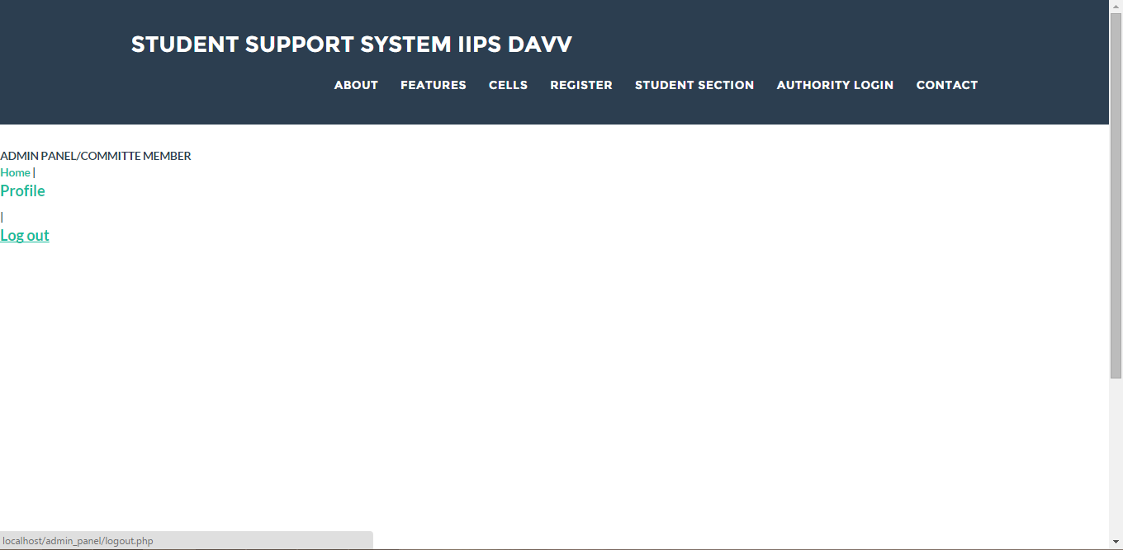

**Admin/committee member registration page**

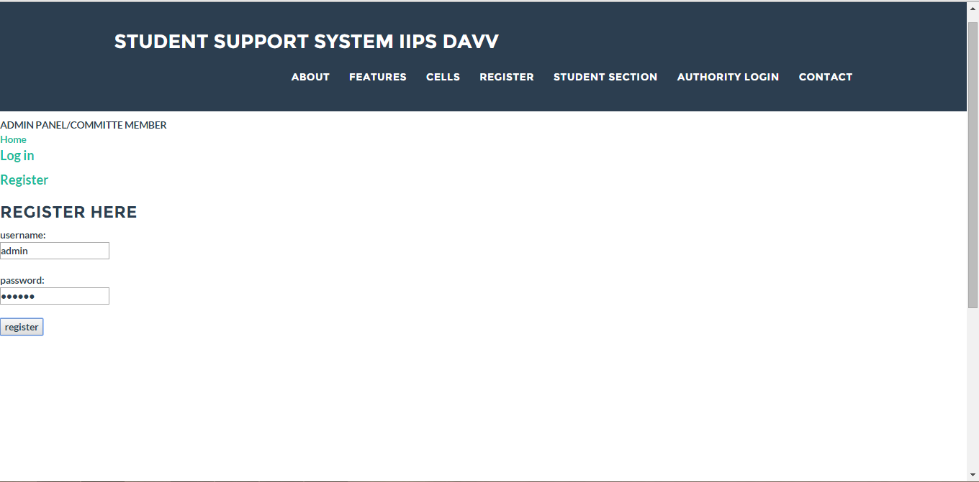

**Admin/committee member registration page**

**Admin adding members page**

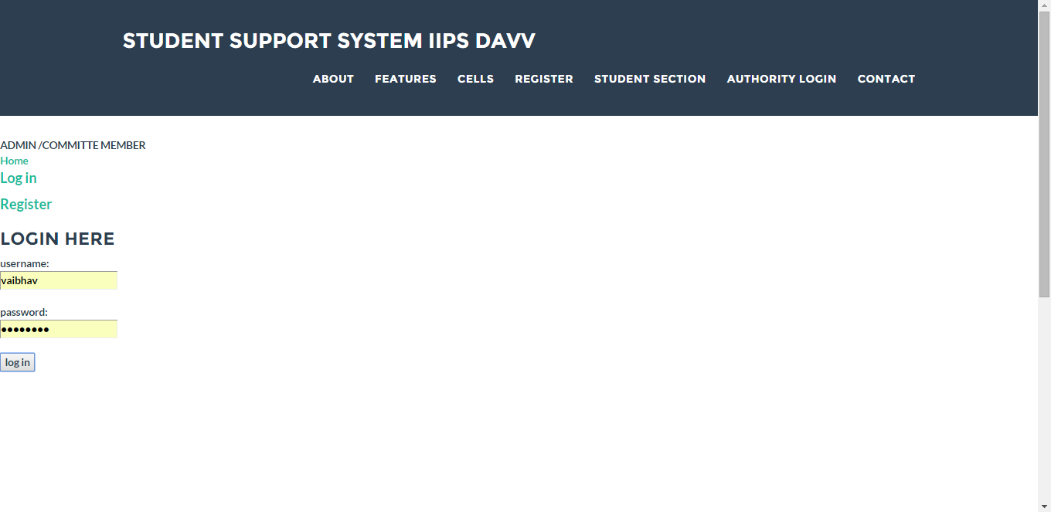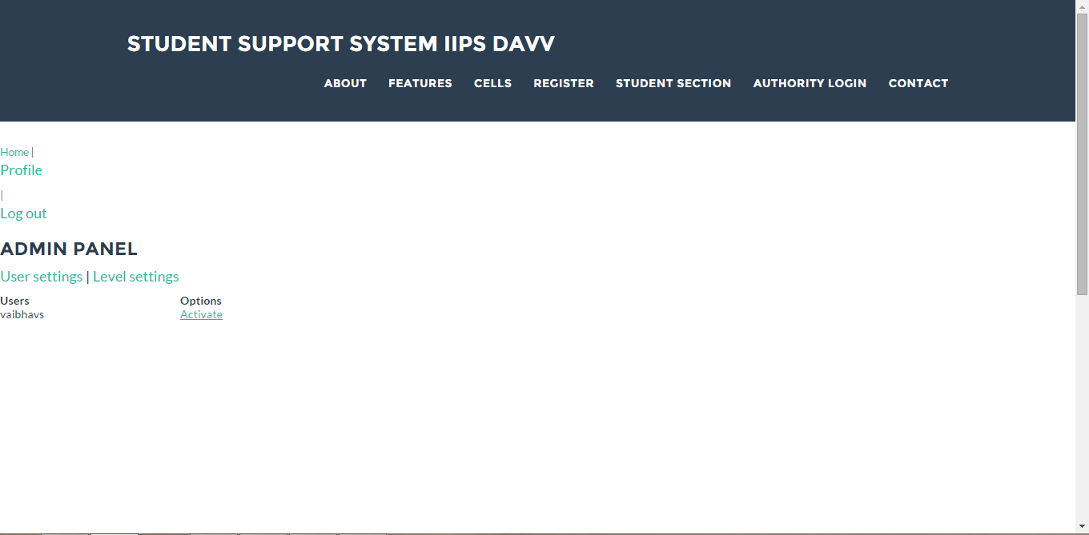

**Admin panel profile page**

**7.Implementation**

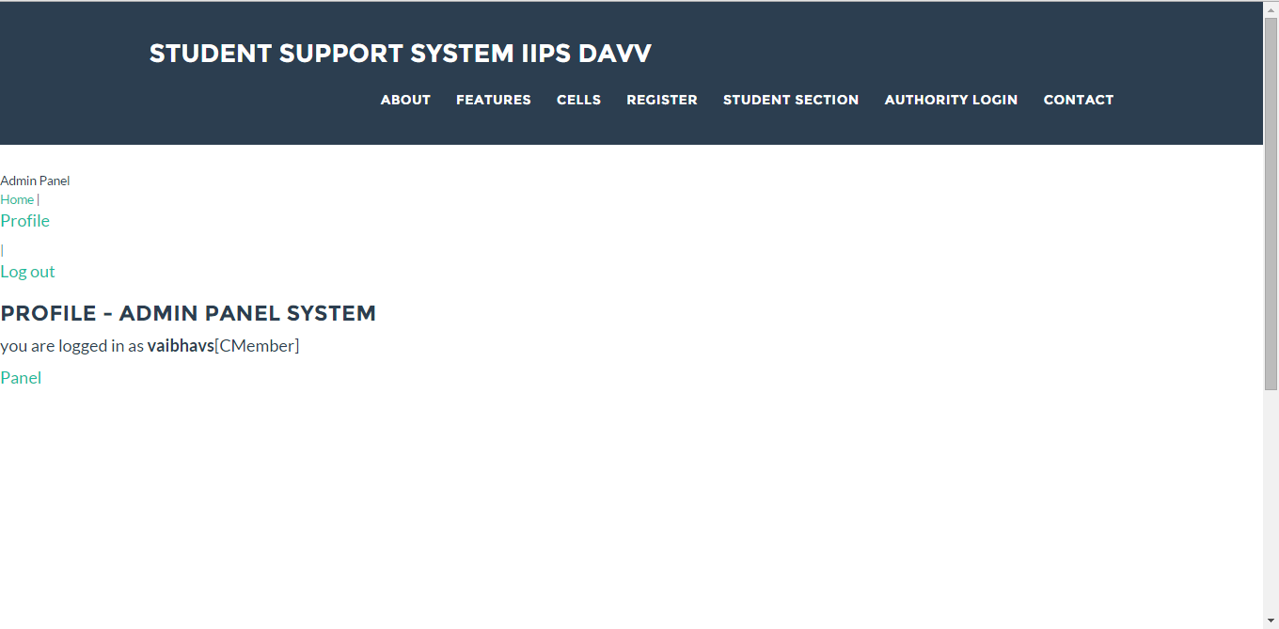

**IMPLEMENTATION**

Implementation is the process of converting the new designed system into the operational one. There are various types of implementation. Some of these are as follows:

* Implementation of a computer system to replace a manual system .
* Implementation of a new computer system to replace an existing system.
* Implementation of a modified application to replace an existing one.

We are following the first implementation method to implement our system. In implementing our system, we do not need to give very hard user training.

For conversion, we will use the parallel system method. The old system and the new system will be in operation simultaneously. This will provide the greatest security. [18]

**8.Code Snippet**

**Main webpage(website landing page)**

<!DOCTYPE html>

<html lang="en">

<head>

<meta charset="utf-8">

<meta http-equiv="X-UA-Compatible" content="IE=edge">

<meta name="viewport" content="width=device-width, initial-scale=1">

<meta name="description" content="">

<meta name="author" content="">

<title>Freelancer - Start Bootstrap Theme</title>

<!-- Bootstrap Core CSS - Uses Bootswatch Flatly Theme: http://bootswatch.com/flatly/ -->

<link href="css/bootstrap.min.css" rel="stylesheet">

<!-- Custom CSS -->

<link href="css/freelancer.css" rel="stylesheet">

<!-- Custom Fonts -->

<link href="font-awesome/css/font-awesome.min.css" rel="stylesheet" type="text/css">

<link href="http://fonts.googleapis.com/css?family=Montserrat:400,700" rel="stylesheet" type="text/css">

<link href="http://fonts.googleapis.com/css?family=Lato:400,700,400italic,700italic" rel="stylesheet" type="text/css">

<!-- HTML5 Shim and Respond.js IE8 support of HTML5 elements and media queries -->

<!-- WARNING: Respond.js doesn't work if you view the page via file:// -->

<!--[if lt IE 9]>

<script src="https://oss.maxcdn.com/libs/html5shiv/3.7.0/html5shiv.js"></script>

<script src="https://oss.maxcdn.com/libs/respond.js/1.4.2/respond.min.js"></script>

<![endif]-->

</head>

<body id="page-top" class="index">

<!-- Navigation -->

<nav class="navbar navbar-default navbar-fixed-top">

<div class="container">

<!-- Brand and toggle get grouped for better mobile display -->

<div class="navbar-header page-scroll">

<button type="button" class="navbar-toggle" data-toggle="collapse" data-target="#bs-example-navbar-collapse-1">

<span class="sr-only">Toggle navigation</span>

<span class="icon-bar"></span>

<span class="icon-bar"></span>

<span class="icon-bar"></span>

</button>

<a class="navbar-brand" href="#page-top">Student Support System IIPS DAVV</a>

</div>

<!-- Collect the nav links, forms, and other content for toggling -->

<div class="collapse navbar-collapse" id="bs-example-navbar-collapse-1">

<ul class="nav navbar-nav navbar-right">

<li class="hidden">

<a href="#page-top"></a>

</li>

<li class="page-scroll">

<a href="#about">About</a>

</li>

<li class="page-scroll">

<a href="#features">Features</a>

</li>

<li class="page-scroll">

<a href="#cells">Cells</a>

</li>

<li>

<li class="page-scroll">

<a href="">Register</a>

</li>

<li class="page-scroll">

<a href="">Student Section</a>

</li>

<li class="page-scroll">

<a href="">Authorised Login</a>

</li>

<li class="page-scroll">

<a href="#contact">Contact</a>

</li>

</ul>

</div>

<!-- /.navbar-collapse -->

</div>

<!-- /.container-fluid -->

</nav>

<!-- Header -->

<header>

<div class="container">

<div class="row">

<div class="col-lg-12">

<img class="img-responsive" src=" https://d13yacurqjgara.cloudfront.net/users/6063/screenshots/2053530/nami_dribbble_03.gif" alt="">

<div class="intro-text">

<span class="name">Let's make each day a problem free Day!</span>

<hr class="star-light">

<span class="skills"> </span>

</div>

</div>

</div>

</div>

</header>

<section class="success" id="about">

<div class="container">

<div class="row">

<div class="col-lg-12 text-center">

<h2>About</h2>

<hr class="star-light">

</div>

</div>

<div class="row">

<div class="col-lg-4 col-lg-offset-2">

<img src="https://encrypted-tbn3.gstatic.com/images?q=tbn:ANd9GcSVJIvwe-UwZ01fylxuHoaHdqO_DJZeXt-8daexy1-hc4795nXI" class="img-responsive" alt="">

<b>The International Institute of Professional Studies, a department of Devi Ahilya Vishwavidyalaya established in the year 1992 </b>is an academic mentor of its kind and an eminently practical graduate and postgraduate institute, recognized by AICTE.<br> With the quality in the content, scope and professionalism of its cross-disciplinary programs,<b> IIPS has emerged as one of the best centers of technical education in central India in just ten years.</b><br> It has been placed in the 'A' category and ranked 24th overall in the Business Standard Survey of best B Schools of India..</p>

</div>

<div class="col-lg-4"><h4>Student Support System</h4><br>

The Students Student Support System is the apex student body of IIPS,Indore<b> The primary objective of SSS is to look after all the issues/problems concerning the students of IIPS,Indore.</b><br> The administrative decisions related to student affairs and infrastructure related issues are also addressed by SSS.<br> The grievances and suggestions of the students are directed to the concerned administration for addressal through the SSS framework.<br>SSS consists of the various boards of IIPS ,Indore and other committees.

</div>

</div>

</div>

</section>

<section class="success" id="features">

<div class="container">

<div class="row">

<div class="col-lg-12 text-center">

<h2>Features</h2>

<hr class="star-light">

</div>

</div>

<div class="row">

<div class="col-lg-4 col-lg-offset-2">

<span class="fa-stack fa-4x"> <i class="fa fa-square fa-stack-2x text-primary"></i> <i class="fa fa-check fa-stack-1x services-icon"></i> </span>

<h4 class="service-heading">Assured Support </h4>

</div>

<div class="col-lg-4">

<span class="fa-stack fa-4x"> <i class="fa fa-square fa-stack-2x text-primary"></i> <i class="fa fa-smile-o fa-stack-1x services-icon"></i> </span>

<h4 class="service-heading">Efficient<br> Methodology</h4>

</div>

<span class="fa-stack fa-4x"> <i class="fa fa-circle fa-stack-2x text-primary"></i> <i class="fa fa-users fa-stack-1x services-icon"></i> </span>

<h4 class="service-heading">Counselling Services</h4>

</div>

</div>

</section>

<!-- Portfolio Grid Section -->

<section id="cells">

<div class="container">

<div class="row">

<div class="col-lg-12 text-center">

<h2>Cells</h2>

<hr class="star-primary">

</div>

</div>

<div class="row">

<div class="col-sm-4 portfolio-item">

<a href="#portfolioModal1" class="portfolio-link" data-toggle="modal">

<div class="caption">

<div class="caption-content">

<i class="fa fa-search-plus fa-3x"></i>

</div>

</div>

<img src="img/portfolio/cabin.png" class="img-responsive" alt="">

</a>

</div>

<div class="col-sm-4 portfolio-item">

<a href="#portfolioModal2" class="portfolio-link" data-toggle="modal">

<div class="caption">

<div class="caption-content">

<i class="fa fa-search-plus fa-3x"></i>

</div>

</div>

<img src="img/portfolio/cake.png" class="img-responsive" alt="">

</a>

</div>

<div class="col-sm-4 portfolio-item">

<a href="#portfolioModal3" class="portfolio-link" data-toggle="modal">

<div class="caption">

<div class="caption-content">

<i class="fa fa-search-plus fa-3x"></i>

</div>

</div>

<img src="img/portfolio/circus.png" class="img-responsive" alt="">

</a>

</div>

</div>

</div>

</section>

<!-- About Section -->

<!-- Contact Section -->

<section id="contact">

<div class="container">

<div class="row">

<div class="col-lg-12 text-center">

<h2>Contact Us</h2>

<hr class="star-primary">

</div>

</div>

<div class="row">

<div class="col-lg-8 col-lg-offset-2">

<!-- To configure the contact form email address, go to mail/contact_me.php and update the email address in the PHP file on line 19. -->

<!-- The form should work on most web servers, but if the form is not working you may need to configure your web server differently. -->

<h5><i class="fa fa-map-marker"></i> Address</h5>

<p>International Institute of Professional Studies , DAVV Indore</p>

<h5><i class="fa fa-envelope-o"></i> Email</h5>

<p>iips@pentagon.com</p>

<div>

<h5><i class="fa fa-phone"></i> Phone</h5>

0731 4214000

</div>

</section>

<!-- Footer -->

<footer class="text-center">

<div class="footer-above">

<div class="container">

<div class="row">

<div class="footer-col col-md-4">

<h3>Location</h3>

<p> Takshashila Campus<br>Khandwa Road,Indore Madhya Pradesh 452001</p>

</div>

<div class="footer-col col-md-4">

</div>

<div class="footer-col col-md-4">

<h3>Around the Web</h3>

<ul class="list-inline">

<li>

<a href="#" class="btn-social btn-outline"><i class="fa fa-fw fa-facebook"></i></a>

</li>

<li>

<a href="#" class="btn-social btn-outline"><i class="fa fa-fw fa-google-plus"></i></a>

</li>

<li>

<a href="#" class="btn-social btn-outline"><i class="fa fa-fw fa-twitter"></i></a>

</li>

<li>

<a href="#" class="btn-social btn-outline"><i class="fa fa-fw fa-linkedin"></i></a>

</li>

</ul>

</div>

</div>

</div>

<div class="footer-below">

<div class="container">

<div class="row">

<div class="col-lg-12">

Copyright &copy;<b> Created by:Vaibhav Sabharwal & Varun Wadhwani</b>

</div>

</div>

</div>

</div>

</footer>

<!-- Scroll to Top Button (Only visible on small and extra-small screen sizes) -->

<div class="scroll-top page-scroll visible-xs visible-sm">

<a class="btn btn-primary" href="#page-top">

<i class="fa fa-chevron-up"></i>

</a>

</div>

<!-- Portfolio Modals -->

<div class="portfolio-modal modal fade" id="portfolioModal1" tabindex="-1" role="dialog" aria-hidden="true">

<div class="modal-content">

<div class="close-modal" data-dismiss="modal">

<div class="lr">

<div class="rl">

</div>

</div>

</div>

<div class="container">

<div class="row">

<div class="col-lg-8 col-lg-offset-2">

<div class="modal-body">

<h2>Project Title</h2>

<hr class="star-primary">

<img src="img/portfolio/cabin.png" class="img-responsive img-centered" alt="">

<p>Use this area of the page to describe your project. The icon above is part of a free icon set by <a href="https://sellfy.com/p/8Q9P/jV3VZ/">Flat Icons</a>. On their website, you can download their free set with 16 icons, or you can purchase the entire set with 146 icons for only $12!</p>

<ul class="list-inline item-details">

<li>Client:

<strong><a href="http://startbootstrap.com">Start Bootstrap</a>

</strong>

</li>

<li>Date:

<strong><a href="http://startbootstrap.com">April 2014</a>

</strong>

</li>

<li>Service:

<strong><a href="http://startbootstrap.com">Web Development</a>

</strong>

</li>

</ul>

<button type="button" class="btn btn-default" data-dismiss="modal"><i class="fa fa-times"></i> Close</button>

</div>

</div>

</div>

</div>

</div>

</div>

<div class="portfolio-modal modal fade" id="portfolioModal2" tabindex="-1" role="dialog" aria-hidden="true">

<div class="modal-content">

<div class="close-modal" data-dismiss="modal">

<div class="lr">

<div class="rl">

</div>

</div>

</div>

<div class="container">

<div class="row">

<div class="col-lg-8 col-lg-offset-2">

<div class="modal-body">

<h2>Project Title</h2>

<hr class="star-primary">

<img src="img/portfolio/cake.png" class="img-responsive img-centered" alt="">

<p>Use this area of the page to describe your project. The icon above is part of a free icon set by <a href="https://sellfy.com/p/8Q9P/jV3VZ/">Flat Icons</a>. On their website, you can download their free set with 16 icons, or you can purchase the entire set with 146 icons for only $12!</p>

<ul class="list-inline item-details">

<li>Client:

<strong><a href="http://startbootstrap.com">Start Bootstrap</a>

</strong>

</li>

<li>Date:

<strong><a href="http://startbootstrap.com">April 2014</a>

</strong>

</li>

<li>Service:

<strong><a href="http://startbootstrap.com">Web Development</a>

</strong>

</li>

</ul>

<button type="button" class="btn btn-default" data-dismiss="modal"><i class="fa fa-times"></i> Close</button>

</div>

</div>

</div>

</div>

</div>

</div>

<div class="portfolio-modal modal fade" id="portfolioModal3" tabindex="-1" role="dialog" aria-hidden="true">

<div class="modal-content">

<div class="close-modal" data-dismiss="modal">

<div class="lr">

<div class="rl">

</div>

</div>

</div>

<div class="container">

<div class="row">

<div class="col-lg-8 col-lg-offset-2">

<div class="modal-body">

<h2>Project Title</h2>

<hr class="star-primary">

<img src="img/portfolio/circus.png" class="img-responsive img-centered" alt="">

<p>Use this area of the page to describe your project. The icon above is part of a free icon set by <a href="https://sellfy.com/p/8Q9P/jV3VZ/">Flat Icons</a>. On their website, you can download their free set with 16 icons, or you can purchase the entire set with 146 icons for only $12!</p>

<ul class="list-inline item-details">

<li>Client:

<strong><a href="http://startbootstrap.com">Start Bootstrap</a>

</strong>

</li>

<li>Date:

<strong><a href="http://startbootstrap.com">April 2014</a>

</strong>

</li>

<li>Service:

<strong><a href="http://startbootstrap.com">Web Development</a>

</strong>

</li>

</ul>

<button type="button" class="btn btn-default" data-dismiss="modal"><i class="fa fa-times"></i> Close</button>

</div>

</div>

</div>

</div>

</div>

</div>

<div class="portfolio-modal modal fade" id="portfolioModal4" tabindex="-1" role="dialog" aria-hidden="true">

<div class="modal-content">

<div class="close-modal" data-dismiss="modal">

<div class="lr">

<div class="rl">

</div>

</div>

</div>

<div class="container">

<div class="row">

<div class="col-lg-8 col-lg-offset-2">

<div class="modal-body">

<h2>Project Title</h2>

<hr class="star-primary">

<img src="img/portfolio/game.png" class="img-responsive img-centered" alt="">

<p>Use this area of the page to describe your project. The icon above is part of a free icon set by <a href="https://sellfy.com/p/8Q9P/jV3VZ/">Flat Icons</a>. On their website, you can download their free set with 16 icons, or you can purchase the entire set with 146 icons for only $12!</p>

<ul class="list-inline item-details">

<li>Client:

<strong><a href="http://startbootstrap.com">Start Bootstrap</a>

</strong>

</li>

<li>Date:

<strong><a href="http://startbootstrap.com">April 2014</a>

</strong>

</li>

<li>Service:

<strong><a href="http://startbootstrap.com">Web Development</a>

</strong>

</li>

</ul>

<button type="button" class="btn btn-default" data-dismiss="modal"><i class="fa fa-times"></i> Close</button>

</div>

</div>

</div>

</div>

</div>

</div>

<div class="portfolio-modal modal fade" id="portfolioModal5" tabindex="-1" role="dialog" aria-hidden="true">

<div class="modal-content">

<div class="close-modal" data-dismiss="modal">

<div class="lr">

<div class="rl">

</div>

</div>

</div>

<div class="container">

<div class="row">

<div class="col-lg-8 col-lg-offset-2">

<div class="modal-body">

<h2>Project Title</h2>

<hr class="star-primary">

<img src="img/portfolio/safe.png" class="img-responsive img-centered" alt="">

<p>Use this area of the page to describe your project. The icon above is part of a free icon set by <a href="https://sellfy.com/p/8Q9P/jV3VZ/">Flat Icons</a>. On their website, you can download their free set with 16 icons, or you can purchase the entire set with 146 icons for only $12!</p>

<ul class="list-inline item-details">

<li>Client:

<strong><a href="http://startbootstrap.com">Start Bootstrap</a>

</strong>

</li>

<li>Date:

<strong><a href="http://startbootstrap.com">April 2014</a>

</strong>

</li>

<li>Service:

<strong><a href="http://startbootstrap.com">Web Development</a>

</strong>

</li>

</ul>

<button type="button" class="btn btn-default" data-dismiss="modal"><i class="fa fa-times"></i> Close</button>

</div>

</div>

</div>

</div>

</div>

</div>

<div class="portfolio-modal modal fade" id="portfolioModal6" tabindex="-1" role="dialog" aria-hidden="true">

<div class="modal-content">

<div class="close-modal" data-dismiss="modal">

<div class="lr">

<div class="rl">

</div>

</div>

</div>

<div class="container">

<div class="row">

<div class="col-lg-8 col-lg-offset-2">

<div class="modal-body">

<h2>Project Title</h2>

<hr class="star-primary">

<img src="img/portfolio/submarine.png" class="img-responsive img-centered" alt="">

<p>Use this area of the page to describe your project. The icon above is part of a free icon set by <a href="https://sellfy.com/p/8Q9P/jV3VZ/">Flat Icons</a>. On their website, you can download their free set with 16 icons, or you can purchase the entire set with 146 icons for only $12!</p>

<ul class="list-inline item-details">

<li>Client:

<strong><a href="http://startbootstrap.com">Start Bootstrap</a>

</strong>

</li>

<li>Date:

<strong><a href="http://startbootstrap.com">April 2014</a>

</strong>

</li>

<li>Service:

<strong><a href="http://startbootstrap.com">Web Development</a>

</strong>

</li>

</ul>

<button type="button" class="btn btn-default" data-dismiss="modal"><i class="fa fa-times"></i> Close</button>

</div>

</div>

</div>

</div>

</div>

</div>

<!-- jQuery -->

<script src="js/jquery.js"></script>

<!-- Bootstrap Core JavaScript -->

<script src="js/bootstrap.min.js"></script>

<!-- Plugin JavaScript -->

<script src="http://cdnjs.cloudflare.com/ajax/libs/jquery-easing/1.3/jquery.easing.min.js"></script>

<script src="js/classie.js"></script>

<script src="js/cbpAnimatedHeader.js"></script>

<!-- Contact Form JavaScript -->

<script src="js/jqBootstrapValidation.js"></script>

<script src="js/contact_me.js"></script>

<!-- Custom Theme JavaScript -->

<script src="js/freelancer.js"></script>

</body>

</html>

**Student Log -in**

<div class="login-card">

<h1>Log-in</h1><br>

<form action="login_index.php" method="post">

<label>

Roll Number

<input type="text" name="roll_no" required placeholder="Roll Number">

</label>

<label>

Password

<input type="password" name="password" required placeholder="Password">

</label>

<input type="submit" class="login login-submit" value="login">

</form>

</div>

<br>

<br>

<br>

<footer>

<div class="footer-below">

<div class="container">

<div class="row">

<div class="col-lg-12">

Copyright &copy;<b> Created by:Vaibhav Sabharwal & Varun Wadhwani</b>

</div>

</div>

</div>

</div>

</footer>

<!--<div class="login-help">

<a href="#">Register</a> • <a href="#">Forgot Password</a>

</div>

</div>-->

<!-- <div id="error"><img src="https://dl.dropboxusercontent.com/u/23299152/Delete-icon.png" /> Your caps-lock is on.</div> -->

<script src='http://cdnjs.cloudflare.com/ajax/libs/jquery/2.1.3/jquery.min.js'></script>

<script src='http://ajax.googleapis.com/ajax/libs/jqueryui/1.11.2/jquery-ui.min.js'></script>

</body>

</html>

**Student Registration**

<form action="register_index.php" method="post">

<label>

Roll Number

<input type="text" name="roll_no" required placeholder="Roll Number">

</label>

<label>

First Name

<input type="text" name="first_name" required placeholder="First Name">

</label>

<label>

Last Name

<input type="text" name="last_name" required placeholder="Last Name">

</label>

<label>

E-mail

<input type="text" name="email" required placeholder="Email">

</label>

<label>

Password

<input type="password" name="password" required placeholder="Password">

</label>

<label>

Password Again

<input type="password" name="password_again" required placeholder="Password Again">

</label>

<input type="submit" name="register" class="login login-submit" value="Register">

</form>

**Admin Panel**

?php include 'connect.php';?>

<?php include 'functions.php';?>

<?php include 'title_bar.php';?>

<h3>Admin Panel</h3>

<?php

if($user_level != 1){

header('location:profile.php') ;}

?>

<p>

<a href='admin.php?type=user'>User settings</a> |

<a href=''>Level settings </a>

</p>

<p>

<?php

if(isset($_GET['type']) && !empty($_GET['type'])){

?>

<table>

<tr><td width = '250px'><b>Users<b></td><td><b>Options<b></td></tr>

<?php

$list_query = mysql_query("SELECT `id`,`username`,`type` FROM `users`" );

while ($run_list = mysql_fetch_assoc($list_query)){

$u_id = $run_list['id'];

$u_username = $run_list['username'];

$u_type = $run_list['type'];

}

?>

<tr><td><?php echo $u_username ?></td><td>

<?php

if($u_type == 'a' ){

echo"<a href ='options.php?u_id=$u_id & type=$u_type'>Deactivate</a>";

}else{

echo"<a href ='options.php?u_id=$u_id & type=$u_type'>Activate</a>";

}

?>

</td></tr>

</table>

<?php

}

**Admin panel (Log-in)**

<html>

<head>

<tiltle> <b>ADMIN /COMMITTE MEMBER <b></tilte>

</head>

<body>

<?php include 'connect.php';?>

<?php include 'functions.php';?>

<?php include 'title_bar.php';?>

<h3>Login Here</h3>

<form method ='post'>

<?php

if(isset($_POST['submit'])){

$username= $_POST['username'];

$password= md5($_POST['password']);

if(empty($username) or empty($password)){

echo"<p>Fields Empty!</p>";

}

else {

$query="SELECT id,password FROM users WHERE username='$username' AND password='$password'";

$check_login = mysql_query($query);

//echo '<br>'.$query.'<br>';

//echo $check_login = mysql_query($query);

/*if($check_login = mysql_query($query)){

echo "success";

}

else{

echo "failed";

}*/

if(mysql_num_rows($check_login)==1)

{

$run = mysql_fetch_array($check_login);

$user_id = $run['id'];

$type = $run['type'];

if($type=='d'){

echo"<p> your site is deactivated by the site admin</p>";

}else {

$_SESSION['user_id'] = $user_id;

header('location:index.php');

}

}

else{

echo"<p>user name or password incorrect</p>";

}

}

}

?>

username: <br/>

<input type='text' name='username'/>

<br/><br/>

password:<br/>

<input type='password' name='password'/>

<br/>

<br/>

<input type='submit' name='submit' value='log in'/>

</form>

</body>

</html>

**Admin panel (Registration)**

<html>

<head>

<tiltle><b> ADMIN PANEL/COMMITTE MEMBER <b></tilte>

</head>

<body>

<?php include 'connect.php';?>

<?php include 'functions.php';?>

<?php include 'title_bar.php';?>

<h3>Register Here</h3>

<form method ='post' >

<?php

if(isset($_POST['submit'])){

$username= $_POST['username'];

$password= md5($_POST['password']);

if(empty($username) or empty($password)){

echo"<p>Fields Empty</p>";

}else {

mysql_query( "INSERT INTO users VALUES('','$username','$password','2','a')" );

echo"<p>Successfully Registered</p>";

}

}

?>

username: <br/>

<input type='text' name='username'/>

<br/><br/>

password:<br/>

<input type='password' name='password'/>

<br/>

<br/>

<input type='submit' name='submit' value='register'/>

</form>

</body>

</html>

**Complaint Registration**

<div class="login-card">

<h1>Complaint Registration</h1><br>

<form>

<form action="complaint_template.php" method="POST">

<div class="col-2">

<label>

Name

<input type="text" required placeholder="What is your full name?" id="name" name="name" tabindex="1">

</label>

</div>

<div class="col-2">

<label>

Roll Number

<input type="text" required placeholder="Enter your Roll number like :'IT-2K12-XX'" id="company" name="roll_no" tabindex="2">

</label>

</div>

<div class="col-3">

<label>

Phone Number

<input type="text" required placeholder="What is the best # to reach you?" id="phone" name="phone_no" tabindex="3">

</label>

</div>

<div class="col-3">

<label>

Email

<input type="text" required placeholder="What is your e-mail address?" id="email" name="email" tabindex="4">

</label>

</div>

<div class="col-4">

<label>

Complaint

<input type="text" required placeholder="What is the type of your complaint?" id="complaint" name="complaint" tabindex="5">

</label>

</div>

<div class="col-5">

</div>

**Status check**

<div class="login-card">

<h1>Status</h1><br>

<form action="status_index2.php" method="post">

<label>

Reference Number

<input type="text" name="reference_no" required placeholder="enter here">

</label>

<input type="submit" class="login login-submit" value="Submit">

</form>

</div>

<br><br><br><br><br><br><br><br><br>

<footer>

<div class="footer-below">

<div class="container">

<div class="row">

<div class="col-lg-12">

Copyright &copy;<b> Created by:Vaibhav Sabharwal & Varun Wadhwani</b>

</div>

</div>

</div>

</div>

</footer

**9.TESTING**

Testing should be done throughout the implementation process. Even before an application is installed, it makes sense to verify that the basic platform is capable of achieving its design capabilities. System testing is a critical process. Testing is a process of executing a program with the explicit intention of finding errors that is, making the program fail. This help in finding the bottlenecks in the system. Executing a program in a simulated environment performs testing. The feedback from testing phase generally produces changes in the software to deal with errors and failures that are uncovered.

**9. 1 Black box testing:**

In Black Box testing or functional testing test cases are decided. Test cases are decided on the basis of the requirements or the specifications of the program or module.

Black Box testing is done in the project to remove the errors:

* Incorrect or missing function.
* Interface errors.
* Errors in data structures or external database access.
* Behavioural or performance errors
* Errors in initiation & termination.

**9.2 White Box testing:**

The White Box testing or Structural testing performs close operation of procedural details. They test the software logical path by having test cases exercising specific sets of conditions and loops.

White Box testing is done in the project to remove the errors.

* All modules path have been exercised at least once.
* Exercised on logical decisions.
* Executed all loops at their boundaries and within their operational bounds.
* Exercised internal data structure to ensure their validity.

**9.3 Unit Testing:**

Unit testing focuses on verification efforts of the smallest grid of software designing i.e. a software component or module is tested. This testing is done at the coding phase. This testing uses procedural design as guide to test major controls path and uncovers errors within the module boundary.

Following tests were performed during unit test:

1. **Module Interface Testing:**

Module interface was tested to ensure information flow in and out of the program unit.

2. **Local Data Structure Testing:**

Local Data Structure were tested to ensure that data store temporally maintain their integrity during all steps in algorithm execution.

3. **Boundary Condition Test:**

Boundary Conditions were tested to make sure that the modules operate properly at boundaries.

4. **Independent Path Test:**

All independent pathsthrough control structure were checked to make sure that all statements in a module have been executed.

5. **Error Handling Path Test:**

Error handling path test was performed to handle exceptions.

**9.4 Integration Testing:**

Integration testing is done to tackle the problem of interface i.e. putting all the interfaces together. When the separate modules are put together and work in an integrated manner, this testing is performed. This testing is a Systematic technique. This testing is performed to check that data should not be lost across an interface. The objective is to take unit tested modules and build a program structure that has been dictated by design.

Regression**:** Regression was done to ensure proper working of each module with the whole system. Each module was embedded in the system and the whole tested for integrity.

**9.5 System Testing:**

System testing is done when the entire system has been fully integrated. The purpose of the system testing is to test how the different modules interact with each other and whether the system provides the functionality that was expected.

Security**:** Security was added to the system by making it password protected. [19]

**Future Perspective**

The project can be further expanded to many levels as:-

* A mobile application of Student Support System can be made.
* All the notifications must be received by the users (i.e., victim, Administrator and committee members) on their mobile phones. This will increase the rate of problem solving.
* A 24*7 toll free helpline for victims to lodge complaints.
* Audio and video proofs can be uploaded on the website as well as on the mobile application with complaints.
* Authentication process can be made much powerful by adding more security features so that fake complaints can’t be filed.
* A tracking system can be introduced which can help victim to track the current /latest status of his/her complaint.

**BIBLIOGRAPHY**

Elias M.Awad, System Analysis and Design, IInd edition 2009, Galgotia Publication

V.Rajaraman, Analysis and Design of Information System, IInd Edition 2002, Prentice Hall of India, New Delhi.

Roger S Pressman, Software Engineering: A Practitioner's Approach, VIth edition 2005, Tata McGraw- Hill Publishing Company Limited, New Delhi.

***References***

*References of the above mentioned sources are given underneath:-*

* *[1]* [*http://www.w3schools.com/html/*](http://www.w3schools.com/html/)
* *[2]* [*http://www.w3schools.com/sql/default.asp*](http://www.w3schools.com/sql/default.asp)
* *[3]* [*http://www.w3schools.com/sql/default.asp*](http://www.w3schools.com/sql/default.asp)
* *[4]* [*http://www.w3schools.com/js/default.asp*](http://www.w3schools.com/js/default.asp)
* *[5]* [*http://www.w3schools.com/js/default.asp*](http://www.w3schools.com/js/default.asp)
* *[6]* [*http://www.w3schools.com/css/default.asp*](http://www.w3schools.com/css/default.asp)
* *[7 http*[*://www.w3schools.com/jquery/default.asp*](http://www.w3schools.com/jquery/default.asp)
* *[8]* [www.fddiindia.com/aboutus-new/img/Grievance_Redressal.pdf](http://www.fddiindia.com/aboutus-new/img/Grievance_Redressal.pdf)
* *[9]* [www.fddiindia.com/aboutus-new/img/Grievance_Redressal.pdf](http://www.fddiindia.com/aboutus-new/img/Grievance_Redressal.pdf)
* *[11] Analysis Graph (based up on the analysis)*
* *[12]* [(http://iips.edu.in/)](http://iips.edu.in/)
* *[13]Analysis of MANIT done on the basis of survey*
* *[14]* <https://www.google.co.in/url?sa=i&rct=j&q=&esrc=s&source=images&cd=&cad=rja&uact=8&ved=0CAYQjB0&url=http%3A%2F%2Fwww.nscbip.org%2F%3Fp%3D1&ei=Xj7mVLvLE8KD8gXGp4DoDA&bvm=bv.85970519,d.dGc&psig=AFQjCNFY_fgGjTO7NK001v0Bgw7oI7Cprg&ust=1424461749181403>
* *[15]* [www.fddiindia.com/aboutus-new/img/Grievance_Redressal.pdf](http://www.fddiindia.com/aboutus-new/img/Grievance_Redressal.pdf)
* *[16]* Elias M.Awad, System Analysis and Design, IInd edition 2009, Galgotia Publication
* *[17]* V.Rajaraman, Analysis and Design of Information System, IInd Edition 2002, Prentice Hall of India, New Delhi
* [18] Roger S Pressman, Software Engineering: A Practitioner's Approach, VIth edition 2005, Tata McGraw- Hill Publishing Company Limited, New Delhi.
* *[19]* Elias M.Awad, System Analysis and Design, IInd edition 2009, Galgotia Publication
* *[19]*